86^
Prepared by: | Accent, 3 Orchard Place, London SW1H 0BF
Contact:  E-mail:  Telephone: | Rachel Risely  Rachel.Risely@accent-mr.com  020 8742 2211
Registered in London No. 2231083, Accent Marketing & Research Limited, Registered Address: 30 City Road, London, EC1Y 2AB
V15

CONTENTS
Affordability and Acceptability Testing Quantitative Fieldwork

Final Report

September 2023
1 Executive Summary 1
1.1 Assurance Statement 1
1.2 Methodology and Fieldwork 1
1.3 Summary of Results 1
2 INTRODUCTION 3
2.1 Background 3
2.2 Objectives 3
2.3 Report Structure 4
2.1 Economic/media backdrop 4
3 METHODOLOGY 6
3.1 Introduction 6
3.2 Cognitive testing 6
3.3 Sampling and approach 6
3.4 Fieldwork dates 10
3.5 Data processing 10
4 FINDINGS 12
4.1 Introduction 12
4.2 HH Demographics 12
4.3 NHH Demographics 13
4.4 HH Financial Temperature Check 14
4.5 NHH Financial Temperature Check 15
4.6 Affordability 17
4.7 HH Affordability 17
4.8 NHH Affordability 20
4.9 Acceptability 20
4.10 HH Acceptability 20
4.11 NHH Acceptability 22
4.12 Intergenerational Phasing 24
4.13 Performance commitments 25
4.14 Enhancement cases 28

APPENDIX A
APPENDIX B
APPENDIX C
APPENDIX D
APPENDIX E
APPENDIX F
APPENDIX G
Adherence to Ofwat’s standards for high quality customer research
Additional Information
Limitations
Fieldwork Materials
Questionnaire (Online version)
Questionnaire (Paper version)
Cognitive Report

Executive Summary

Assurance Statement
This fieldwork was conducted in accordance with the requirements of the “Guidance for water companies: testing customers’ views of the acceptability and affordability of PR24 business plans” document issued by Ofwat and CCW (“the guidance”).

Methodology and Fieldwork
1,872 Household (HH) interviews were conducted, mainly via a “push to web” approach (i.e. invitation to complete online). 1,304 interviews were generated by an email approach, 568 by post. The Ofwat mandated minimum sample size was 500.

836 Non-Household (NHH) interviews were conducted. All NHH participants came from email sample provided by Welsh Water. The Ofwat mandated minimum sample size was 200.

Summary of Results

Economic Outlook
The economic situation for households in particular was found to be challenging with 39% of households experiencing difficulty with paying household bills. 14% of households stated that it was very or fairly difficult to manage financially and 38% expect their financial situation to worsen in the next few years.

Amongst NHH participants 28% reported at least some difficulty paying bills and 12% reported finding it difficult to manage financially now. 27% of NHH participants expect the situation to improve, whilst 21% expect it to worsen in the next few years.

Affordability
Overall affordability of the plan stands at 16% of participants saying the bill increases would be very or fairly easy to afford.

Current household affordability was 41%, however, this declines to 15% when asked to consider the future bills associated with the business plan. Participants aged under 65 found the future bills particularly unaffordable, with 61% of those aged 18-24 finding the increases very or fairly difficult to afford. Affordability was higher amongst females (55%) compared to males (38%).

Current affordability is higher among the NHH population compared to the HH. 42% of businesses find their bills easy or very easy to afford. This however drops down to 18% when thinking about the future bill.

Acceptability
Acceptability of the plan is much higher than affordability – 84% overall.

84% of household participants finding the plan acceptable (either fairly or very). The main reason for HH participants not finding the plan acceptable was no trust in Welsh Water to make the service improvements. The next two top reasons for not finding the plan acceptable were financially driven; with Welsh Waters’ profits and the bill increases that go along with the plan being too high.

Acceptability of the plan amongst NHH participants was slightly lower, with 82% of businesses finding the plan acceptable. Reasons for NHH participants finding the plan unacceptable were similar to reasons given by household participants; top 3 reasons were ‘I don’t trust them to make these service improvements’, ‘I expect better service improvements’ and ‘the bill increases are too expensive’.

Intergenerational Phasing
Both HH and NHH audiences would prefer increases to start sooner and be better spread across different generations of bill payers (45% and 46% of responses respectively).

Over a third of both HH and NHH audiences said they didn’t know enough to answer – potentially indicating the difficulty of the choice in the current financial circumstances.

Just 17% of HH participants, and 15% of NHH participants chose to delay increases and pass more of them on to younger and future bill payers.

Top Priorities for investment
Reducing leakage was the top water related investment priority for both HH participants (47%) and NHH participants (50%).

Reducing the number of pollution incidents was the top sewerage related investment area for both HH participants (55%) and NHH participants (63%).

Of the 3 enhancement cases (protecting and improving the environment, securing long-term water resources and making the service more resilient), protecting and improving the environment was the clear priority of both audiences – with 44% of HH participants and 46% of NHH participants choosing it as being most important.

INTRODUCTION

Background
Dŵr Cymru Welsh Water is a not-for-profit company which supplies drinking water and wastewater services across Wales, Herefordshire & parts of Deeside. Dŵr Cymru Welsh Water serves 1.2 million households and 110,000 business customers.

The water sector in England and Wales faces a series of long-term challenges. Meeting these challenges requires business planning decisions to be made in a long-term context. At PR24, water companies are required to set out their five-year business plans in the context of a 25-year long-term delivery strategy. This will help ensure that what is delivered in the short term is likely to maximise long-term value for customers, communities and the environment.

As part of this process, all water and wastewater companies are required to test the acceptability and affordability of their Business Plans with their customers before submitting their plans for the upcoming Price Review (PR24) in October 2023.

To ensure a standardised approach is used across the industry, Ofwat and CCW have produced guidance on how this research should be undertaken. This guidance has been designed to facilitate consistency and comparability between companies (e.g. question language, methodologies, approach taken to inflation, the degree to which participants are informed, clarity on least cost vs. proposed options, inclusion of vulnerabilities, different futures, single affordability scheme).

Welsh Water have commissioned Accent to carry out the quantitative component of affordability and acceptability testing (AAT) with their customers. This report represents the findings from the quantitative stage.

Objectives
The overarching objective of this research is to measure customer support for the PR24 Business Plan.

More specifically, the research aims to:

- Ensure that customers priorities and preferences are driving Welsh Water’s PR24 investment plan decisions where appropriate
- Provide evidence to demonstrate that customers consider the forecast bill impacts to be acceptable at various stages of development, including on affordability, levels of service and operational risk in the short and long term
- Understand why customers have formed their opinions, and if plans are not thought to be acceptable, to understand what would need to change in order for the plan to become acceptable (this is particularly important between the qualitative and quantitative phases)
- Demonstrate that the engagement with customers reflects the potential range of affordability impacts in different futures.
Accent conforms to the requirements of the quality management system ISO 20252:2019.

Report Structure
This document is the report on the quantitative stage of the affordability and acceptability testing for Welsh Water. This report describes survey design and methodologies alongside customers’ view on the affordability and acceptability of Welsh Water’s AMP8 business plan.

Economic/media backdrop
This research was conducted against a backdrop of difficult circumstances for the economy, and with the water industry repeatedly making headline news for negative reasons.

Since late 2021, a large proportion of the UK population have been feeling the effects of the cost-of-living crisis. This has meant that households typically have less disposable income and Welsh Water customers may be feeling more financially squeezed than normal.

In early February 2023, Welsh Water announced that 2023/24 bills would see a 2.9% increase on 2022/23 bills. This was said to bring Welsh Water's average bill to £499 a year - the second highest in Wales and England (BBC, 2023).

In May 2023, Welsh Water announced that customers would receive a £10 rebate as company apologises for incorrect regulatory reporting of leakage performance in 2020 and 2021.

Throughout the year of 2023, media coverage has been focussed on stories of water companies releasing raw sewage into the UK waterways. Welsh Water was criticised for heavily polluting rivers across Wales. The company's decline in environmental performance has resulted in the company’s downgraded status to a two-star rating, by Natural Resources Wales.

In reaction to this, a number of actions were taken within the industry:
- A number of water service provider CEOs declined to accept their contracted bonuses (water company exec bonuses having been subject to much media scrutiny and public discontent)
- A joint apology was offered to the public for not acting quickly enough to prevent sewage spills, with a promise to increase investment to prevent spills in future to £10bn by 2030. However, some criticism was received due to this increased investment being funded by customers’ bills
- In March 2023, Welsh Water announced its investment of £3.6m to improve quality of the River Wye after this river was listed as one of the most polluted river in the UK.

METHODOLOGY

Introduction
The methodology was heavily prescribed, by the “Guidance for water companies: testing customers’ views of the acceptability and affordability of PR24 business plans” document issued by Ofwat and CCW (“the guidance”).

This guidance changed and was clarified frequently throughout the research period. In all respects (unless documented within this report) the guidance in effect at the time was consistently followed.

Welsh Water’s Independent Challenge Group was informed and consulted throughout the research process, including inception, design, and fieldwork (particularly on parts of the research where the guidance was not specific, there was room for interpretation, or in the rare instance that it was thought best not to follow the guidance on a particular issue).

Cognitive testing
Comprehensive cognitive testing was carried out. Eight HH and four NHH cognitive interviews were carried out using Zoom with the participant filling in the online survey and an Accent moderator observing and probing.

Findings were presented to Welsh Water’s ICG, and all changes resulting from the cognitive testing process were implemented with ICG approval. Full report can be found in Appendix G.

Sampling and approach

Household (HH) sampling
The Welsh Water area was treated as a single location, all of which is dual supplied by Welsh Water. These are the only supply areas that meet the criteria for selection under Ofwat/CCW’s guidance (namely that they make up over 10% of Welsh Water’s customer base).

Recruitment was using Welsh Water customer lists with flags for PSR and social tariff.

The target number of interviews was set to 1,200.

The guidance specified that a random sample of domestic customers was to be approached and asked to take part in the research. Where the water company has an email address for a selected property, the approach was to be made by email. Where the company does not have an email address for the property, the approach was to be made by letter. A £10 incentive (in the form of either a high street retail voucher or a donation to WaterAid) was offered to all participants to encourage participation. Primarily, the recruitment used a push-to-web approach with online survey links and QR codes provided in the letter and email invitations. Participants were also offered the opportunity to make any accessibility requests (including requesting a paper version of the questionnaire to fill in and post back – 94 such requests were received and honoured.

The guidance mandates that areas of differing deprivation (as defined by the Index of Multiple Deprivation (IMD)) be boosted or suppressed by certain percentages, to account for lower response rates amongst more deprived areas and their importance in the research. The process by which this component of the guidance was followed, was to effectively convert the percentage given in the guidance to a “boost factor”, to sample by IMD decile naturally (using a consistent assumed response rate) and then adjust the number of selections by the boost factor. Where the IMD decile was not known, no boost was applied. The calculations used to define the universe for the research (and from which all sub-sampling was conducted), follows:

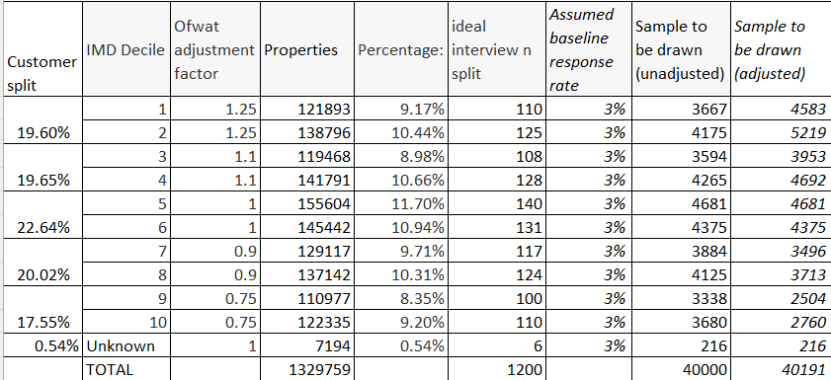

This ensured that the selection (a) matched the profile of the Welsh Water supply area, and (b) boosted each IMD decile appropriately in line with the guidance.

The percentages of records drawn for email vs postal, were checked (between the overall complete sample universe of all non-excluded customers, and the drawn sample), to ensure a selection bias had not been introduced that would later require remedial weighting. It was judged that the two data sets were sufficiently closely aligned that this was not the case.

Sample exclusions were kept to a minimum:

- Customers who have previously requested not to be included in research/surveys
- Customers who have previously unsubscribed from E-Marketing
- Customers with a total bill amount of zero
- Customers not on a dual service
- Measured/unmeasured customers that have been in occupation for less than 6 months.

No quotas were set (in line with the Ofwat and CCW guidance).

Household (HH) Fieldwork
An initial sample was drawn from the universe, based on a much more optimistic response rate (4.5%), to ensure we did not invite more participants than was necessary. The proportions by IMD decile as defined above, were maintained. Records with an email address were sent a single email, records without, a letter.

Responses to these mailings follow:

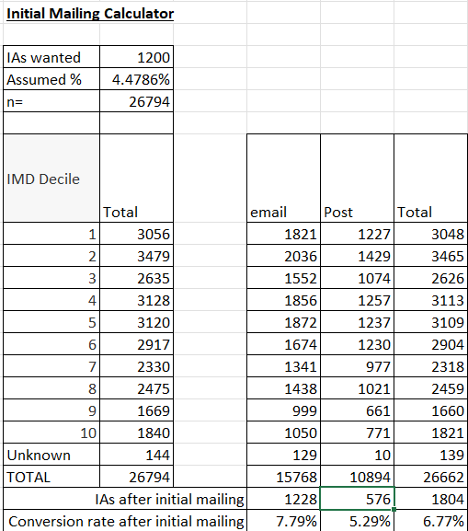

The full target of 1,200 interviews was exceeded and hence no reminders were required or sent.

Non Household (NHH) sampling and fieldwork
A target of 200 non-household interviews was set. NHH bill-payers were recruited from Welsh Water’s customer database, using contacts with an email address only. 838 NHH participants took part in the research.

Survey
The questionnaire itself was generally tightly prescribed and was implemented as mandated.

The exceptions to this were:

- The bill chart graph, where following cognitive feedback it was decided that it would benefit comprehension if a total (of bill impact plus inflation) were added above each bar on the graph showing the impact of the plan on bills. This was added with the approval of Welsh Water’s Independent Challenge Group.

Example follows (based on the average bill amount, and showing the actual increases tested (the difference being accounted for by the respective contributions of the respective wastewater services providers, to the total bill):

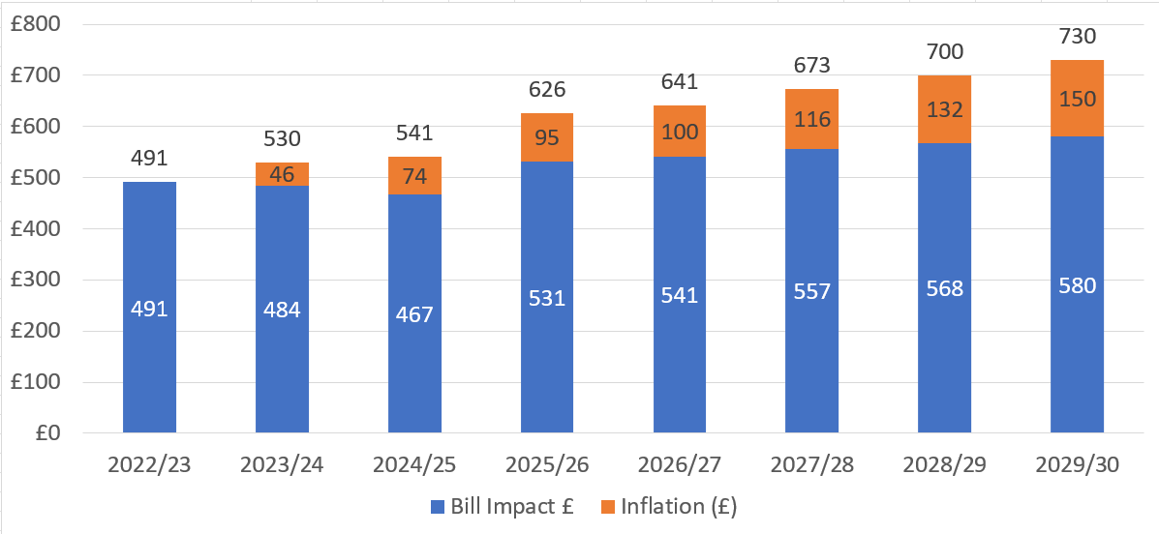

- In addition, results from the qualitative and quantitative cognitive interviews showed that participants found contextual information on Welsh Water insightful. Therefore, the decision was taken, with agreement from the ICG, to include introductory slides to provide some background information as follows:

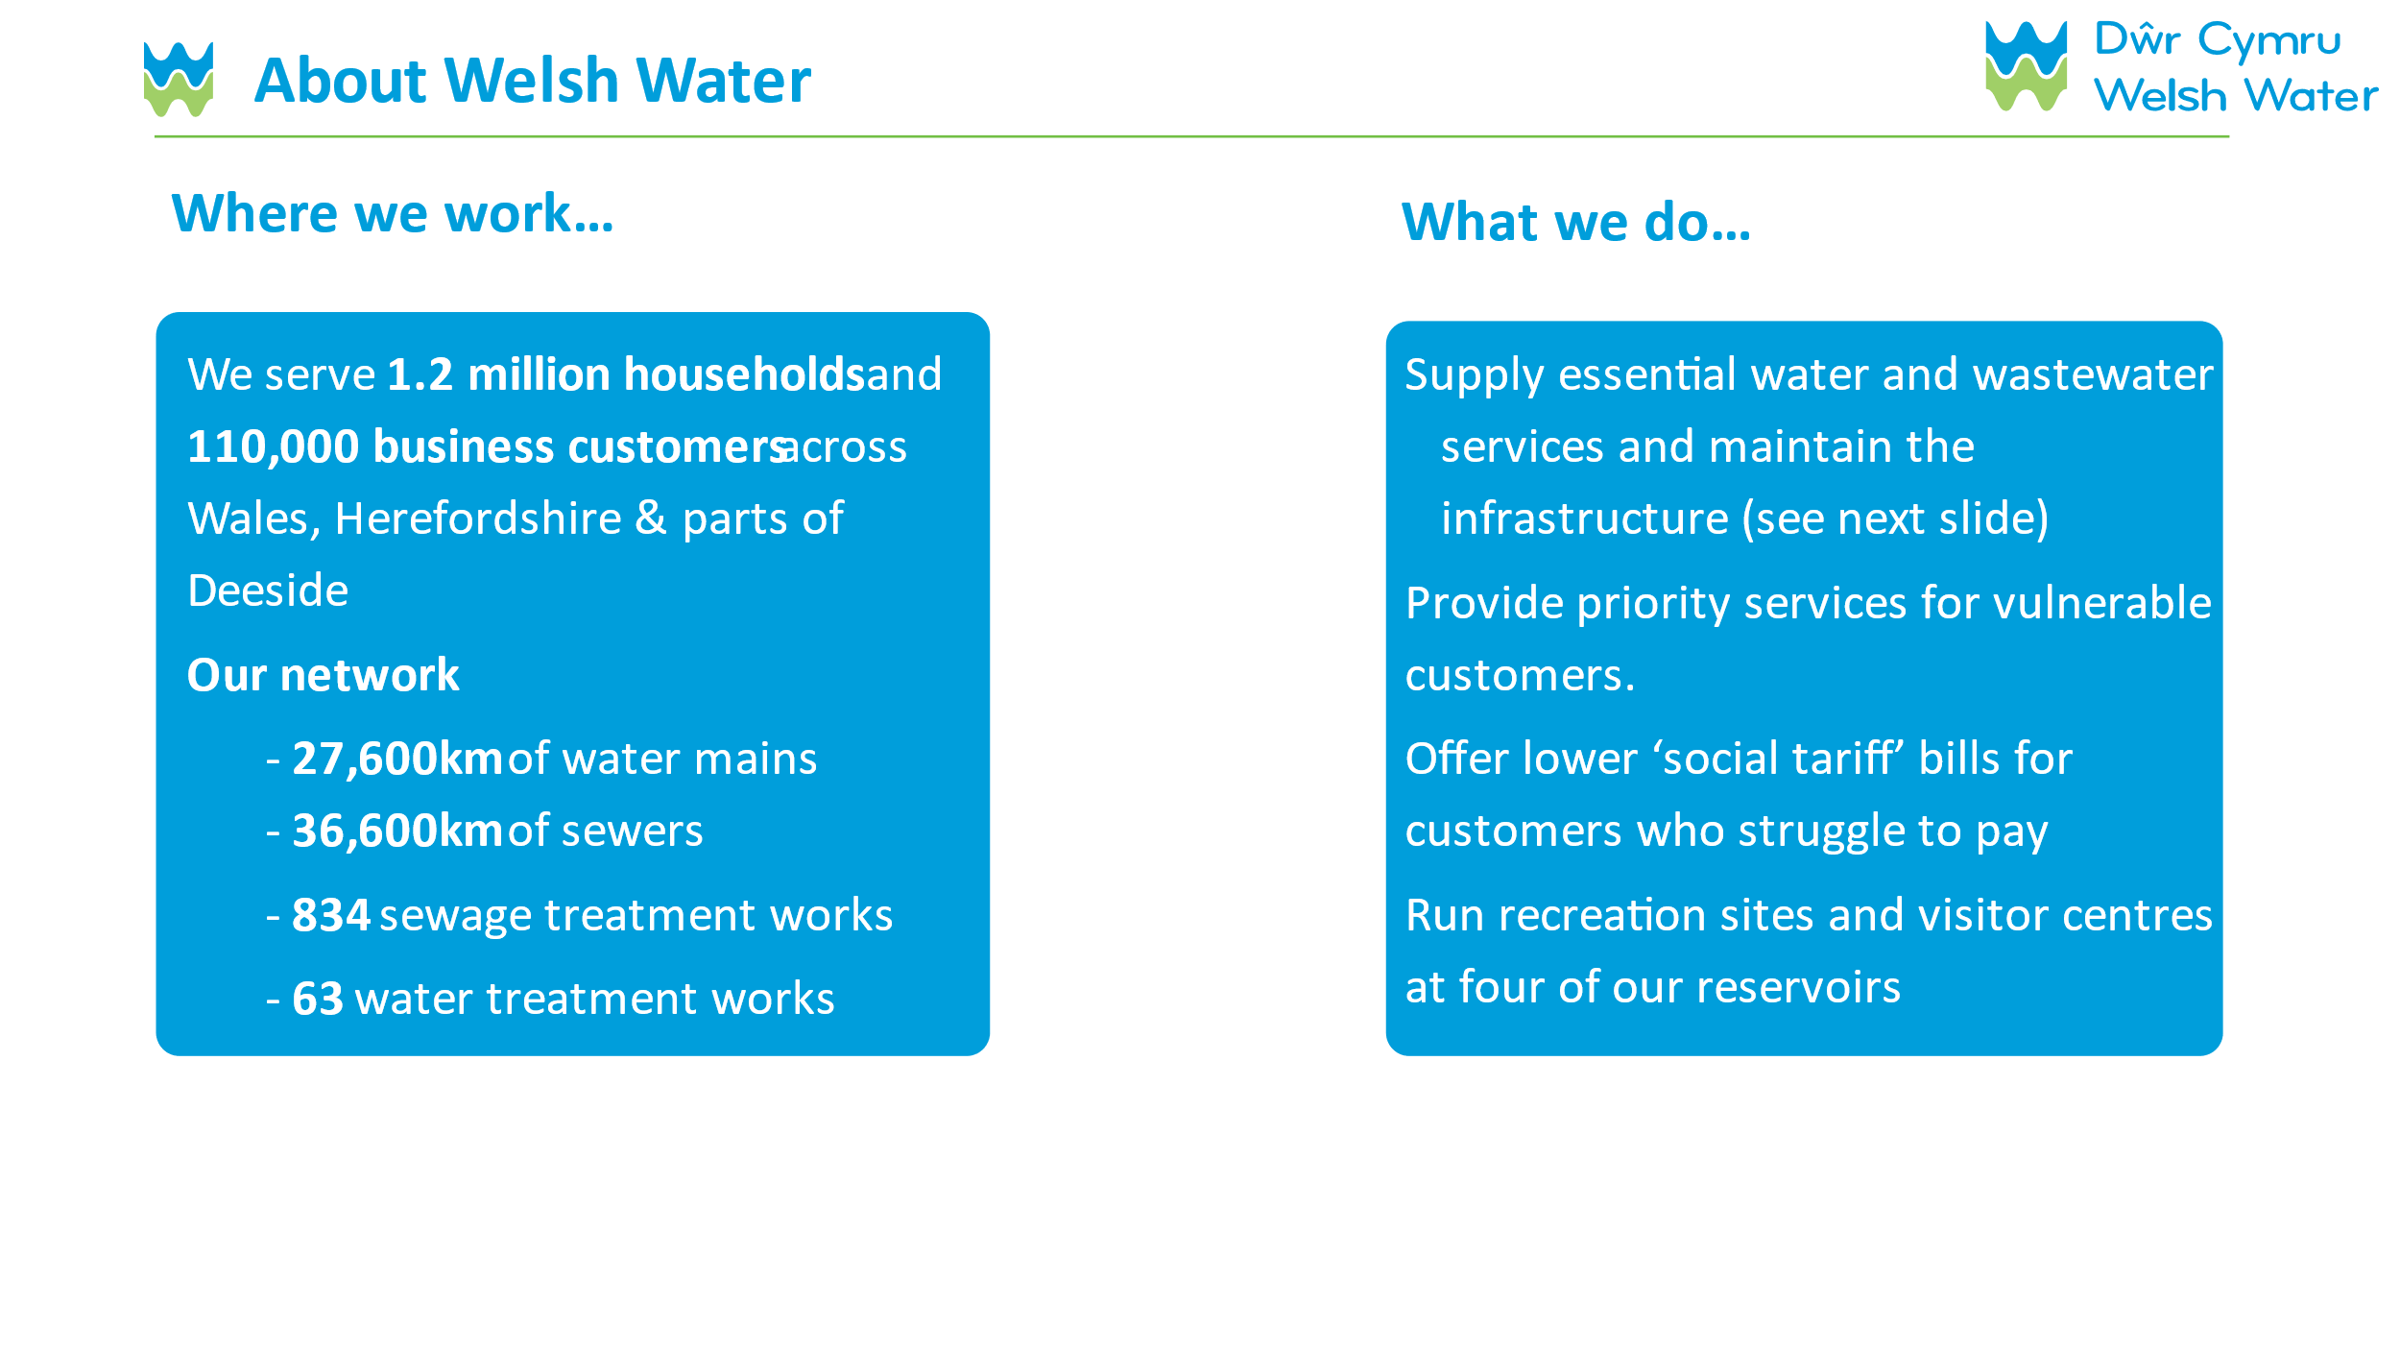
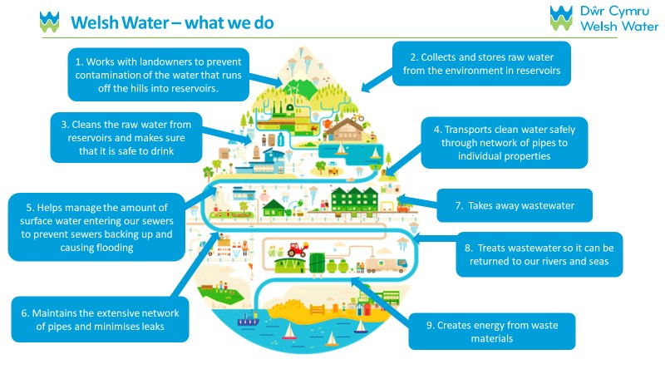

All survey communications were send in bilingual English and Welsh, and Welsh language interviewing was offered to all participants. Twenty two HH participants chose this option, 0 NHH.

Fieldwork dates
Household and Non-Household interviews took place simultaneously. Fieldwork commenced on the 14th August 2023 and closed on the 4th September 2023.

Data processing
Once fieldwork was completed, the resulting dataset was cleaned to remove poor quality responses (including suspiciously low interview durations (speeders), those clearly choosing the first answer code in all questions even when that meant contradictor responses (straight liners), multiple responses from the same IP address etc).

As mandated by Ofwat, data was checked to ensure that no interview was completed in a time of less than 1/3 of the median interview duration.

Weighting
SPSS was used to run RIM weighting (Random Iterative Methods, or “Raking”).

HH survey responses were weighted to the following targets (using figures derived from neighbourhood level Census data (2021) for age and gender/IMD decile as a proxy for SEG as per the guidance):

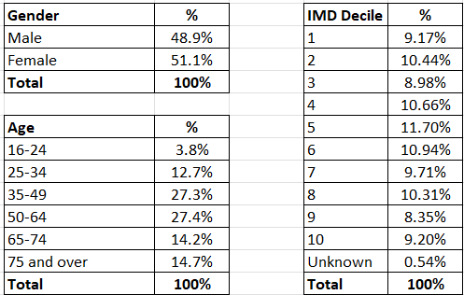

NHH survey responses were weighted to the following targets (using data derived from BEIS (Department for Business, Energy and Industrial Strategy) 2022):

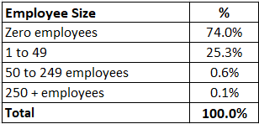

Once individual data sets had been weighted, they were merged NHH with HH to the following proportions (reflecting consumption, using data from table 6B of the water company’s 2022/23 Annual Performance Report):

FINDINGS

Introduction
The following section of this report details the findings of the study.

HH Demographics
1,872 Welsh Water customers took part in the Affordability and Acceptability Testing research. 1,304 responded to the email invitation and 568 to the postal invitations. Profiles are shown below (pre-weighting). Percentages may not add up to 100 due to rounding.
IMD decile
Female 49%
Male 50%
1% prefer not to say
Gender

Gender
1 | 9%
2 | 10%
3 | 9%
4 | 11%
5 | 12%
6 | 11%
7 | 10%
8 | 10%
9 | 8%
10 | 9%
Unknown | 1%
Gender

Age
Age

Census = 17% 16-34, 55% 35-64, 29% 65+.
Vulnerability ^
Social Grade

AB | 38%
C1C2 | 33%
DE | 23%
Not stated | 5%
… is disabled or suffer(s) from a debilitating illness | 26%
… have/has a learning difficulty | 6%
… relies on water for medical reasons | 10%
… is visually impaired | 3%
… am/is over the age of 75 years old | 13%
… am/is not confident as either an English or Welsh speaker | 1%
… is deaf or hard of hearing | 10%
… is a new parent | 3%
None of these apply to me | 53%
Prefer not to say | 3%

Ethnicity
English, Welsh, Scottish, Northern Irish or British | 93%
Any other White background | 2%
Indian | 1%
Prefer not to say | 1%
Ethnicity
^ Throughout this report a vulnerable household is defined as any household that has selected at least one of the options at this question. Q42 Which of the following apply to you?

NHH Demographics
838 (pre-weighting) Non-Household (NHH) interviews were conducted. All NHH participants came from email sample provided by Welsh Water. Profiles are shown below (pre-weighting).
Main use of water on premises

For normal domestic of s customers and employees | 78%
For the supply of services your organisation provides | 14%
For an ingredient or part of the product or service your organisation provides | 10%
For the manufacturing process, essential to the running of your organisation | 8%
None of the above | 8%
Don’t know | 2%

Industry
Number of business sites

Hotels & catering | 13%
Agriculture, forestry and fishing | 12%
Wholesale and retail trade | 10%
Arts, entertainment and recreation | 6%
Construction | 5%
Human health and social work activities | 5%
Real estate activities | 5%
Manufacturing | 3%
Professional, scientific and technical activities | 3%
Finance and insurance activities | 2%
Education | 2%
Transport and storage | 2%
IT and Communication | 1%
Administrative and Support Service Activities | 1%
Public administration and defence | 1%
Other service activities | 5%
Other | 17%
Prefer not to say | 8%
Number of employees

Percentages may not add up to 100 due to rounding.

HH Financial Temperature Check
- 2 in 5 (40%) stated they never struggle to pay their bill; however, nearly the same number of people struggle (39%), this is split by all the time (4%), most of the time (10%) and sometimes (25%)
- Those encountering the greatest challenges appear to be individuals between the ages of 18 and 54, with 52% in the 25-34 age group and 55% in the 35-44 age group expressing struggles
- 44% of households with vulnerable members say they struggle to pay at least sometimes; this is significantly higher than households without vulnerable members (33%)
- 49% of females say they struggle to pay at least sometimes, this is significantly higher than males (29%)
- 55% of SEG AB say they never struggle to pay their bill, this is significantly higher compared to SEG C1C2 (40%) and SEG DE (21%)
- 50% of households with a meter say they never struggle to pay their bill, this is significantly higher compared to households without a meter (34%).

Figure 1. Q9 Thinking about your finances over the last year, how often, if at all, has your household struggled to pay at least one of its bills.

Base: All HH participants (1,872)

- Half of the household participants are also finding it difficult to manage financially or are just about getting by.
- Those aged 55 and over are significantly more likely to say they are living comfortably or doing alright are aged 55-64 (54%), 65-74 (65%) and 75+ (68%)
- 57% of males are significantly more likely to say they are living comfortably or doing alright compared to females (40%)
- 17% of households with vulnerable members say they find it difficult to manage financially or are just about getting by; this is significantly higher than households without vulnerable members (11%).

Figure 2. Q10 Overall, how well would you say you are managing financially now?

Base: All HH participants (1,872)

- Over a third of households anticipate a decline in their financial circumstances in the coming years (38%)
- This increases to 47% among those already struggling financially (those finding it very or quite difficult to manage financially), which is significanlty higher compared to the 32% that are not struggling at the moment.

- The anticipation of positive change diminishes as age increases:
- Individuals in the younger age brackets maintain a more optimistic outlook, foreseeing an enhancement in their situations. Conversely, those in older age groups expect a deterioration. (Overall, 67% for 18-24; 44% for 25-34; 30% for 35-44; 29% for 45-54; 19% for 55-64; 12% for 65-74 and 6% for 75+ expect improvement).

Figure 3 Q11 Thinking about your household’s/organisation’s financial situation over the next few years up to 2030, do you expect it to get?

Base: All HH participants (1,872)

NHH Financial Temperature Check
- Over two thirds (68%) of businesses say they never struggle to pay their bills but 28% do have some difficulties.

Figure 4. Q9 Thinking about your finances over the last year, how often, if at all, has your organisation struggled to pay at least one of its bills?

Base: All NHH participants (728)

- 12% of businesses are operating with financial difficulty, however, over half of businesses (52%) say they are operating comfortably.

Figure 5. Q10 Overall, how well would you say your organisation is managing financially now?

Base: All NHH participants (728)

- Over one quarter of businesses (27%) expect their financial situation to improve in the years to come, whilst one in five expect it to worsen (21%).

Figure 6. Q11 Thinking about your organisation’s financial situation over the next few years up to 2030, do you expect it to get

Base: All NHH participants (728)

Affordability
Affordability of the plan was low – with just 16% of participants saying the bill increases would be very or fairly easy to afford.

HH Affordability
- Slightly more than 2 out of 5 (41%) of Welsh Water customers stated that paying their current water and sewerage bill is either very or fairly easy. However, this percentage declines to 15% when asked to consider the future bills associated with the business plan.
- A greater proportion of individuals under 65 are significantly more likely to encounter difficulties with forthcoming bills (61% 18-24; 60% 25-34; 49% 45-54; 44% 55-64), in contrast to those aged over 65-74 (34% and 75+ (29%).
- Females exhibit a notably higher likelihood of grappling with this impending rise (55%) compared to males (38%).

- 53% of those that are struggling financially (those finding it very or quite difficult to manage financially) say they find the current bill very or fairly difficult to pay. This increases to 80% when thinking about the 2025-30 bill.

Figure 6. Q13 How easy or difficult is it for you to afford to pay your current water and sewerage bill? Q14 How easy or difficult do you think it would be for you to afford these water/sewerage bills?
Base: All HH participants (1,872)

- As expected, affordability of the future bill will become more problematic for those on the lower end of the income scale. Specifically difficult for those earning under £10,399 (69%). These households are significantly more likely to find their future bills fairly/very difficult to afford compared to any household earning over £36,000.
- The percentage of participants saying that they would find their bill very difficult to afford decreased almost in a linear manner with the increase of income.
Figure 7. Q14 How easy or difficult do you think it would be for you to afford these water/sewerage bills?
Denotes significantly higher than *
NET
Difficult
(Base on household income) All HH participants (1,872)

- Affordability is lower among households that have vulnerable members at 14% (Net Very/fairly easy) compared to households without vulnerable members at 18%.
- These households are significantly more likely to find these bills fairly/very difficult to pay (18%) compared to those without a vulnerable member (12%).
Figure 8. Q14 How easy or difficult do you think it would be for you to afford these water/sewerage bills?

Base: All HH with vulnerable members (868) and HH with no vulnerable members (942) *Details of conditions listed under each vulnerability can be found in Appendix E

NHH Affordability
- Affordability is higher among the NHH population compared to the HH.
- 42% of businesses find their bills easy or very easy to afford. This however drops down to 18% when thinking about the future bill.
Figure 9. Q13 How easy or difficult is it for your company/organisation to afford to pay your current water and sewerage bill? Q14 How easy or difficult do you think it would be for your company/organisation to afford these water/sewerage bills?

Base: All NHH participants (728)

Acceptability
Acceptability of the plan was much higher than affordability – 84% overall.

HH Acceptability
- 84% of the Welsh Water HH customers found the proposed plan acceptable:
- Acceptability figures were broadly consistent among different age groups with no significant differences
- The business plan is significantly more acceptable to participants who are not struggling financially (85%) than those who are struggling financially (80%).

Figure 10. Q32 Based on everything you have seen and read about Welsh Water’ proposed business plan, how acceptable or unacceptable is it to you?

Base: All HH participants (1,872)

Reasons for unacceptability
- Nearly a third stated, ‘I don’t trust them to make these service improvements’ as their top reason for unacceptability (31%). This is closely followed by ‘the bill increases are too expensive’ (30%) and ‘company profits are too high’ (21%).
Figure 11. Q33. What are the two main reasons that you feel the proposals for your water services are unacceptable?

Base: All HH participants that felt proposals were unacceptable (140)

Reasons for acceptability
- Customers that found the plan acceptable, support what Welsh Water is trying to do long term (60%), feel like their plans are focusing on the right services (46%) and they are doing what is best for their customers (26%).
Figure 12. Q34. What are the two main reasons that you feel the proposals for your water supply are acceptable?
Base: All HH participants that felt proposals were acceptable (1,576)

NHH Acceptability
- Acceptability is slightly lower among NHH compared to HH. 82% of the businesses found the proposed business plan acceptable
  - The business plan is significantly more acceptable to NHH participants who are not struggling financially (85%) than those who are struggling financially (68%).

Figure 13. Q32 Based on everything you have seen and read about Welsh Water’ proposed business plan, how acceptable or unacceptable is it to you?
Base: All HH participants (728)

Reasons for unacceptability
- Similar to household customers, nearly a third of business customers stated, ‘I don’t trust them to make these service improvements’ as their top reason for unacceptability (30%). This is followed by ‘I expect better service improvements’ (23%) and ‘the bill increases are too expensive’ (22%).
Figure 14. Q33. What are the two main reasons that you feel the proposals for your water services are unacceptable?

Base: All NHH participants that felt proposals were unacceptable (76)

Reasons for acceptability
- Similarly to HH customers, business customers find the plan acceptable and support what Welsh Water is trying to do long term (59%), feel like their plans are focusing on the right services (46%) and trust they are doing what is best for their customers (25%).

Figure 15. Q34. What are the two main reasons that you feel the proposals for your water supply are acceptable?

Base: All NHH participants that felt proposals were acceptable (595)

Intergenerational Phasing
- For both business and household customers, the preferred phasing option amongst those able to choose from was for an immediate increase in bills rather than a delay (mirroring the findings of the qualitative phase of this A&AT study, and Welsh Water’s Long Term Delivery Strategy research).
- There were no significant differences between the views of household and business customers across the three options.
- A significantly higher proportion of females (42%) compared to males (33%) said I don’t know.

Figure 16. Q35. Long term investment by Welsh Water will require an increase in customer bills. Bills could increase in different ways over time. Which one of the following options would you prefer?

Base: All HH participants (1,872) and all NHH participants (728)

Performance commitments
There was engagement from both household and non-household customers with the performance commitments as the majority have been able to choose an option at these questions.

Participants were shown the performance commitments in two banks of three (water, and waste) and asked to pick which is most important to them. Details follow:

Water related

- Reducing leaks was chosen as the most important performance commitment by household customers.
- Reducing leaks is significantly more important to those aged 45+ than to those aged under 45 and males (54%) compared to females (42%)
  - The quality of water is most important to those aged under 55, but highest for those aged 25-34 (54%), significantly higher compared to those aged 65-74 (29%) and 75+ (24%)

- Reducing leaks was also named as most important by NHH customers.
- The quality of water was ranked second
- Reducing the duration of water interruptions was ranked third and was significantly more important for businesses (12%) than households (9%) – perhaps unsurprisingly as so many rely on water to operate.

Figure 17. Q19. Based on what you have just read, which of these three parts of the business plan is the most important to you?
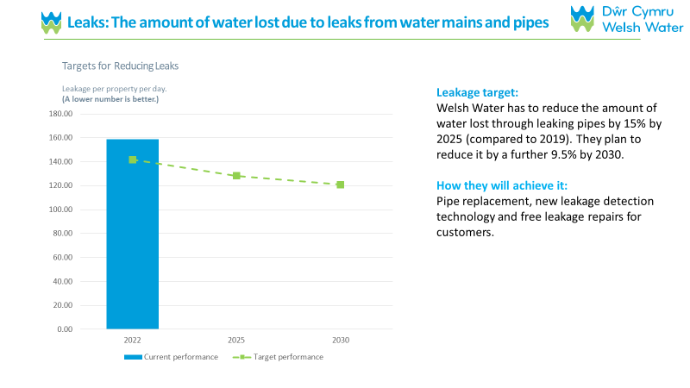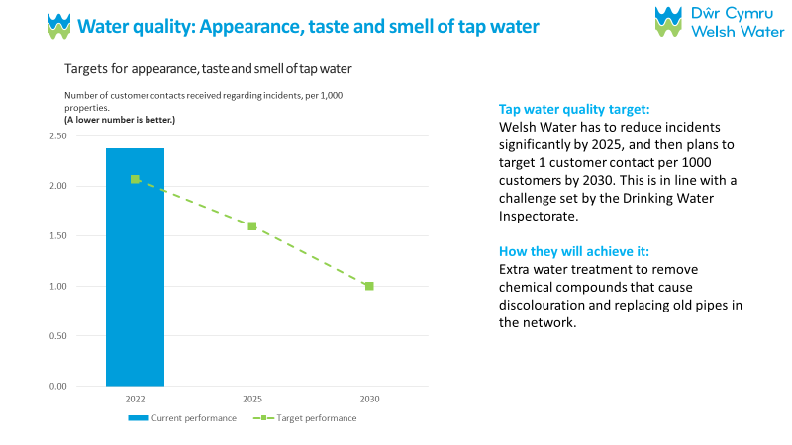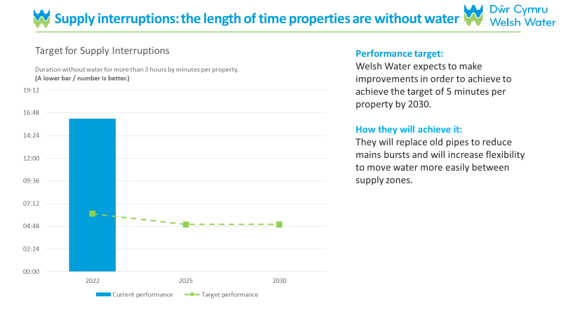
9%
12%
Reducing the duration of water interruptions of longer than 3 hours
HH
NHH
39%
35%
Reducing the incidents of poor water quality
HH
NHH
47%
50%
Reducing leakage
HH
NHH

Don’t know/ can’t say: 4% HH; 3% NHH
Base: All HH participants (1,872) and all NHH participants (728)

Sewerage and Pollution related
- Preventing the number of pollution incidents is the most important performance commitment for household customers from this bank
- Participants aged 45-54 (57%), 55-64 (58%) and 65-74 (67%) are significantly more concerned about reducing the number of pollution incidents than those aged under 45
- Males (61%) are significantly more likely to choose reducing the number of pollution incidents compared to females (51%)

- Reducing the number of pollution incidents is also at the top of the list for NHH customers and significantly more important to NHH customers (63%) than HH customers (55%)
- Reducing sewer flooding inside properties is ranked second in this bank for both HH (25%) and NHH (21%) customers, the difference is significant
- Females (29%) are significantly more likely to choose reducing sewer flooding inside properties compared to males (21%)

- Reducing sewer flooding outside properties is ranked third in this bank for both HH (15%) and NHH (12%) customers, the difference is significant.
Figure 18. Q23. Based on what you have just read, which of these three parts of the business plan is the most important to you?
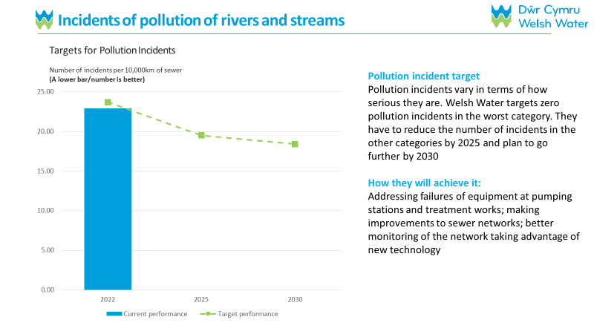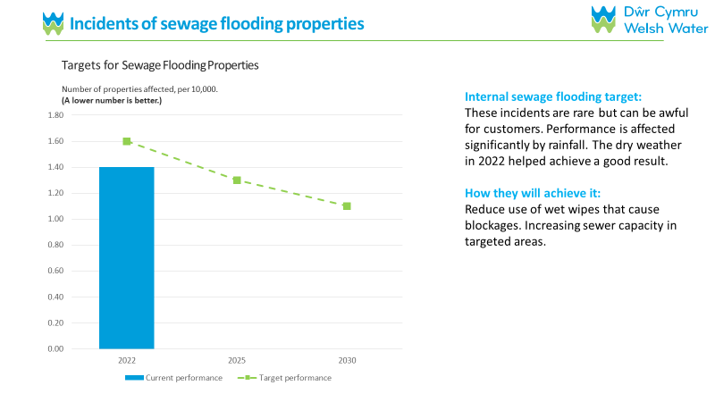
55%
63%
Reducing the number of pollution incidents
HH
NHH
25%
21%
Reducing sewer flooding inside properties
HH
NHH
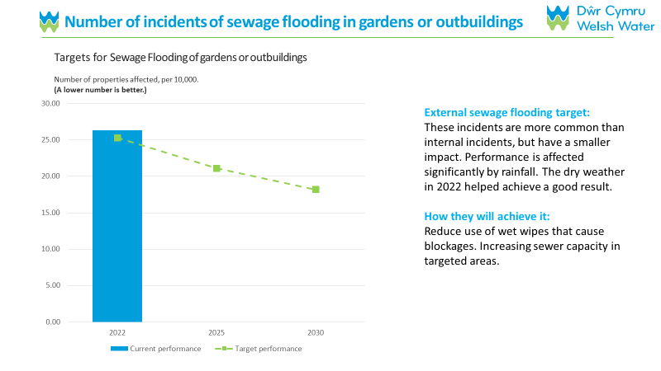
Denotes significantly higher
15%
12%
Reducing sewer flooding outside properties
HH
NHH
Don’t know/ can’t say: 5% HH; 5% NHH
Base: All HH participants (1,827) and all NHH participants (728)

Enhancement cases
There has been notable engagement from participants with the enhancement cases of the business plan as only 3% of HH and 4% of NHH customers weren’t able to make a decision.

- Protecting and improving the environment has had the most backing from household (44%) and business (46%) customers alike
- This was rated significantly more important by those aged 25-34 (51%) and 45-54 (47%)
  - This was also significantly more important to females (48%) compared to males (40%) and those in SEG DE (49%) compared to the other social grades

- Securing long-term water resources came in second highest
- 38% of Household customers stated this is the most important part of the business plan, which is significantly higher than the 32% of business customers

- Making the service more resilient were not considered as important to participants as the other enhancement cases
- They did appeal more to males (19%) compared to females (12%) and to those in SEW AB (17%) and C1C2 (17%).
- Participants with a meter (17%) were also significantly more likely to choose this enhancement compared to those without a meter (14%).
Figure 19. Q27. Based on what you have just read, which of these four parts of the business plan is the most important to you?

Base: All HH participants (1,872) and all NHH participants (728)

APPENDIX A
Adherence to Ofwat’s standards for high quality customer research

- Requirement | - How the study has adhered
- Useful and contextualised | Research objectives aligned to PR24 and undertaken in accordance with Ofwat & CCW’s published guidance.
- Neutrally designed | Outside of the prescribed Ofwat guidance, every effort has been made to ensure that the research is neutral and free from bias. All elements of design were checked and challenged by Welsh Water’ ICG. Where there is the potential for bias, this has been acknowledged in the report.
- Fit for purpose | Research undertaken in accordance with Ofwat & CCW’s published guidance. Cognitive testing was carried out to ensure the complex subject matter was presented in the questionnaire in a way which was as understandable and engaging as possible for respondents. Visual stimulus was created in order to aid participant understanding of the proposed plan.
- Inclusive | Household and business customers were represented. Lower IMD deciles were over-sampled and higher IMD deciles under-sampled, to compensate for lower response rates. The response rates were monitored across a range of demographics to ensure representation, although the prescribed methodology prevents any interventions in this regard. Accommodation was made for any accessibility requests (including paper/postal versions, large print, high contrast print), via a freephone number.
- Continual | This research builds on the foundation of the qualitative work and contributes towards the ongoing development of policy and plans.
- Independently assured | All research was conducted by Accent, an independent market research agency. Welsh Water collaborated with their Independent Challenge Group, who reviewed all research materials and provided a check and challenge approach on the method and findings.
- Shared in full with others | The research will be published and shared on the Welsh Water website.
- Ethical | Research conducted in accordance with the Market Research Society code of conduct and conforming to the requirements of ISO 20252:2019. Accent and Welsh Water were subject to strict data protection protocols.

APPENDIX B
Additional Information

The following information on Quantitative work is available upon request:

- The fieldwork method (e.g. in-person, telephone or online, individual or group interviews, synchronous or asynchronous),
- The target group and sample selection methods,
- Assessment of sample representation of target population and respective implications,
- The sampling method, including size of planned and achieved sample, reasons for differences in planned and achieved and how any problems in this respect were dealt with,
- Response rate where probability samples were used and its definition and calculation method,
- Participation rate where non-probability samples were used,
- The number of interviewers or moderators, if applicable,
- The fieldworker/moderator validation methods, if applicable,
- The questionnaires, any visual exhibits or show cards, and other relevant data collection documents,
- The weighting procedures, if applicable,
- Any methods statistical analysis used,
- The estimating and imputation procedures, if applicable,
- The results that are based on subgroups and the number of cases used in subgroup analysis,
- Variance and estimates of non-sampling errors or indicators thereof (when probability samples are used).

APPENDIX C
Limitations

Limitation | Impact
Small non-household participants are unlikely to be in scope (either by not having a dedicated business water supply, or by being in serviced offices with inclusive water) | The non-household sample is skewed towards larger organisations.
Some undesirably high weighting values were evident | The household sample was (as a result of the prescribed methodology) heavily skewed towards older participants therefore the youngest age groups attracted some undesirably high weights (precluding reliable analysis into that age category in particular. Similarly, micro non-household were not represented particularly well in the sample (due to the prevalence of small businesses that do not have a dedicated non-household water supply, which made them ineligible for participation) and were weighted up more than might otherwise have been desirable. Impact to the overall affordability & acceptability figures was minimal.

APPENDIX D
Fieldwork Materials
Invitation letter (English Version)
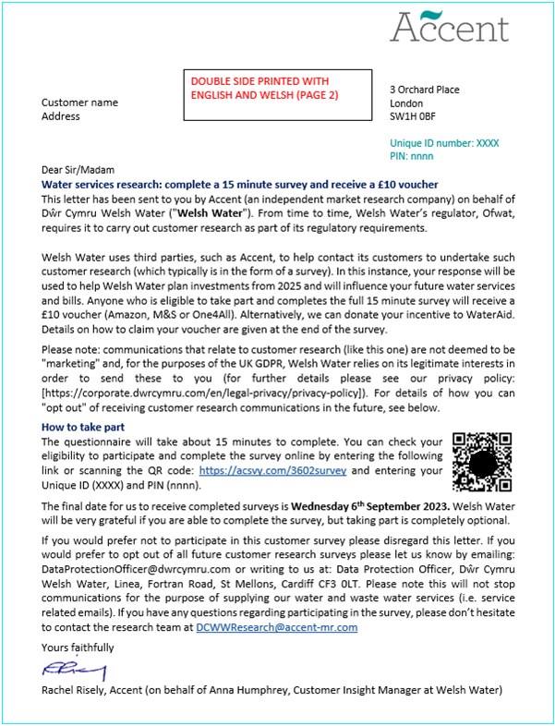

Invitation letter (Welsh Version)
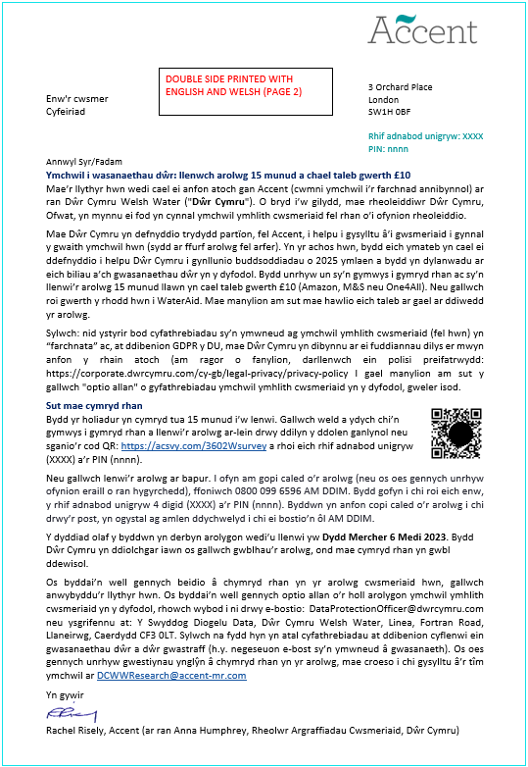

Email invite (HH)
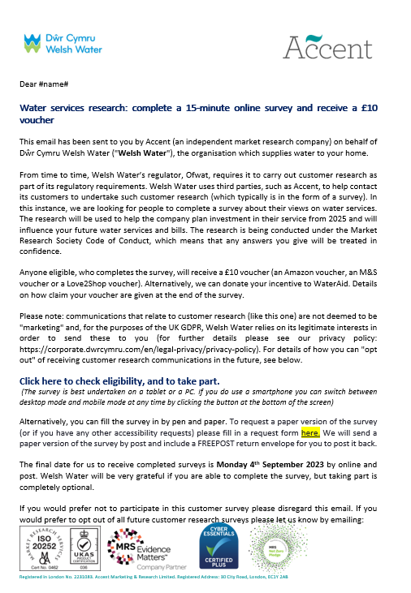
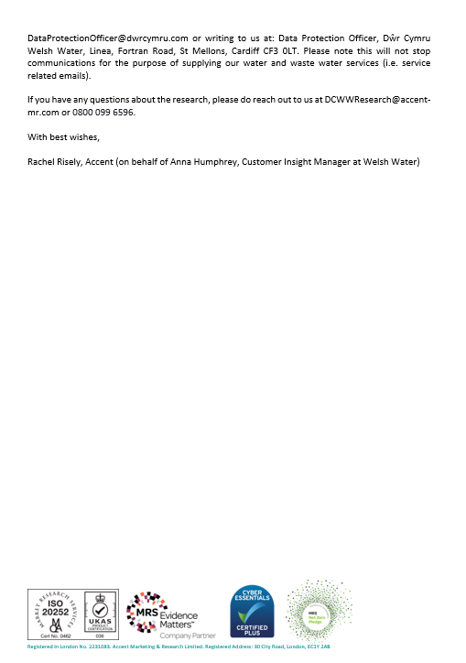
Email invite (NHH)
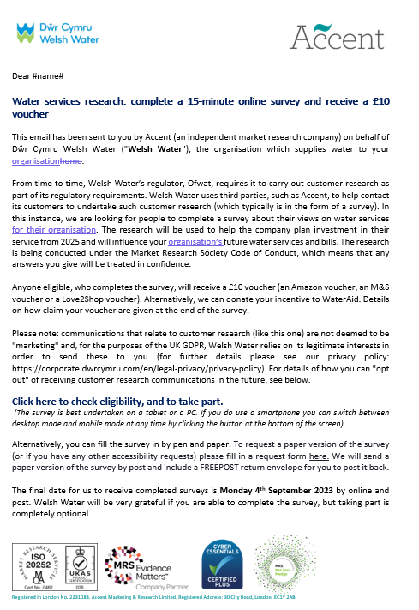
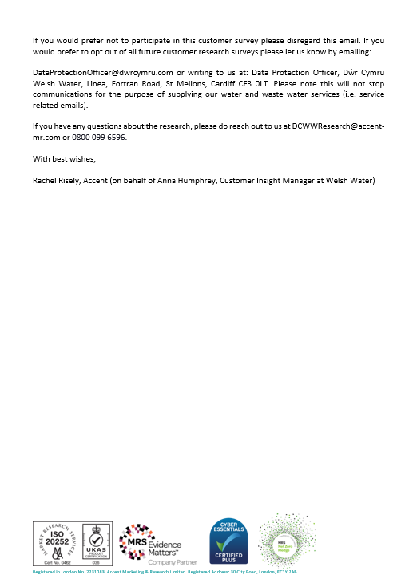

Email invite (Welsh) (HH)
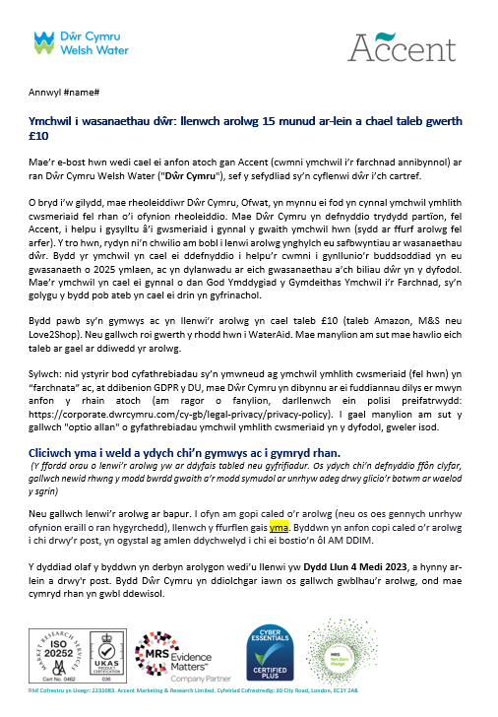
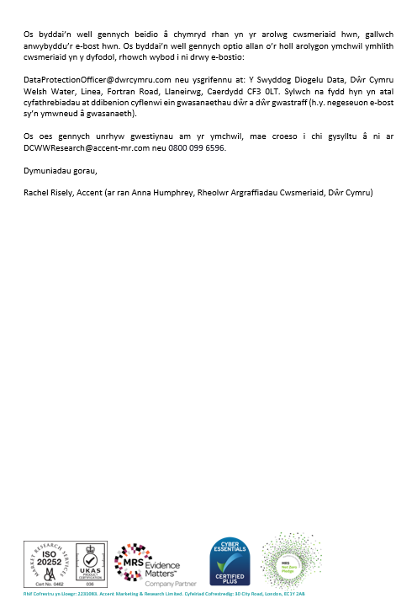

Email invite (Welsh) – NHH
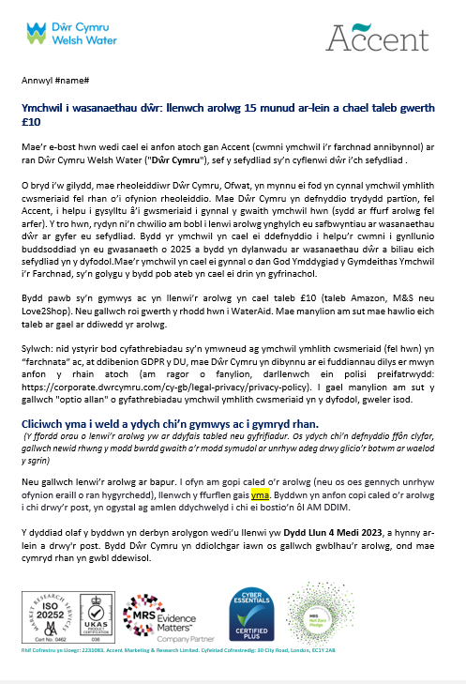
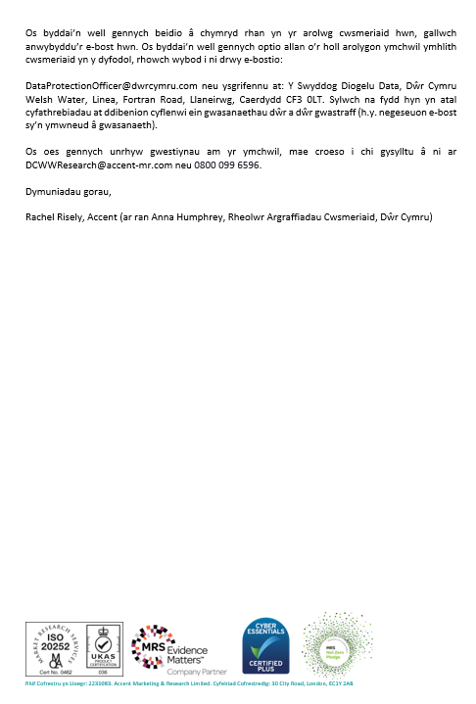

Paper version cover
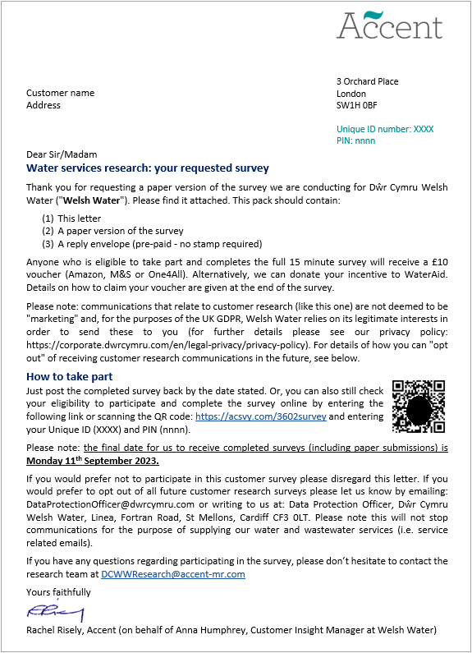
APPENDIX E
Questionnaire (Online version)
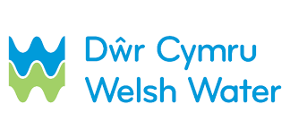

Affordability and Acceptability Testing

Thank you very much for agreeing to complete this [IF ONLINE] on-line survey which is being conducted by Accent, an independent research agency. This survey is designed to help Welsh Water, your water and wastewater service provider, to understand your views on how affordable and acceptable their future plans are.

We will just ask you a couple of questions to check that you are eligible to take part in this research.

Anyone completing the survey will be eligible for a £10 voucher (either an Amazon voucher, an M&S voucher or a One4All voucher). Alternatively, we can donate your incentive to WaterAid. Details on how to claim your voucher are given at the end of the survey.

Any answer you give will be treated in confidence in accordance with the Code of Conduct of Market Research Society. If you would like to confirm Accent’s credentials type Accent in the search box at: https://www.mrs.org.uk/researchbuyersguide.

You do not have to answer any question you do not wish to and you may terminate the interview at any point.

IF MOBILE DEVICE SHOW: This survey is best undertaken on a tablet or a PC. If you do use a smartphone you can switch between desktop mode and mobile mode at any time by clicking the button at the bottom of the screen.

Scoping questions
- Any data collected over the course of this interview that could be used to identify you, such as your name, address, or other contact details, will be held securely and will not be shared with any third party unless you give permission (or unless we are legally required to do so). Our privacy statement is available at https://www.accent-mr.com/privacy-policy/.

Please do not include names, addresses, or other personal data in your responses to any questions, unless asked to do so.
Do you agree to proceeding with the interview on this basis?
Yes
No THANK AND CLOSE

- IF HH: Do you or any of your close family work in market research or for a water company?
Yes THANK & CLOSE
No

- IF HH: How old are you? Please enter your age.
DP PLEASE ADD TEXT BOX
Range: 0 to 99
Prefer not to say THANK AND CLOSE

Q3a. IF HH: Hidden question
DP Lookup Q3 to identify:
Under 18 THANK AND CLOSE
18-24
25-34
35-44
45-54
55-64
65-74
75+
Prefer not to say THANK AND CLOSE

- IF HH: Are you the person in your household who is responsible, either solely or jointly, for paying for your water services bill?
Yes
No, I am not responsible for paying the bill THANK AND CLOSE
Don’t know THANK AND CLOSE

- Are you currently charged for water through a water meter?
Yes
No
Don’t know

- Welsh Water is your water supplier and is responsible for your sewerage services. Does this sound right?
Yes GO TO MAIN QUESTIONNAIRE
No THANK AND CLOSE
Don’t know GO TO MAIN QUESTIONNAIRE

- IF NHH: Are you solely or jointly responsible as the decision maker for your organisation’s water and sewerage service at any of its premises?
Yes
No THANK AND CLOSE

- IF NHH: Is Welsh Water responsible for the water and sewerage services at your organisation?
Yes
No THANK AND CLOSE
Don’t know THANK AND CLOSE

Q8A IF NHH: When answering this questionnaire, we would like you to think only about sites your organisation might have that are in the Welsh Water area. Is that OK?
Yes
No THANK AND CLOSE

Main Questionnaire
Thank you, I can confirm you are in scope for the survey. The questionnaire will take about 15 minutes to complete.

ONLINE ONLY: For convenience you can stop and return to complete the questionnaire as many times as you wish, although once submitted you will not be able to enter again.

Affordability
We are now going to ask you some questions about your [IF HH] household’s[IF NHH] organisation’s financial situation.

- Thinking about your finances over the last year, how often, if at all, [IF HH] have you struggled to pay at least one of your household bills? [IF NHH] has your organisation struggled to pay at least one of its bills? SINGLECODE, RANDOMISE WITH REVERSE ORDER EXCEPT FOR PREFER NOT TO SAY
All of the time
Most of the time
Sometimes
Rarely
Never
Prefer not to say

- Overall, how well would you say [IF HH] you are/[IF NHH] your organisation is managing financially now? SINGLECODE, RANDOMISE WITH REVERSE ORDER EXCEPT FOR PREFER NOT TO SAY
[IF HH] Living/[IF NHH] Operating comfortably
Doing alright
Just about getting by
Finding it quite difficult
Finding it very difficult
Prefer not to say

- Thinking about your [IF HH] household’s/ IF NHH] your organisation’s financial situation over the next few years up to 2030, do you expect it to get: SINGLECODE, RANDOMISE WITH REVERSE ORDER EXCEPT FOR PREFER NOT TO SAY
Please select one answer only
A lot worse
A bit worse
Stay the same
A bit better
A lot better
Prefer not to say
Don't know

- IF NHH: How much are you currently paying for your water and sewerage services bill, each year?
[Open-ended answer] DP PLEASE ADD TEXT BOX
Don’t know

- How easy or difficult is it for [IF HH] you [IF NHH] your company/organisation to afford to pay your current water and sewerage bill: SINGLECODE, RANDOMISE WITH REVERSE ORDER EXCEPT FOR PREFER NOT TO SAY
Please select one answer only
Very easy
Fairly easy
Neither easy nor difficult
Fairly difficult
Very difficult
Don’t know

Q13a. [CATI ONLY] IF NHH: At this point I need you to look at an individualised graph, mapping out what future water bills may look like for your organisation under the plans Welsh Water have.

Please could you go to HTTPS://acsvy.com/3606

You should see a thank you note, then on the next page somewhere to put your annual water bill amount into. Please enter the bill for all sites your company operates in the Welsh Water area. An estimate is absolutely fine.

Interviewer note: do not proceed until they have gone to the website and put in their bill amount. Only then can you proceed. You must not proceed without them seeing these materials.

Looking at web page
Cannot proceed now Open appointment box

Proposed changes to your water/sewerage bill for the years 2025-2030
DP: PLEASE ADD A 7 SECOND DELAY TO THIS SCREEN
The next set of questions are about proposed changes to your water and sewerage bill for the years 2025-2030. The chart below shows these changes. It also shows how inflation may impact on your bill, based on the Bank of England's inflation forecasts.

Water bills change each year in line with inflation.
Inflation is the increase in prices paid for goods and services over time. Household incomes also change over time.
• If your household income keeps up with inflation (ie. increases at the same rate), then you are likely to notice little difference in what you are paying for things.
• If inflation increases by a faster rate than your household income, then you are likely to have less money to go around.
• If your household income increases by a faster rate than inflation, then you are likely to have more money to go around.
The Bank of England aims to keep inflation at 2%, but it has recently been much higher than this. As well as changing by inflation each year, bills change by an amount set by Ofwat (the water regulator) as part of their price review process every five years.
The proposed bills you will see from 2025 to 2030 include the Bank of England forecasts for inflation from 2025 to 2030, and proposed amounts to cover the investment in water and sewerage services needed over the next few years.

The following chart shows the expected increase in your water/sewerage bill over the next few years. This is your predicted bill based on your bill amount of £[DP ADD BILL AMOUNT FROM SAMPLE].

The blue part of each column is what the underlying change to your bills would look like if there were no inflation. The orange part is what inflation will add on top. So, your actual bill would be the two parts added together.

The figure above each bar represents the total expected bill amount (the blue plus the orange)

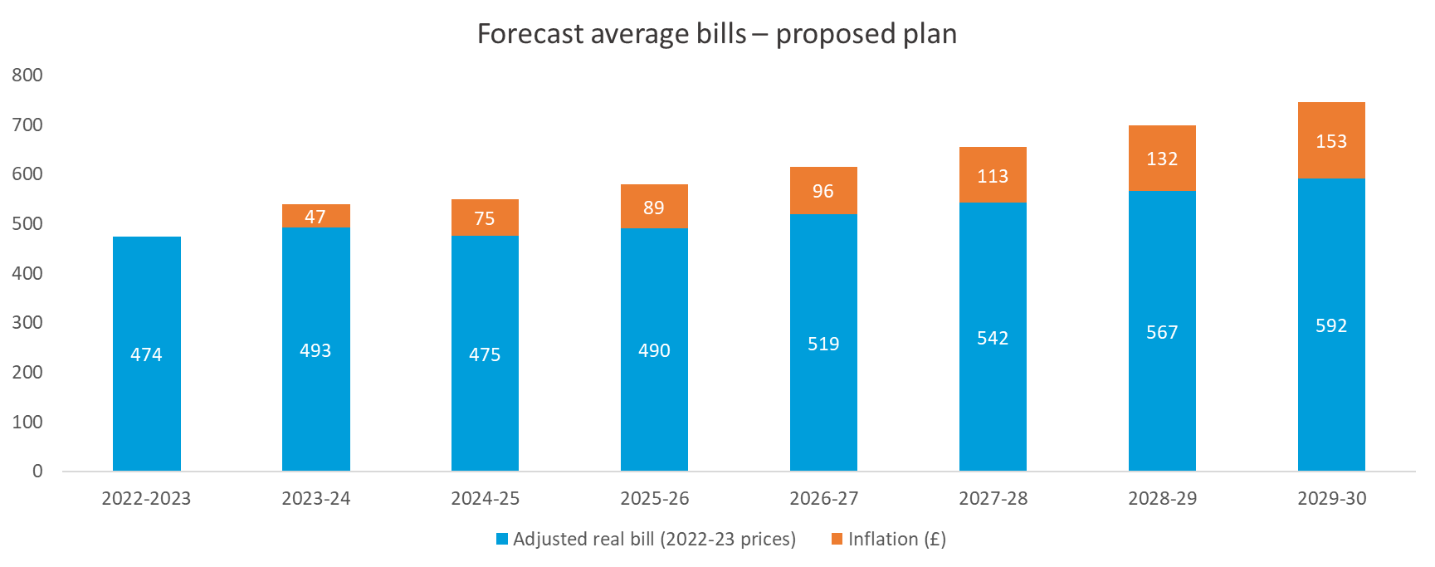

(Placeholder – this graph will be tailored according to bill amounts) using: INSERT LINK TO FINAL BILL CALCS WHEN RECEIVED FROM DCWW using MAIN GRAPH HH & NHH on the “Quant” tab, cell L4

IF Social Tariff Customer (from sample): This bill profile is based on the financial support scheme you are currently on.

- How easy or difficult do you think it would be for [IF HH] you [IF NHH] your company/organisation to afford these water/sewerage bills? SINGLECODE, RANDOMISE WITH REVERSE ORDER EXCEPT FOR DON’T KNOW
Very easy
Fairly easy
Neither easy nor difficult HH ONLY GO TO Q16
Fairly difficult HH ONLY GO TO Q16
Very difficult HH ONLY GO TO Q16
Don’t know

- [IF HH ONLY] IF Q15= 3,4,5 Which of the following do you think you would need to do to pay for the increase in your water bills between 2025 and 2030 MULTICODE, RANDOMISE WITH REVERSE ORDER EXCEPT FOR DON’T KNOW
Shopping around more
Spending less on food shopping and essentials
Spending less on non-essentials
Cutting back on non-essential journeys in my vehicle
Eat out less
Using less fuel such as gas or electricity in my home
Using less water
Using my savings
Using credit more than usual, for example, credit cards, loans or overdrafts
Ask family and friends for financial support
Other, please specify [OPEN RESPONSE] DP PLEASE ADD TEXT BOX
Don’t know

DP PLEASE ADD A TIMESTAMP

About Welsh Water
Q15a. Please take a look at the following information about Welsh Water:

MOBILE: The following options work best if you view them in landscape and alternatively you can switch to desktop mode by clicking the button at the bottom of the screen.

DP: PLEASE ADD A 7 SECOND DELAY TO THIS SCREEN

DP – USE SLIDES 1 AND 2

Before this survey how familiar were you with Welsh Water and the services they offer?

Very familiar
Quite familiar
Not very familiar
Not at all familiar

Welsh Water’s Plans
We are now going to ask you some questions about your views on Welsh Water’s business plan. Water companies are required to put together business plans for each five year period. The plan we are showing you is for the next five-year period which is 2025-2030.

Owing to space constraints we are not able to cover in this survey everything that Welsh Water does and will continue to do in its Business Plan. We will focus on a few key performance measures and areas of investment, so please don't worry if something that you are interested in is not covered.

First we are going to show you how Welsh Water is doing in six aspects of company performance in which the performance levels are measured and can be compared across all water companies in England and Wales. We will show you the comparison and the company's targets for 2025 and 2030. We will then ask you to rate how important and acceptable you think the proposals are.

MOBILE: The following options work best if you view them in landscape and alternatively you can switch to desktop mode by clicking the button at the bottom of the screen.

- Water Supply Interruptions

The following chart shows how Welsh Water are performing on “Water Supply Interruptions”, against both their target and also the other water companies.
DP – USE SLIDE 3

DP: PLEASE ADD A 7 SECOND DELAY TO THIS SCREEN

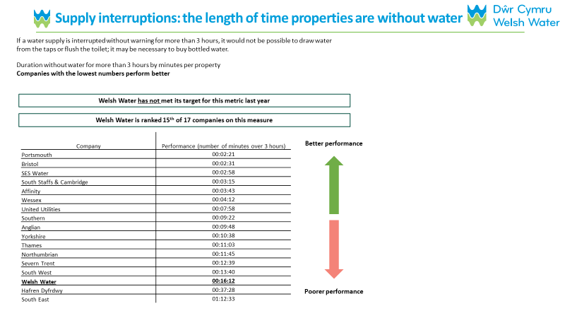
The following chart shows what Welsh Water is proposing doing to improve on this measure:
DP – USE SLIDE 4

- Leakage
The following chart shows how Welsh Water are performing on “Leakage”, against both their target and also the other water companies.
DP – USE SLIDE 5
DP: PLEASE ADD A 7 SECOND DELAY TO THIS SCREEN

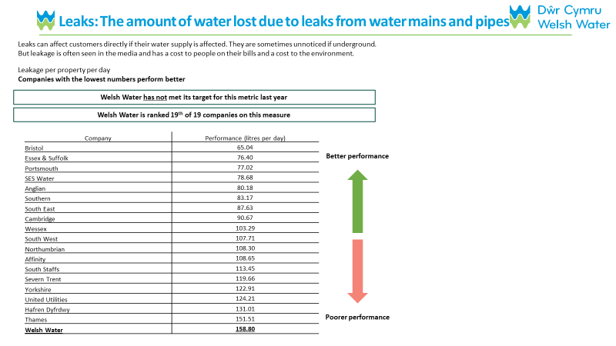
The following chart shows what Welsh Water is proposing doing to improve on this measure:
DP – USE SLIDE 6

- Water Quality Contacts DP – USE SLIDE 7
The following chart shows how Welsh Water are performing on “Water Quality Contacts”, against both their target and also the other water companies.

DP: PLEASE ADD A 7 SECOND DELAY TO THIS SCREEN

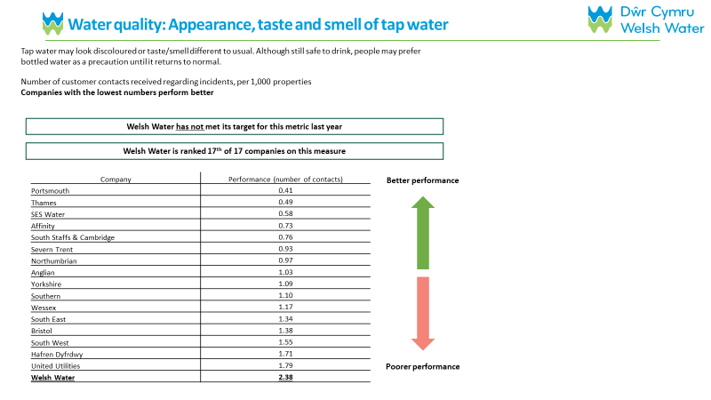
The following chart shows what Welsh Water is proposing doing to improve on this measure:
DP – USE SLIDE 8

- Based on what you have just read, which of these three parts of the business plan is the most important to you? SINGLECODE, RANDOMISE WITH REVERSE ORDER EXCEPT FOR DON’T KNOW
Please select one answer only

Reducing the duration of water interruptions of longer than 3 hours
Reducing leakage
Reducing the incidents of poor water quality
Don't know/can't say

- Internal Sewer Flooding
The following chart shows how Welsh Water are performing on “Internal Sewer Flooding”, against both their target and also the other water companies.
DP – USE SLIDE 9
DP: PLEASE ADD A 7 SECOND DELAY TO THIS SCREEN

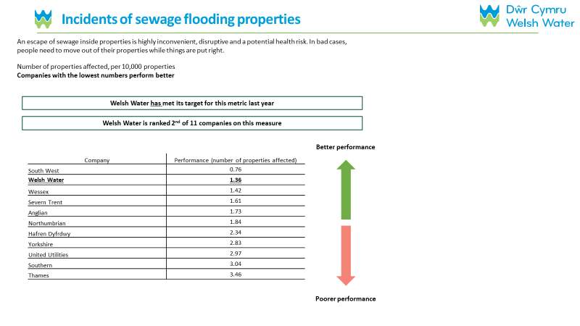
The following chart shows what Welsh Water is proposing doing to improve on this measure:
DP – USE SLIDE 10

- External Sewer Flooding
The following chart shows how Welsh Water are performing on “External Sewer Flooding”, against both their target and also the other water companies.
DP – USE SLIDE 11
DP: PLEASE ADD A 7 SECOND DELAY TO THIS SCREEN

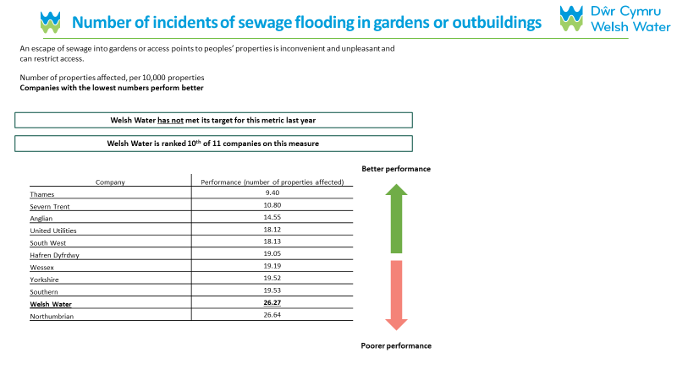
The following chart shows what Welsh Water is proposing doing to improve on this measure:
DP – USE SLIDE 12

- Pollution Incidents
The following chart shows how Welsh Water are performing on “Pollution Incidents”, against both their target and also the other water companies.
DP – USE SLIDE 13
DP: PLEASE ADD A 7 SECOND DELAY TO THIS SCREEN

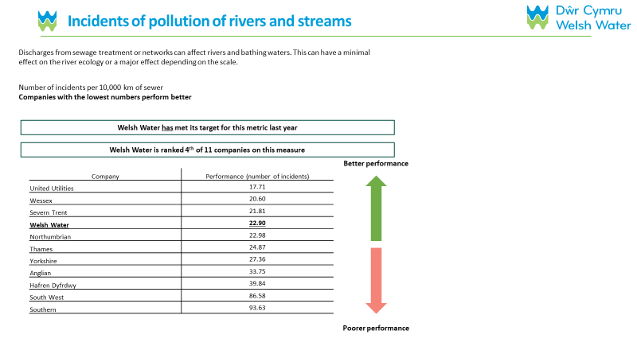
The following chart shows what Welsh Water is proposing doing to improve on this measure:
DP – USE SLIDE 14

- Based on what you have just read, which of these three parts of the business plan is the most important to you? SINGLECODE, RANDOMISE WITH REVERSE ORDER EXCEPT FOR DON’T KNOW
Please select one answer only

Reducing sewer flooding inside properties
Reducing sewer flooding outside properties
Reducing the number of pollution incidents
Don't know/can't say
DP PLEASE ADD A TIMESTAMP

Welsh Water’s Plans – Key Investment Areas
DP: PLEASE ADD A 7 SECOND DELAY TO THIS SCREEN
The next section will show you six of the key areas of investment in Welsh Water’s business plan before asking for your views on the plan as a whole.

- The following slide describes one of the key investment areas of Welsh Water’s business plan: Protecting and improving the environment. Welsh Water is proposing to improve river water quality through additional investment. You can see further details below:
DP – USE SLIDE 15

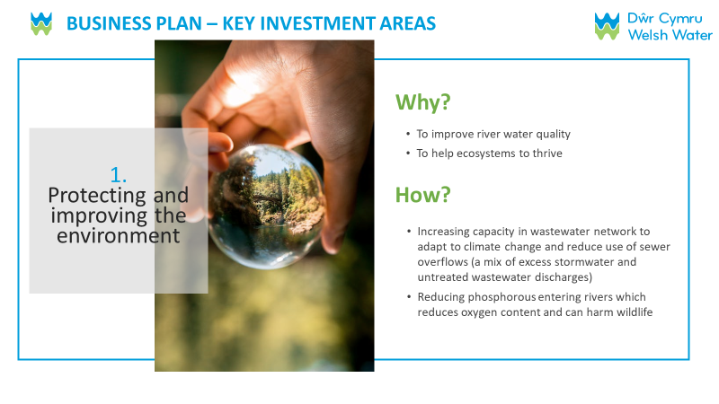

- The next slide describes another of the key investment areas of Welsh Water’s business plan; Securing long-term water resources. Welsh Water is proposing to ensure a long-term reliable water supply through additional investment. Below you can see further details:
DP – USE SLIDE 16
DP: PLEASE ADD A 7 SECOND DELAY TO THIS SCREEN

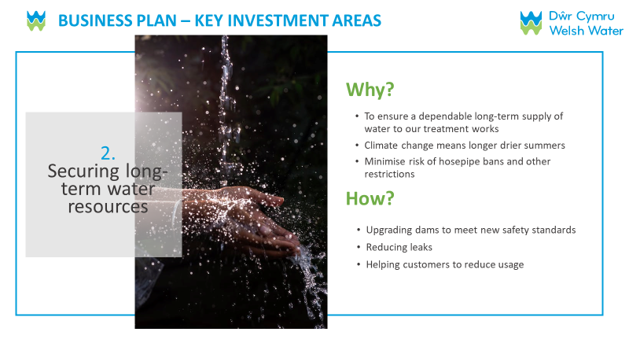

- The next slide describes another of the key investment areas of Welsh Water’s business plan; Making the service more resilient. Welsh Water is proposing to respond to the growing threats to the water supply due to climate change through additional investment. You can see further details below:
DP – USE SLIDE 17
DP: PLEASE ADD A 7 SECOND DELAY TO THIS SCREEN

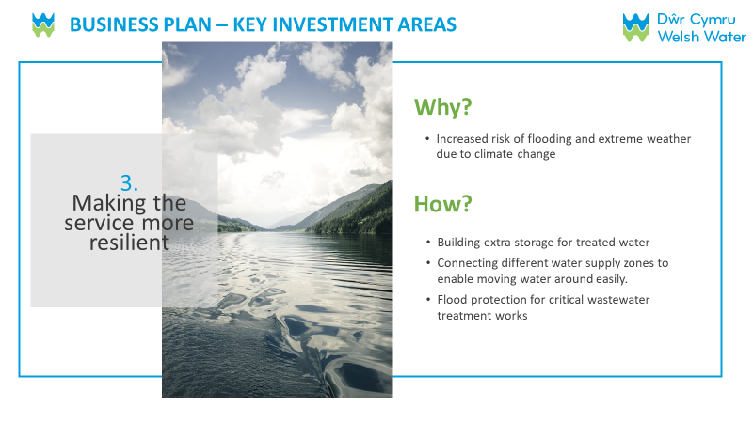

- Based on what you have just read, which of these three parts of the business plan is the most important to you? SINGLECODE, RANDOMISE WITH REVERSE ORDER EXCEPT FOR DON’T KNOW
Please select one answer only

Protecting and improving the environment
Securing long-term water resources
Making the service more resilient
Don't know/can't say

- The following slide describes one of the key investment areas of Welsh Water’s business plan; Wider environmental work. Welsh Water is proposing to reduce greenhouse gas emissions through additional investment. You can see further details below:
DP - USE SLIDE 18
DP: PLEASE ADD A 7 SECOND DELAY TO THIS SCREEN

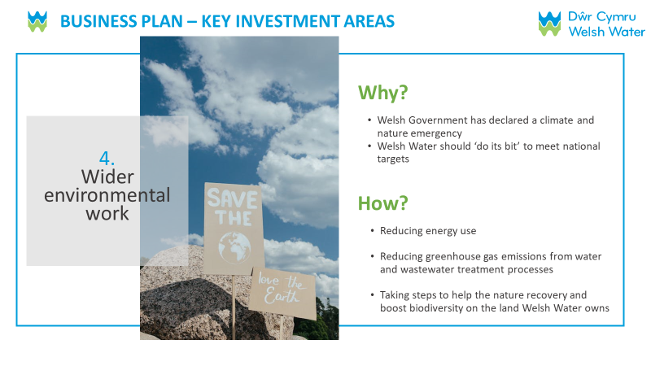

- The next slide describes another of the key investment areas of Welsh Water’s business plan; Quality of drinking water. Welsh Water is proposing to improve tap water quality through additional investment. You can see further details below:
DP – USE SLIDE 19
DP: PLEASE ADD A 7 SECOND DELAY TO THIS SCREEN

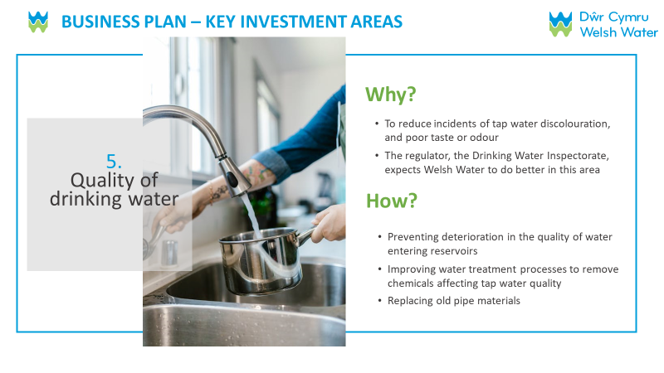

- The next slide describes another of the key investment areas of Welsh Water’s business plan; Replacement of lead pipes connecting homes to the network. Welsh Water is proposing to reduce the potentially harmful impacts of lead pipes through additional investment. You can see further details below:
DP – USE SLIDE 20
DP: PLEASE ADD A 7 SECOND DELAY TO THIS SCREEN

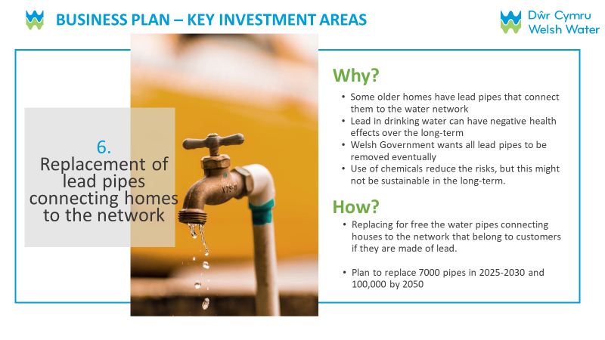

- Based on what you have just read, which of these three areas of investment in the business plan is the most important to you? SINGLECODE, RANDOMISE WITH REVERSE ORDER EXCEPT FOR DON’T KNOW
Please select one answer only

Wider environmental work
Quality of drinking water
Replacement of lead pipes connecting homes to the network
Don't know/can't say

- Based on everything you have seen and read about Welsh Water’s proposed business plan, how acceptable or unacceptable is it to you? SINGLECODE, RANDOMISE WITH REVERSE ORDER EXCEPT FOR DON’T KNOW
Please select one answer only

Completely acceptable GO TO Q35
Acceptable GO TO Q35
Unacceptable GO TO Q34
Completely unacceptable GO TO Q34
Don't know/can't say

- IF Q33=3 or 4 What are the two main reasons that you feel the proposals for your water services are unacceptable? MAXIMUM 2 ANSWERS, RANDOMISE
Please choose up to two answers only
The bill increases are too expensive
Company profits are too high
Companies should pay for service improvements
I expect better service improvements
The plan is poor value for money
Compared to energy prices it is more expensive
I am dissatisfied with current services
The plans don’t focus on the right services
I won’t be able to afford this
I don’t trust them to make these service improvements
Other 1, please specify [OPEN RESPONSE] DP PLEASE ADD TEXT BOX
Other 2, please specify [OPEN RESPONSE] DP PLEASE ADD TEXT BOX
Don’t know/ can’t say

- IF Q33=1 OR 2 What are the two main reasons that you feel the proposals for your water supply are acceptable? MAXIMUM 2 ANSWERS, RANDOMISE
Please choose up to two answers only

The plan is good value for money
The plan is affordable
Compared to energy prices it’s cheaper
Their plans seem to focus on the right services
The company provides a good service now
I support what they are trying to do in the long term
The change to my bill is small
I trust them to do what’s best for customers
I have been dissatisfied with the service recently but am pleased that they are making improvements
Other 1, please specify [OPEN RESPONSE] DP PLEASE ADD TEXT BOX
Other 2, please specify [OPEN RESPONSE] DP PLEASE ADD TEXT BOX
Don’t know/ can’t say

DP PLEASE ADD A TIMESTAMP

- Long term investment by Welsh Water will require an increase in customer bills. Bills could increase in different ways over time. For example, there could be increases now for current bill payers, or bigger increases in the long term for future generations. Which one of the following options would you prefer? SINGLECODE
Please select one answer only

An increase in bills starting sooner, spreading increases across different generations of bill-payers
An increase in bills starting later, putting more of the increases onto younger and future bill-payers
I don’t know enough at the moment to give an answer

Q35a. ASK IF Q33=5 (DON’T KNOW), OTHERS GO TO Q36: After everything you have seen and read about Welsh Water’s proposed business plan, we asked how acceptable or unacceptable the business plan is to you. Why did you select don’t know in response to this question?

DP – ADD TEXT BOX

HH ONLY: Household Demographic
- Thank you. Now just a few questions to check that we are speaking to people of all types.
In which of the following ways do you identify?

Female
Male
I identify in another way
Prefer not to say

- Please indicate which one of the following best describes the profession of the chief income earner in your household
Higher managerial/ professional/ administrative (e.g. Established doctor, Solicitor, Board Director in a large organisation (200+ employees), top level civil servant/public service employee)
Intermediate managerial/ professional/ administrative (e.g. Newly qualified (under 3 years) doctor, Solicitor, Board director small organisation, middle manager in large organisation, principle officer in civil service/local government)
Supervisory or clerical/ junior managerial/ professional/ administrative (e.g. Office worker, Student Doctor, Foreman with 25+ employees, salesperson, etc)
Skilled manual work (e.g. Skilled Bricklayer, Carpenter, Plumber, Painter, Bus/Ambulance Driver, HGV driver, AA patrolman, pub/bar worker, etc)
Semi or unskilled manual work (e.g. Manual worker, apprentice to skilled trade, Caretaker, Park keeper, non-HGV driver, shop assistant)
Housewife/Househusband
Unemployed
Retired GO TO Q39
Student
Prefer not to say

- IF Q38=RETIRED ASK Does the main income earner have a state pension, a private pension or both?
State only
Private only
Both
Prefer not to say

- IF Q39= PRIVATE OR BOTH ASK: How would you describe the main income earner’s occupation type before retirement?

Higher managerial/ professional/ administrative (e.g. Established doctor, Solicitor, Board Director in a large organisation (200+ employees), top level civil servant/public service employee)
Intermediate managerial/ professional/ administrative (e.g. Newly qualified (under 3 years) doctor, Solicitor, Board director small organisation, middle manager in large organisation, principle officer in civil service/local government)
Supervisory or clerical/ junior managerial/ professional/ administrative (e.g. Office worker, Student Doctor, Foreman with 25+ employees, salesperson, etc)
Skilled manual work (e.g. Skilled Bricklayer, Carpenter, Plumber, Painter, Bus/ Ambulance Driver, HGV driver, AA patrolman, pub/bar worker, etc)
Semi or unskilled manual work. (e.g. Manual worker, apprentice to skilled trade, Caretaker, Park keeper, non-HGV driver, shop assistant)
None of these
Prefer not to say

- Which of the following apply to you? We would like to collect this to ensure that a variety of particular needs are represented in the study, but you do not need to answer if you do not wish to. This information will not be shared with any third party and will be destroyed within 12 months of project completion. MULTICODE
Please select all that apply
I or another member of my household is disabled or suffer(s) from a debilitating illness CODED AS MEDICAL VULNERABILITY
I or another member of my household have/has a learning difficulty CODED AS MEDICAL VULNERABILITY
I or another member of my household relies on water for medical reasons CODED AS MEDICAL VULNERABILITY
I or another member of my household is visually impaired (ie struggles to read even with glasses) CODED AS COMMUNICATIONS VULNERABILITY
I or another member of my household am/is over the age of 75 years old CODED AS LIFE STAGE VULNERABILITY
I or another member of my household am/is not confident as either an English or Welsh speaker CODED AS COMMUNICATIONS VULNERABILITY
I or another member of my household is deaf or hard of hearing CODED AS COMMUNICATIONS VULNERABILITY
I or another member of my household is a new parent CODED AS LIFE STAGE VULNERABILITY
None of these apply to me
Prefer not to say

- What is your ethnic group? Choose one option that best describes your ethnic group or background SINGLECODE
Please select one answer only
WHITE
English, Welsh, Scottish, Northern Irish or British
Irish
Gypsy or Irish Traveller
Any other White background
Mixed
White and Black Caribbean
White and Black African
White and Asian
Any other Mixed background
Asian or Asian British
Indian
Pakistani
Bangladeshi
Chinese
Any other Asian background
Black or Black British
Caribbean
African
Any other Black background
Other Ethnic Group
Arab
Any other ethnic group
Prefer not to say

- Which of the following bands does your household income fall into from all sources before tax and other deductions? SINGLECODE
Up to £199 a week/Up to £10,399 a year
From £200 to £299 a week/From £10,400 to £15,599 a year
From £300 to £499 a week/From £15,600 to £25,999 a year
From £500 to £699 a week/From £26,000 to £36,399 a year
From £700 to £999 a week/From £36,400 to £51,999 a year
From £1,000 to £1,399 a week/From £52,000 to £72,799 a year
From £1,400 to £1,999 a week/From £72,800 to £103,999 a year
£2,000 and above a week/£104,000 and above a Year
Don’t know
Prefer not to say
GO TO Q48

NHH only: Demographic Questions
- How does your organisation mainly use water at its premises? MULTICODE
Please select all that apply
For the manufacturing process which is essential to the running of your organisation (eg to power machinery, agricultural production etc)
For the supply of services your organisation provides (eg cleaning services etc)
For an ingredient or part of the product or service your organisation provides (eg food or drink, chemical, cosmetics manufacturer etc)
For normal domestic use for your organisation’s customers and employees (eg customer toilets, supply of drinking water)
None of the above
Don’t Know

- How many sites in the UK does your organisation operate from?
1
2
3
4
5-10
11-50
51-250
250 or more
Prefer not to say

- How many employees does your organisation have in the UK?
0 (sole trader)
1 to 9 employees (micro)
10 to 49 employees (small)
50 to 249 employees (medium)
250+ employees (large)
Prefer not to say

- Which of the following best defines the core activity of your organisation?
Agriculture, forestry and fishing
Mining and quarrying
Energy or water service & supply
Manufacturing
Construction
Wholesale and retail trade (including motor vehicles repair)
Transport and storage
Hotels & catering
IT and Communication
Finance and insurance activities
Real estate activities
Professional, scientific and technical activities
Administrative and Support Service Activities
Public administration and defence
Education
Human health and social work activities
Arts, entertainment and recreation
Other service activities
Other (please specify)
Prefer not to say

Thank you
- We mentioned that there would be a £10 incentive for completing this survey. This incentive will be administered by Accent, within 4 weeks.
This can be sent as an Amazon, Marks & Spencer or One4All voucher by email. Alternatively, we can donate your incentive to WaterAid. Which would you prefer?
Amazon voucher by email COLLECT email address
M&S Voucher by email COLLECT email address
One4All by email COLLECT email address
Donation to Water Aid

If you have any queries about your incentive, please contact us on 0131 220 8770.

- Thank you. Would you be willing to be contacted again if we need to clarify any of the answers you have given today?
Yes
No

- CATI ONLY Interviewer Confirmation
I confirm that this interview was conducted under the terms of the MRS code of conduct and is completely confidential

Yes
No

QEND [IF HH] Water companies offer help to qualifying low-income households that are struggling to afford their water and wastewater bills. More information about this can be found here: insert link to DCWW’s social tariff support page

Thank you. This research was conducted under the terms of the MRS code of conduct and is completely confidential.

SYSTEM INFORMATION
Time interview completed:

Online questionnaire - Welsh version

Profi Fforddiadwyedd a Derbynioldeb

Diolch yn fawr iawn am gytuno i gwblhau'r arolwg ar-lein hwn [OS YW AR-LEIN] sy'n cael ei gynnal gan Accent, asiantaeth ymchwil annibynnol. Cafodd yr arolwg hwn ei gynllunio i helpu Dŵr Cymru, eich darparwr gwasanaeth dŵr a dŵr gwastraff, i ddeall eich barn am ba mor fforddiadwy a pha mor dderbyniol yw eu cynlluniau ar gyfer y dyfodol.

Byddwn ni’n gofyn ychydig o gwestiynau i chi er mwyn gwirio ydych chi’n gymwys i gymryd rhan yn yr ymchwil hwn.

Bydd unrhyw un sy'n cwblhau'r arolwg yn gymwys i gael taleb gwerth £10 (naill taleb Amazon, taleb M&S neu daleb One4All). Fel arall, gallwn roi eich cymhelliant i WaterAid. Mae manylion am sut i hawlio'ch taleb ar ddiwedd yr arolwg.

Bydd unrhyw ateb a roddwch chi yn cael ei drin yn gyfrinachol yn unol â Chod Ymddygiad y Market Research Society. Os hoffech gadarnhau manylion Accent, teipiwch Accent yn y blwch chwilio yn: https://www.mrs.org.uk/researchbuyersguide.

Does dim rhaid i chi ateb unrhyw gwestiwn nad ydych am ei wneud a gallwch ganslo'r cyfweliad ar unrhyw adeg.

IF MOBILE DEVICE SHOW: Mae'n well gwneud yr arolwg hwn ar lechen neu ar gyfrifiadur personol. Os ydych yn defnyddio ffôn clyfar gallwch newid rhwng modd bwrdd gwaith a modd symudol ar unrhyw adeg drwy glicio ar y botwm ar waelod y sgrin.

Cwestiynau cwmpasu
- Fyddwn ni ddim yn rhannu unrhyw ddata sy’n cael ei gasglu yn ystod y cyfweliad hwn y byddai pobl yn gallu ei ddefnyddio i’ch adnabod, fel eich enw, eich cyfeiriad neu manylion cyswllt eraill, gydag unrhyw drydydd parti oni bai eich bod yn rhoi caniatâd inni wneud hynny (neu bod rhaid inni wneud hynny dan y gyfraith). Byddwn ni’n storio’r data hwnnw mewn ffordd ddiogel. Mae ein datganiad preifatrwydd ar gael yn https://www.accent-mr.com/privacy-policy/.

Peidiwch â chynnwys enwau, cyfeiriadau, neu ddata personol arall yn eich ymatebion i unrhyw gwestiynau, os nad ydym ni’n gofyn i chi wneud hynny.
Ydych yn cytuno i fwrw ymlaen â'r cyfweliad ar y sail hon?
Ydw
Nac ydw

- Ydych chi neu unrhyw un o'ch teulu agos yn gweithio mewn ymchwil i'r farchnad neu i gwmni dŵr?
Ydw THANK & CLOSE
Nac ydw

- IF HH: Faint yw eich oed? Rhowch eich oedran.
DP PLEASE ADD TEXT BOX
Range: 0 to 99
Mae'n well gen i beidio â dweudTHANK AND CLOSE

Q3a. IF HH: Cwestiwn cudd
DP Lookup Q3 to identify:
O dan 18THANK AND CLOSE
18-24
25-34
35-44
45-54
55-64
65-74
75+
Mae'n well gen i beidio â dweudTHANK AND CLOSE

- IF HH: Ai chi yw'r person yn eich cartref sy'n gyfrifol, naill ai'n unigol neu ar y cyd, am dalu am eich bil gwasanaethau dŵr?
Ie
Nage, nid fi sy'n gyfrifol am dalu'r bilTHANK AND CLOSE
Ddim yn gwybod THANK AND CLOSE

- Ydych chi’n talu am eich dŵr trwy fesurydd dŵr ar hyn o bryd?
Ie
Nac ydw
Ddim yn gwybod

- Dŵr Cymru yw eich cyflenwr dŵr ac mae'n gyfrifol am eich gwasanaethau carthffosiaeth. Ydy hyn yn swnio'n gywir?
Ydy GO TO MAIN QUESTIONNAIRE
Nac ydy THANK AND CLOSE
Ddim yn gwybod GO TO MAIN QUESTIONNAIRE

- IF NHH: Ai chi yn unig neu ar y cyd sy’n gyfrifol fel yr un sy’n gwneud penderfyniadau ar gyfer gwasanaeth dŵr a charthffosiaeth eich sefydliad yn unrhyw un o'i safleoedd?
Ie
Nage THANK AND CLOSE

- IF NHH: Ydy Dŵr Cymru yn gyfrifol am y gwasanaethau dŵr a charthffosiaeth yn eich sefydliad?
Ydy
Nac ydy THANK AND CLOSE
Ddim yn gwybod THANK AND CLOSE

C8A IF NHH: Wrth ateb yr holiadur hwn, hoffem i chi feddwl am y safleoedd sydd gan eich sefydliad yn ardal Dŵr Cymru yn unig. Ydy hynny'n iawn?
Ydy
Nac ydy THANK AND CLOSE

Prif Holiadur
Diolch yn fawr, gallaf gadarnhau eich bod mewn lle ar gyfer yr arolwg. Bydd yr holiadur yn cymryd tua 15 munud i'w gwblhau.

AR-LEIN YN UNIG: Er hwylustod gallwch stopio a dychwelyd i gwblhau'r holiadur gymaint o weithiau ag y dymunwch chi, er na fyddwch yn gallu mynd i mewn eto ar ôl ei gyflwyno.

Fforddiadwyedd
Rydyn ni nawr yn mynd i ofyn rhai cwestiynau i chi am sefyllfa ariannol eich [IF HH] tŷ [IF NHH] sefydliad.

- Gan feddwl am eich arian dros y flwyddyn ddiwethaf, pa mor aml, os o gwbl, [IF HH] ydych chi wedi cael trafferth talu o leiaf un o filiau eich cartref? [IF NHH] Ydy'ch sefydliad wedi cael trafferth talu o leiaf un o'i filiau? SINGLECODE, RANDOMISE WITH REVERSE ORDER EXCEPT FOR PREFER NOT TO SAY
Drwy’r amser
Rhan fwyaf o'r amser
Weithiau
Anaml
Byth
Mae'n well gen i beidio â dweud

- Ar y cyfan, pa mor dda y byddech chi'n ei ddweud [IF HH] rydych chi/[IF NHH] y mae eich sefydliad yn ymdopi'n ariannol nawr? SINGLECODE, RANDOMISE WITH REVERSE ORDER EXCEPT FOR PREFER NOT TO SAY
[IF HH] Byw/[IF NHH] Gweithredu yn gyfforddus
Gwneud yn iawn
Dim ond yn llwyddo i ymdopi
Mae pethau’n eithaf anodd
Mae pethau’n anodd iawn
Mae'n well gen i beidio â dweud

- Gan feddwl am eich sefyllfa ariannol eich [IF HH] tŷ/ IF NHH] eich sefydliad dros yr ychydig flynyddoedd nesaf hyd at 2030, a ydych yn disgwyl iddo fynd yn: SINGLECODE, RANDOMISE WITH REVERSE ORDER EXCEPT FOR PREFER NOT TO SAY
Dewiswch un ateb yn unig
Llawer gwaeth
Ychydig yn waeth
Aros yr un peth
Ychydig yn well
Llawer gwell
Mae'n well gen i beidio â dweud
Ddim yn gwybod

- IF NHH: Faint rydych chi'n ei dalu ar hyn o bryd am eich bil gwasanaethau dŵr a charthffosiaeth, bob blwyddyn?
[Ateb penagored] DP PLEASE ADD TEXT BOX
Ddim yn gwybod

- Pa mor hawdd neu anodd yw hi [IF HH] i chi [IF NHH] i’ch cwmni/sefydliad fforddio talu eich bil dŵr a charthffosiaeth cyfredol: SINGLECODE, RANDOMISE WITH REVERSE ORDER EXCEPT FOR PREFER NOT TO SAY
Dewiswch un ateb yn unig
Hawdd iawn
Eithaf hawdd
Ddim yn hawdd nac yn anodd
Eithaf anodd
Anodd iawn
Ddim yn gwybod

Q13a. [CATI ONLY] IF NHH: Ar y pwynt hwn rwyf angen i chi edrych ar y graff unigol, gan fapio sut y gallai biliau dŵr yn y dyfodol edrych ar gyfer eich sefydliad o dan y cynlluniau sydd gan Ddŵr Cymru.

Ewch i HTTPS://acsvy.com/3606

Dylech weld nodyn diolch, yna ar y dudalen nesaf dylech weld rhywle i nodi swm eich bil dŵr blynyddol Nodwch y bil ar gyfer pob safle y mae eich cwmni yn gweithredu arno yn ardal Dŵr Cymru. Mae amcangyfrif yn hollol iawn.

Nodyn i’r cyfwelydd: peidiwch â mynd ymlaen nes eu bod wedi mynd i'r wefan a nodi swm eu bil. Dim ond wedyn y gallwch chi fwrw ymlaen. Mae’n rhaid i chi beidio â myned ymlaen os nad ydynt wedi gweld y deunyddiau hyn.

Edrychwch ar y dudalen we
Methu symud ymlaen nawr Open appointment box

Newidiadau arfaethedig i'ch bil dŵr/carthffosiaeth ar gyfer y blynyddoedd 2025-2030.
DP: PLEASE ADD A 7 SECOND DELAY TO THIS SCREEN
Mae’r set nesaf o gwestiynau yn ymwneud â newidiadau arfaethedig i’ch bil dŵr a charthffosiaeth ar gyfer blynyddoedd 2025-2030. Mae'r siart isod yn dangos y newidiadau hyn. Mae hefyd yn dangos sut y gall chwyddiant effeithio ar eich bil, yn seiliedig ar ragolygon chwyddiant Banc Lloegr.

Mae biliau dŵr yn newid bob blwyddyn yn unol â chwyddiant.
Chwyddiant yw'r cynnydd yn y prisiau a delir am nwyddau a gwasanaethau dros amser. Mae incwm aelwydydd hefyd yn newid dros amser.
• Os yw incwm eich cartref yn codi gyda chwyddiant (h.y. yn cynyddu ar yr un gyfradd), yna mae'n debygol na fyddwch yn sylwi fawr o wahaniaeth yn yr hyn rydych chi’n ei dalu am bethau.
• Os bydd chwyddiant yn cynyddu'n gyflymach nag incwm eich cartref, yna mae'n debygol y bydd gennych lai o arian i dalu am bethau.
• Os bydd incwm eich cartref yn cynyddu'n gyflymach na chwyddiant, yna mae'n debygol y bydd gennych fwy o arian i dalu am bethau.
Nod Banc Lloegr yw cadw chwyddiant ar 2%, ond mae wedi bod yn llawer uwch na hyn yn ddiweddar. Yn ogystal â newid yn ôl chwyddiant bob blwyddyn, mae biliau'n newid yn ôl swm a bennir gan Ofwat (y rheoleiddiwr dŵr) fel rhan o'u proses adolygu prisiau bob pum mlynedd.
Mae’r biliau arfaethedig a welwch rhwng 2025 a 2030 yn cynnwys rhagolygon Banc Lloegr ar gyfer chwyddiant o 2025 i 2030, a symiau arfaethedig i dalu am y buddsoddiad mewn gwasanaethau dŵr a charthffosiaeth sydd eu hangen dros yr ychydig flynyddoedd nesaf.

Mae’r siart hwn yn dangos y cynnydd disgwyliedig yn eich bil dŵr/carthffosiaeth dros yr ychydig flynyddoedd nesaf. Dyma’r bil rydym yn rhagweld y byddwch yn ei dalu £[DP YCHWANEGU SWM BIL O'R SAMPL].

Rhan las pob colofn yw sut olwg fyddai ar y newid sylfaenol i'ch biliau pe na bai chwyddiant. Y rhan oren yw'r hyn y bydd chwyddiant yn ei ychwanegu ato. Felly eich bil gwirioneddol fyddai'r ddwy ran wedi'u hadio at ei gilydd.

Mae'r ffigwr uwchben pob bar yn cynrychioli cyfanswm y bil disgwyliedig (y glas plws yr oren)

(Placeholder – this graph will be tailored according to bill amounts) using: INSERT LINK TO FINAL BILL CALCS WHEN RECEIVED FROM DCWW using MAIN GRAPH HH & NHH on the “Quant” tab, cell L4

OS YW’N GWSMER TARIFF CYMDEITHASOL (O SAMPL): Mae'r proffil bil hwn yn seiliedig ar y cynllun cymorth ariannol rydych chi arno ar hyn o bryd.

- Pa mor hawdd neu anodd fyddai hi yn eich barn chi i [IF HH] chi [IF NHH] i’ch cwmni/sefydliad i fforddio’r biliau dŵr/carthffosiaeth hyn? SINGLECODE, RANDOMISE WITH REVERSE ORDER EXCEPT FOR DON’T KNOW
Hawdd iawn
Eithaf hawdd
Ddim yn hawdd nac yn anodd HH ONLY GO TO Q15
Fairly difficult HH ONLY GO TO Q15
Very difficult HH ONLY GO TO Q15
Don’t know

- [IF HH ONLY] IF Q14= 3,4,5 Which of the following do you think you would need to do to pay for the increase in your water bills between 2025 and 2030 MULTICODE, RANDOMISE WITH REVERSE ORDER EXCEPT FOR DON’T KNOW
Shopping around more
Spending less on food shopping and essentials
Spending less on non-essentials
Cutting back on non-essential journeys in my vehicle
Eat out less
Using less fuel such as gas or electricity in my home
Using less water
Using my savings
Using credit more than usual, for example, credit cards, loans or overdrafts
Ask family and friends for financial support
Other, please specify [OPEN RESPONSE] DP PLEASE ADD TEXT BOX
Don’t know

DP PLEASE ADD A TIMESTAMP

Am Ddŵr Cymru
Q15a. Edrychwch ar y wybodaeth ganlynol am Dŵr Cymru:

SYMUDOL: Mae'r opsiynau canlynol yn gweithio orau os edrychwch arnynt yn y dirwedd ac fel arall gallwch newid i'r modd bwrdd gwaith trwy glicio ar y botwm ar waelod y sgrin.

DP: PLEASE ADD A 7 SECOND DELAY TO THIS SCREEN

DP – USE SLIDES 1 AND 2

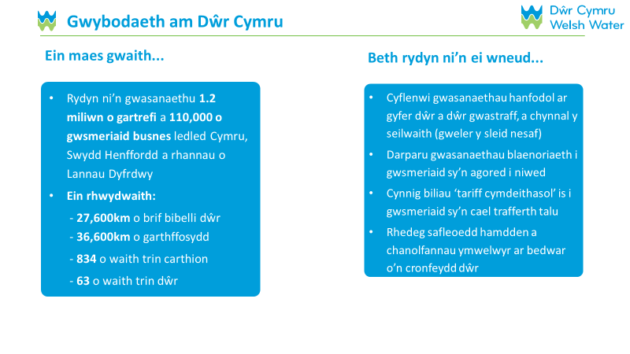
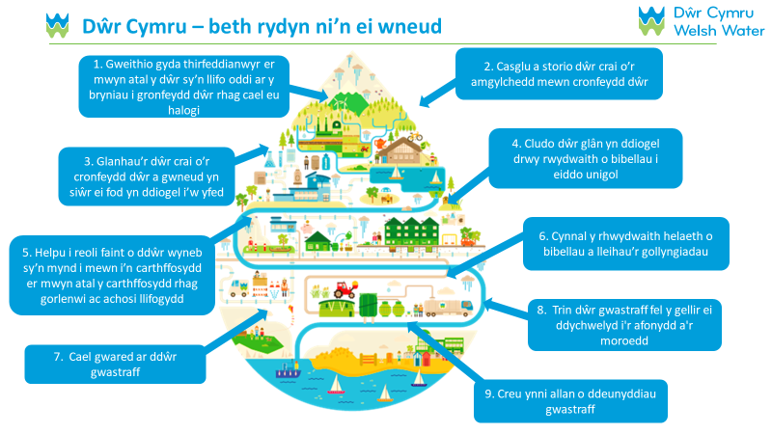
Cyn yr arolwg hwn, pa mor gyfarwydd oeddech chi â Dŵr Cymru a’r gwasanaethau maen nhw’n eu cynnig?

Cyfarwydd iawn
Eithaf cyfarwydd
Ddim yn gyfarwydd iawn
Ddim yn gyfarwydd o gwbl

Cynlluniau Dwr Cymru
Rydyn ni nawr yn mynd i ofyn rhai cwestiynau i chi am eich barn ar gynllun busnes Dŵr Cymru. Mae'n ofynnol i gwmnïau dŵr lunio cynlluniau busnes ar gyfer pob cyfnod o bum mlynedd. Mae'r cynllun yr ydym yn ei ddangos i chi ar gyfer y cyfnod pum mlynedd nesaf, sef 2025-2030.

Oherwydd y cyfyngiadau ar le, nid ydym yn gallu cynnwys popeth y mae Dŵr Cymru yn ei wneud ac y bydd yn parhau i'w wneud yn ei Gynllun Busnes yn yr arolwg hwn. Byddwn yn canolbwyntio ar ychydig o fesurau perfformiad allweddol a meysydd buddsoddi, felly peidiwch â phoeni os na fyddwn yn trafod rhywbeth y mae gennych ddiddordeb ynddo.

Yn gyntaf, rydyn ni'n mynd i ddangos i chi sut mae Dŵr Cymru yn gwneud mewn chwe agwedd ar berfformiad cwmnïau lle mae'r lefelau perfformiad yn cael eu mesur a bod modd eu cymharu ar draws yr holl gwmnïau dŵr yng Nghymru a Lloegr. Byddwn yn dangos y gymhariaeth i chi a thargedau'r cwmni ar gyfer 2025 a 2030. Yna byddwn yn gofyn ichi raddio pa mor bwysig a derbyniol yw'r cynigion yn eich barn chi.

SYMUDOL: Mae'r opsiynau canlynol yn gweithio orau os edrychwch arnynt yn y dirwedd ac fel arall gallwch newid i'r modd bwrdd gwaith trwy glicio ar y botwm ar waelod y sgrin.

- Amharu ar Gyflenwadau Dŵr
Mae’r siart hwn yn dangos sut mae Dŵr Cymru yn perfformio o ran “Amhariadau ar Gyflenwad Dŵr”, yn erbyn ei darged a hefyd y cwmnïau dŵr eraill.
DP – USE SLIDE 3

DP: PLEASE ADD A 7 SECOND DELAY TO THIS SCREEN

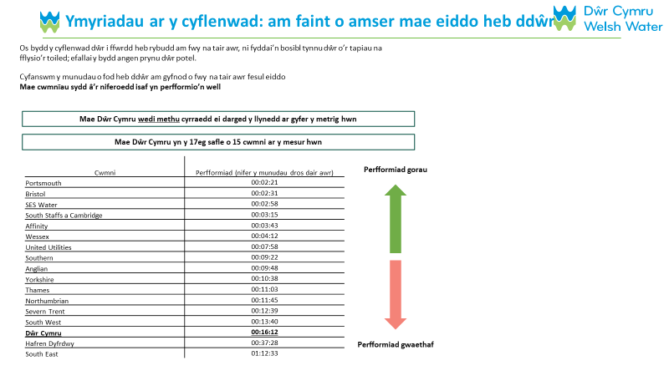
Mae’r siart hwn yn dangos yr hyn y mae Dŵr Cymru yn bwriadu ei wneud i wella’r mesuriad hwn:
DP – USE SLIDE 4

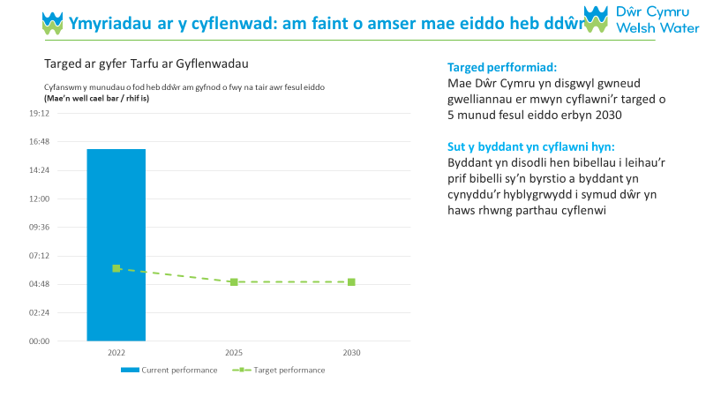

- Gollyngiadau
Mae’r siart hwn yn dangos sut mae Dŵr Cymru yn perfformio o ran “Gollyngiadau”, yn erbyn eu targed a hefyd yn erbyn y cwmnïau dŵr eraill.
DP – USE SLIDE 5
DP: PLEASE ADD A 7 SECOND DELAY TO THIS SCREEN

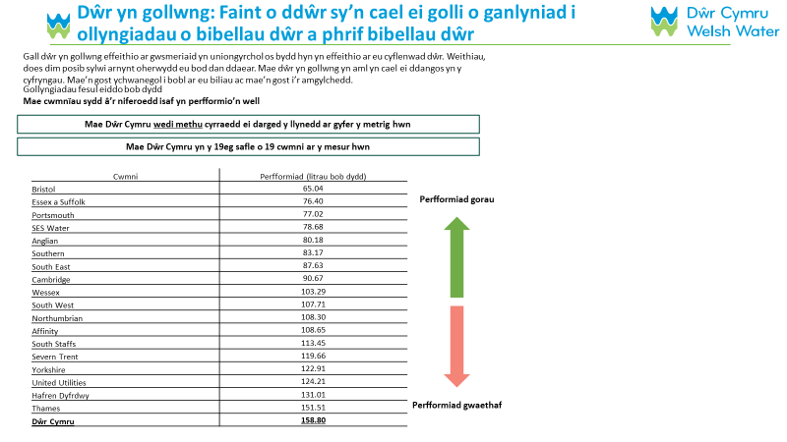
Mae’r siart hwn yn dangos yr hyn y mae Dŵr Cymru yn bwriadu ei wneud i wella’r mesuriad hwn:
DP – USE SLIDE 6

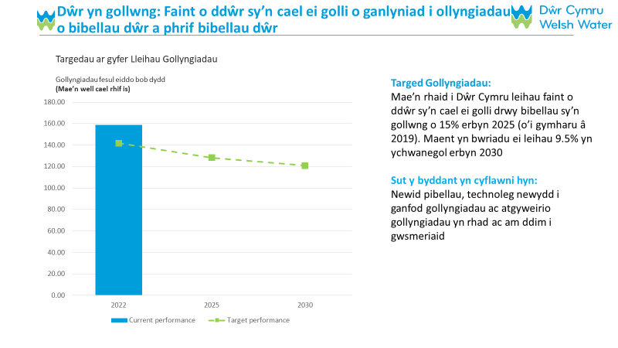
- Cysylltiadau Ansawdd Dŵr DP – DEFNYDDIO SLEID 7
Mae’r siart hwn yn dangos sut mae Dŵr Cymru yn perfformio ar “Gysylltiadau Ansawdd Dŵr”, yn erbyn ei darged a hefyd yn erbyn y cwmnïau dŵr eraill.

DP: PLEASE ADD A 7 SECOND DELAY TO THIS SCREEN

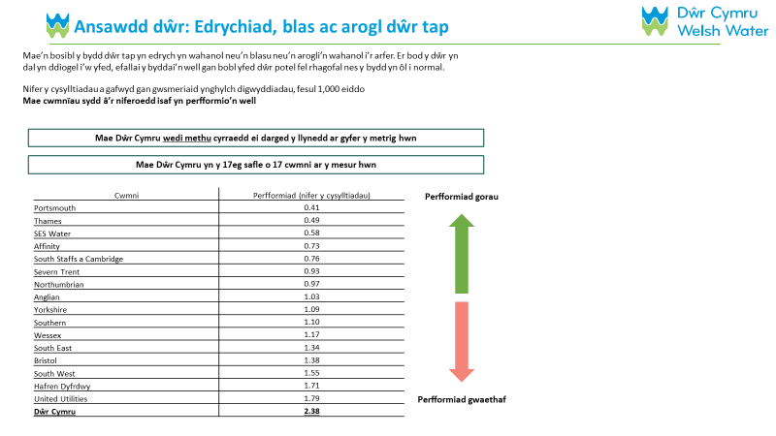
Mae’r siart hwn yn dangos yr hyn y mae Dŵr Cymru yn bwriadu ei wneud i wella’r mesuriad hwn:
DP – USE SLIDE 8

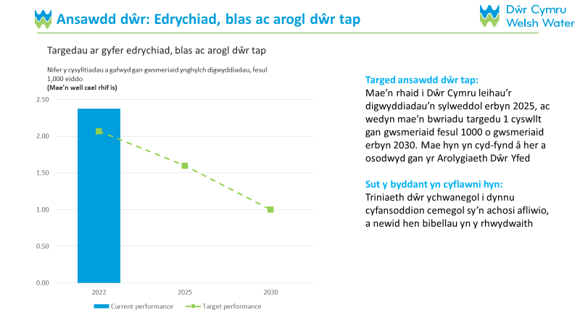

- Yn seiliedig ar yr hyn rydych chi newydd ei ddarllen, pa un o'r tair rhan hyn o'r cynllun busnes sydd bwysicaf i chi?SINGLECODE, RANDOMISE WITH REVERSE ORDER EXCEPT FOR DON’T KNOW
Dewiswch un ateb yn unig

Lleihau hyd ymyriadau dŵr sy’n para mwy na 3 awr
Lleihau gollyngiadau
Lleihau'r achosion o ansawdd dŵr gwael
Ddim yn gwybod/methu dweud

- Llifogydd Carthffosydd Mewnol
Mae’r siart hwn yn dangos sut mae Dŵr Cymru yn perfformio ar “Llifogydd Carthffosydd Mewnol”, yn erbyn ei darged a hefyd yn erbyn y cwmnïau dŵr eraill.
DP – USE SLIDE 9
DP: PLEASE ADD A 7 SECOND DELAY TO THIS SCREEN

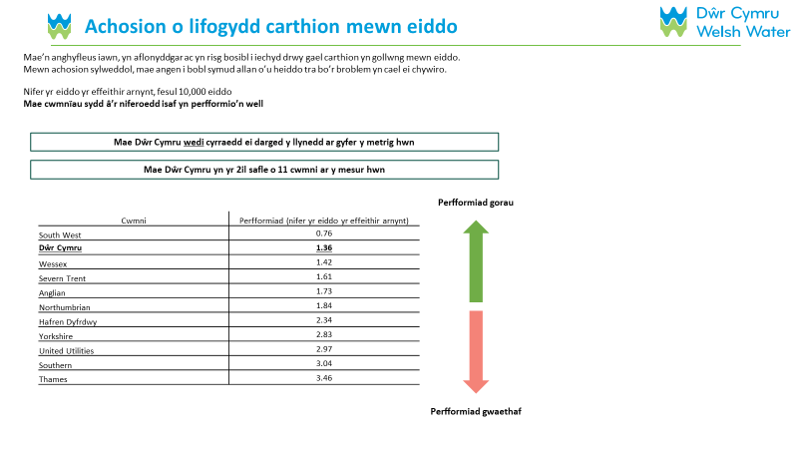
Mae’r siart hwn yn dangos yr hyn y mae Dŵr Cymru yn bwriadu ei wneud i wella’r mesuriad hwn:
DP – USE SLIDE 10

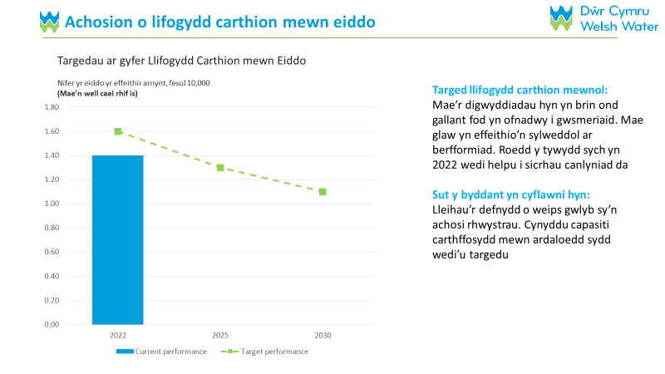

- Llifogydd Carthffosydd Allanol
Mae’r siart hwn yn dangos sut mae Dŵr Cymru yn perfformio ar “Llifogydd Carthffosydd Allanol”, yn erbyn ei darged a hefyd yn erbyn y cwmnïau dŵr eraill.
DP – USE SLIDE 11
DP: PLEASE ADD A 7 SECOND DELAY TO THIS SCREEN

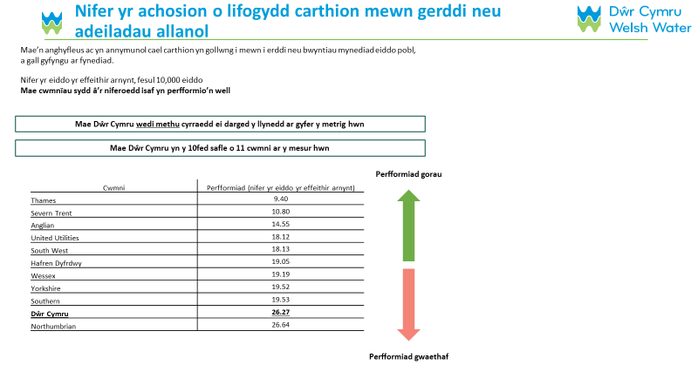
Mae’r siart hwn yn dangos yr hyn y mae Dŵr Cymru yn bwriadu ei wneud i wella’r mesuriad hwn:
DP – USE SLIDE 12

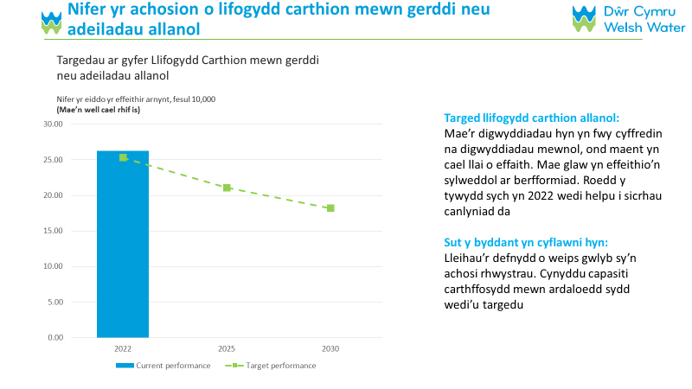

- Digwyddiadau Llygredd
Mae’r siart hwn yn dangos sut mae Dŵr Cymru yn perfformio o ran “Digwyddiadau Llygredd”, yn erbyn ei darged a hefyd yn erbyn y cwmnïau dŵr eraill.
DP – USE SLIDE 13
DP: PLEASE ADD A 7 SECOND DELAY TO THIS SCREEN

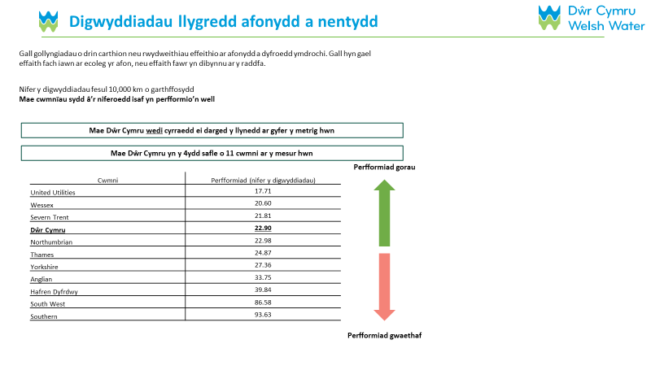
Mae’r siart hwn yn dangos yr hyn y mae Dŵr Cymru yn bwriadu ei wneud i wella’r mesuriad hwn:
DP – USE SLIDE 14

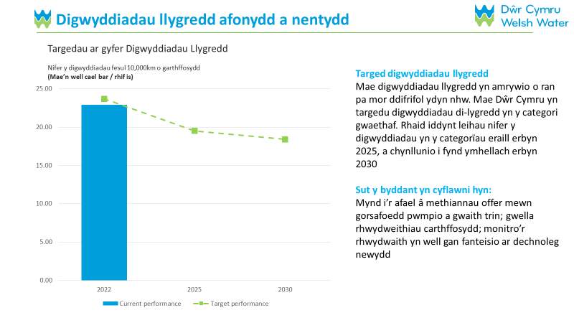

- Yn seiliedig ar yr hyn rydych chi newydd ei ddarllen, pa un o'r tair rhan hyn o'r cynllun busnes sydd bwysicaf i chi?SINGLECODE, RANDOMISE WITH REVERSE ORDER EXCEPT FOR DON’T KNOW
Dewiswch un ateb yn unig

Lleihau llifogydd o garthffosydd y tu mewn i eiddo
Lleihau llifogydd o garthffosydd y tu allan i eiddo
Lleihau nifer yr achosion o lygredd
Ddim yn gwybod/methu dweud
DP PLEASE ADD A TIMESTAMP

Cynlluniau Dŵr Cymru - Meysydd Buddsoddi Allweddol
DP: PLEASE ADD A 7 SECOND DELAY TO THIS SCREEN
Bydd yr adran nesaf yn dangos i chi chwech o'r meysydd buddsoddi allweddol yng nghynllun busnes Dŵr Cymru cyn gofyn am eich barn ar y cynllun yn ei gyfanrwydd.

- Mae’r sleid hwn yn disgrifio un o feysydd buddsoddi allweddol cynllun busnes Dŵr Cymru: Gwarchod a gwella'r amgylchedd. Mae Dŵr Cymru yn bwriadu gwella ansawdd dŵr afonydd trwy fuddsoddiad ychwanegol. Gallwch weld rhagor o fanylion isod:
DP – USE SLIDE 15

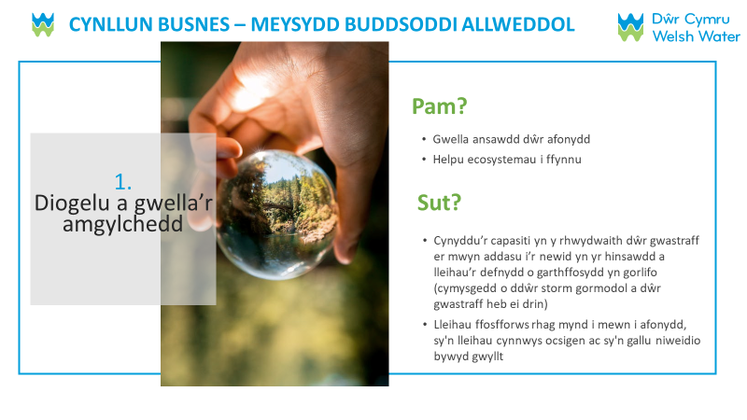

- Mae'r sleid nesaf yn disgrifio un arall o feysydd buddsoddi allweddol cynllun busnes Dŵr Cymru; Sicrhau adnoddau dŵr hirdymor. Mae Dŵr Cymru yn cynnig sicrhau cyflenwad dŵr dibynadwy hirdymor drwy fuddsoddiad ychwanegol. Gallwch weld rhagor o fanylion isod:
DP – USE SLIDE 16
DP: PLEASE ADD A 7 SECOND DELAY TO THIS SCREEN

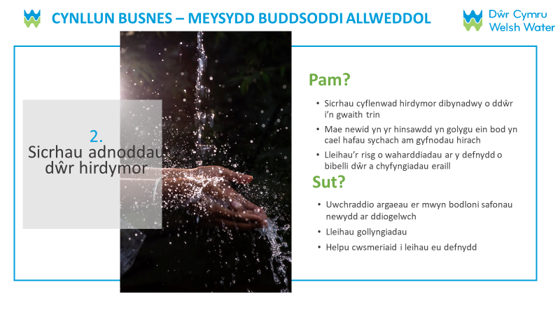

- Mae'r sleid nesaf yn disgrifio un arall o feysydd buddsoddi allweddol cynllun busnes Dŵr Cymru; Gwneud y gwasanaeth yn fwy gwydn. Mae Dŵr Cymru yn cynnig ymateb i’r bygythiadau cynyddol i’r cyflenwad dŵr oherwydd newid yn yr hinsawdd drwy fuddsoddiad ychwanegol. Gallwch weld rhagor o fanylion isod:
DP – USE SLIDE 17
DP: PLEASE ADD A 7 SECOND DELAY TO THIS SCREEN

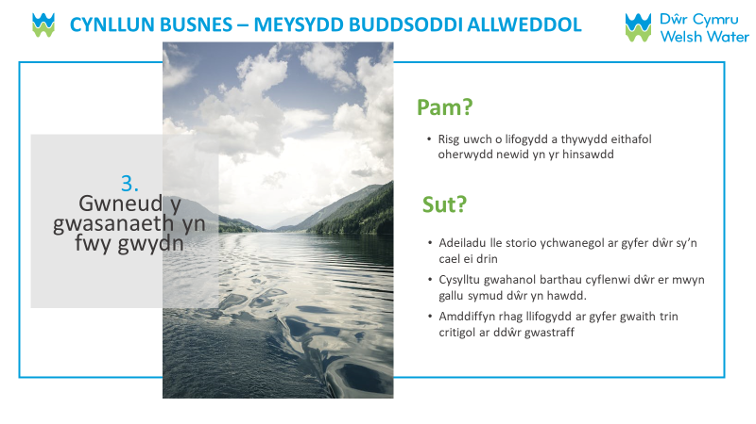

- Yn seiliedig ar yr hyn rydych chi newydd ei ddarllen, pa un o'r tair rhan hyn o'r cynllun busnes sydd bwysicaf i chi?SINGLECODE, RANDOMISE WITH REVERSE ORDER EXCEPT FOR DON’T KNOW
Dewiswch un ateb yn unig

Gwarchod a gwella'r amgylchedd
Sicrhau adnoddau dŵr hirdymor
Gwneud y gwasanaeth yn fwy gwydn
Ddim yn gwybod/methu dweud

- Mae'r sleid hwn yn disgrifio un o feysydd buddsoddi allweddol cynllun busnes Dŵr Cymru; Gwaith amgylcheddol ehangach. Mae Dŵr Cymru yn cynnig lleihau allyriadau nwyon tŷ gwydr drwy fuddsoddiad ychwanegol. Gallwch weld rhagor o fanylion isod:
DP - USE SLIDE 18
DP: PLEASE ADD A 7 SECOND DELAY TO THIS SCREEN

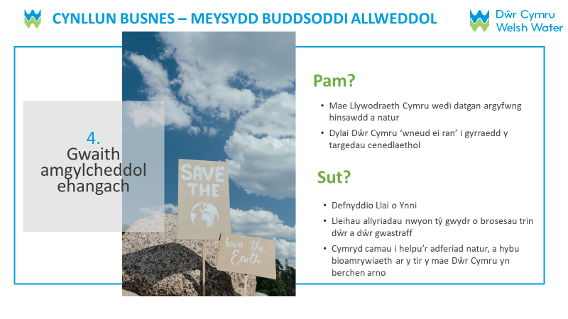

- Mae'r sleid nesaf yn disgrifio un arall o feysydd buddsoddi allweddol cynllun busnes Dŵr Cymru; Ansawdd dŵr yfed. Mae Dŵr Cymru yn bwriadu gwella ansawdd dŵr tap trwy fuddsoddiad ychwanegol. Gallwch weld rhagor o fanylion isod:
DP – USE SLIDE 19
DP: PLEASE ADD A 7 SECOND DELAY TO THIS SCREEN

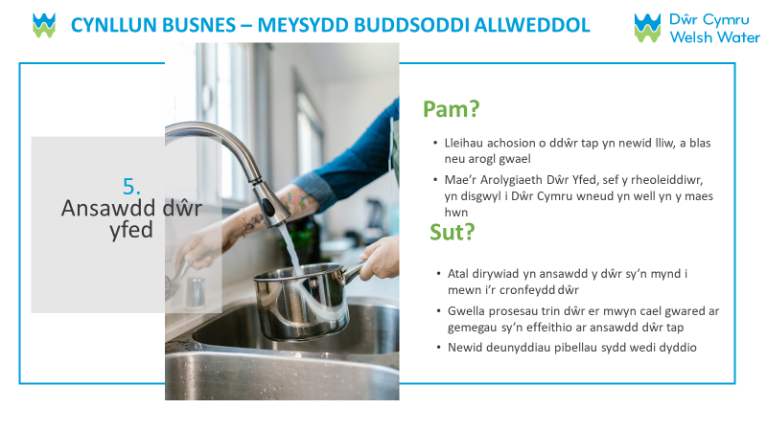

- Mae'r sleid nesaf yn disgrifio un arall o feysydd buddsoddi allweddol cynllun busnes Dŵr Cymru; Gosod pibellau newydd yn lle rhai plwm sy'n cysylltu cartrefi â'r rhwydwaith. Mae Dŵr Cymru yn cynnig lleihau effeithiau niweidiol posibl pibellau plwm drwy fuddsoddiad ychwanegol. Gallwch weld rhagor o fanylion isod:
DP – USE SLIDE 20
DP: PLEASE ADD A 7 SECOND DELAY TO THIS SCREEN

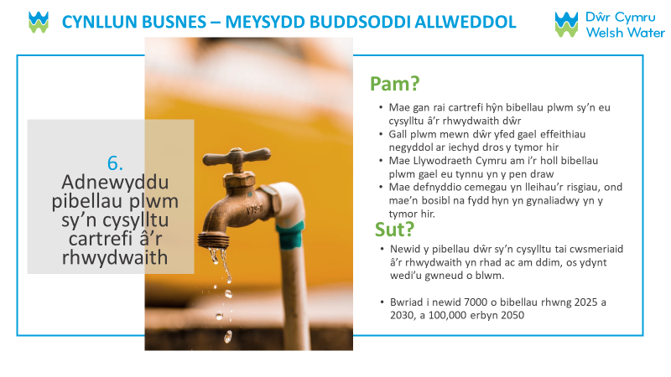

- Yn seiliedig ar yr hyn yr ydych newydd ei ddarllen, pa un o’r tri maes buddsoddi hyn yn y cynllun busnes sydd bwysicaf i chi?SINGLECODE, RANDOMISE WITH REVERSE ORDER EXCEPT FOR DON’T KNOW
Dewiswch un ateb yn unig

Gwaith amgylcheddol ehangach
Ansawdd dŵr yfed
Ailosod pibellau plwm sy'n cysylltu cartrefi â'r rhwydwaith
Ddim yn gwybod/methu dweud

- Yn seiliedig ar bopeth yr ydych wedi'i weld a'i ddarllen am gynllun busnes arfaethedig Dŵr Cymru, pa mor dderbyniol neu annerbyniol ydyw i chi?SINGLECODE, RANDOMISE WITH REVERSE ORDER EXCEPT FOR DON’T KNOW
Dewiswch un ateb yn unig

Hollol dderbyniolGO TO Q34
Derbyniol GO TO Q34
Annerbyniol GO TO Q33
Hollol annerbyniolGO TO Q33
Ddim yn gwybod/methu dweud

- IF Q32=3 or 4 Beth yw'r ddau brif reswm pam eich bod yn teimlo bod y cynigion ar gyfer eich gwasanaethau dŵr yn annerbyniol?MAXIMUM 2 ANSWERS, RANDOMISE
Dewiswch hyd at ddau ateb yn unig
Mae'r cynnydd mewn biliau yn rhy ddrud
Mae elw’r cwmni yn rhy uchel
Dylai cwmnïau dalu am wella gwasanaethau
Rwy'n disgwyl gwell gwelliannau yn y gwasanaeth
Mae’r cynllun yn werth gwael am arian
O gymharu â phrisiau ynni, mae'n ddrutach
Rwy'n anfodlon ar y gwasanaethau presennol
Nid yw'r cynlluniau'n canolbwyntio ar y gwasanaethau cywir
Ni fyddaf yn gallu fforddio hyn
Nid wyf yn ymddiried ynddynt i wneud y gwelliannau hyn i'r gwasanaeth
Arall 1, nodwch [YMATEB AGORED] DP PLEASE ADD TEXT BOX
Arall 2, nodwch [YMATEB AGORED] DP PLEASE ADD TEXT BOX
Ddim yn gwybod/ methu dweud

- IF Q32=1 OR 2 Beth yw’r ddau brif reswm pam eich bod yn teimlo bod y cynigion ar gyfer eich cyflenwad dŵr yn dderbyniol? MAXIMUM 2 ANSWERS, RANDOMISE
Dewiswch hyd at ddau ateb yn unig

Mae'r cynllun yn werth da am arian
Mae'r cynllun yn fforddiadwy
O'i gymharu â phrisiau ynni mae'n rhatach
Mae'n ymddangos bod eu cynlluniau'n canolbwyntio ar y gwasanaethau cywir
Mae'r cwmni'n darparu gwasanaeth da nawr
Rwy’n cefnogi’r hyn maen nhw’n ceisio ei wneud yn y tymor hir
Mae'r newid i fy mil yn fach
Rwy'n ymddiried ynddynt i wneud yr hyn sydd orau i gwsmeriaid
Rwyf wedi bod yn anfodlon ar y gwasanaeth yn ddiweddar ond rwy'n falch eu bod yn gwneud gwelliannau
Arall 1, nodwch [YMATEB AGORED] DP PLEASE ADD TEXT BOX
Arall 2, nodwch [YMATEB AGORED] DP PLEASE ADD TEXT BOX
Ddim yn gwybod/ methu dweud

DP PLEASE ADD A TIMESTAMP

- Bydd buddsoddiad hirdymor gan Dŵr Cymru yn gofyn am gynnydd mewn biliau i gwsmeriaid. Gallai biliau gynyddu mewn gwahanol ffyrdd dros amser. Er enghraifft, gallai fod cynnydd nawr i dalwyr biliau presennol, neu gynnydd mwy yn y tymor hir ar gyfer cenedlaethau'r dyfodol. Pa un o'r opsiynau canlynol fyddai orau gennych chi? SINGLECODE
Dewiswch un ateb yn unig

Cynnydd mewn biliau yn dechrau yn gynharach, gan wasgaru cynnydd ar draws gwahanol genedlaethau o dalwyr biliau
Cynnydd mewn biliau yn dechrau'n hwyrach, gan roi mwy o'r codiadau i dalwyr biliau iau a rhai'r dyfodol
Nid wyf yn gwybod digon ar hyn o bryd i roi ateb

C35a. ASK IF Q32=5 (DON’T KNOW), OTHERS GO TO Q36: Ar ôl popeth yr ydych wedi'i weld a'i ddarllen am gynllun busnes arfaethedig Dŵr Cymru, fe wnaethom ofyn pa mor dderbyniol neu annerbyniol yw'r cynllun busnes i chi. Pam gwnaethoch chi ddewis dim yn gwybod mewn ymateb i'r cwestiwn hwn?

DP – ADD TEXT BOX

HH ONLY: Demograffeg yr Aelwyd
- Diolch. Nawr dim ond ychydig o gwestiynau i wirio ein bod yn siarad â phobl o bob math.
Ym mha rai o'r ffyrdd canlynol rydych chi'n uniaethu?

Benyw
Gwryw
Rwy'n uniaethu mewn ffordd arall
Mae'n well gen i beidio â dweud

- Nodwch pa un o'r canlynol sy'n disgrifio orau proffesiwn y prif enillydd incwm yn eich cartref
Rheolaethol / proffesiynol / gweinyddol uwch (e.e. Meddyg sefydledig, Cyfreithiwr, Cyfarwyddwr Bwrdd mewn sefydliad mawr (200+ o weithwyr), gwas sifil l/gweithiwr gwasanaeth cyhoeddus lefel uchaf)
Canolradd rheolaethol/proffesiynol/gweinyddol (e.e. Meddyg newydd gymhwyso (dan 3 blynedd), Cyfreithiwr, cyfarwyddwr Bwrdd sefydliad bach, rheolwr canol mewn sefydliad mawr, prif swyddog yn y gwasanaeth sifil/llywodraeth leol)
Goruchwyliol neu glerigol / rheolaeth / proffesiynol / gweinyddol iau (e.e. gweithiwr swyddfa, Meddyg dan Hyfforddiant, Fforman gyda 25+ o weithwyr, gwerthwr, ac ati)
Gwaith llaw medrus (e.e. Briciwr, Saer Coed, Plymwr, Peintiwr Medrus, Gyrrwr Bws/Ambiwlans, gyrrwr HGV, patroliwr AA, gweithiwr mewn tafarn/bar, ac ati)
Gwaith llaw lled-grefftus neu ddi-grefft. (ee Gweithiwr llaw, prentis crefft fedrus, Gofalwr, Ceidwad Parc, gyrrwr nad yw'n yrrwr HGV, cynorthwyydd siop)
Gwraig tŷ/Gŵr tŷ
Di-waith
Wedi ymddeol GO TO Q38
Myfyriwr
Mae'n well gen i beidio â dweud

- IF Error! Reference source not found.=RETIRED ASK Oes gan y prif enillydd incwm bensiwn y wladwriaeth, pensiwn preifat neu'r ddau?
Pensiwn y Wladwriaeth yn unig
Preifat yn unig
Y ddau
Mae'n well gen i beidio â dweud

- IF Q38= PRIVATE OR BOTH ASK: Sut fyddech chi'n disgrifio gwaith y prif enillydd incwm cyn ymddeol?

Rheolaethol / proffesiynol / gweinyddol uwch (e.e. Meddyg sefydledig, Cyfreithiwr, Cyfarwyddwr Bwrdd mewn sefydliad mawr (200+ o weithwyr), gwas sifil l/gweithiwr gwasanaeth cyhoeddus lefel uchaf)
Canolradd rheolaethol/proffesiynol/gweinyddol (e.e. Meddyg newydd gymhwyso (dan 3 blynedd), Cyfreithiwr, cyfarwyddwr Bwrdd sefydliad bach, rheolwr canol mewn sefydliad mawr, prif swyddog yn y gwasanaeth sifil/llywodraeth leol)
Goruchwyliol neu glerigol / rheolaeth / proffesiynol / gweinyddol iau (e.e. gweithiwr swyddfa, Meddyg dan Hyfforddiant, Fforman gyda 25+ o weithwyr, gwerthwr, ac ati)
Gwaith llaw medrus (e.e. Briciwr, Saer Coed, Plymwr, Peintiwr Medrus, Gyrrwr Bws/Ambiwlans, gyrrwr HGV, patroliwr AA, gweithiwr mewn tafarn/bar, ac ati)
Gwaith llaw lled-grefftus neu ddi-grefft. (ee Gweithiwr llaw, prentis crefft fedrus, Gofalwr, Ceidwad Parc, gyrrwr nad yw'n HGV, cynorthwyydd siop)
Dim un o'r rhain
Mae'n well gen i beidio â dweud

- Pa un o'r canlynol sy'n berthnasol i chi? Hoffem gasglu hyn i sicrhau bod amrywiaeth o anghenion penodol yn cael eu cynrychioli yn yr astudiaeth, ond does dim angen i chi ateb os nad ydych yn dymuno gwneud. Ni fydd y wybodaeth hon yn cael ei rhannu ag unrhyw drydydd parti a bydd yn cael ei dinistrio o fewn 12 mis i gwblhau'r prosiect. MULTICODE
Dewiswch yr holl rai sy'n berthnasol
Rwyf i neu aelod arall o'm cartref yn anabl neu'n dioddef o salwch gwanychol CODED AS MEDICAL VULNERABILITY
Mae gennyf i neu aelod arall o'm cartref anhawster dysgu CODED AS MEDICAL VULNERABILITY
Rwyf i neu aelod arall o’m cartref yn dibynnu ar ddŵr oherwydd rhesymau iechyd CODED AS MEDICAL VULNERABILITY
Mae nam ar fy ngolwg i neu ar olwg aelod arall o'm cartref (h.y. yn cael trafferth darllen hyd yn oed gyda sbectol) CODED AS COMMUNICATIONS VULNERABILITY
Rwyf i neu aelod arall o'r aelwyd yn 75 oed neu’n hŷn CODED AS LIFE STAGE VULNERABILITY
Rwyf i neu aelod arall o'm cartref yn/ddim yn hyderus wrth siarad Cymraeg neu Saesneg CODED AS COMMUNICATIONS VULNERABILITY
Rwyf i neu aelod arall o’m cartref yn fyddar neu'n drwm ei glyw CODED AS COMMUNICATIONS VULNERABILITY
Rwyf i neu aelod arall o'm cartref yn rhiant newydd CODED AS LIFE STAGE VULNERABILITY
Does dim un o’r rhain yn berthnasol imi
Mae'n well gen i beidio â dweud

- Beth yw eich grŵp ethnig? Dewiswch un opsiwn sy'n disgrifio orau eich grŵp ethnig neu’ch cefndir
Dewiswch un ateb yn unig
GWYN
Seisnig, Cymreig, Albanaidd, Gogledd Iwerddon neu Brydeinig
Gwyddelig
Sipsi neu Deithiwr Gwyddelig
Unrhyw gefndir Gwyn arall
CYMYSG
Gwyn a Du Caribïaidd
Gwyn a Du Affricanaidd
Gwyn ac Asiaidd
Unrhyw gefndir Cymysg arall
ASIAIDD NEU BRYDEINIG ASIAIDD
Indiaidd
Pacistanaidd
Bangladeshi
Tsieineaidd
Unrhyw gefndir Asiaidd arall
DU NEU BRYDEINIG DU
Caribïaidd
Affricanaidd
Unrhyw gefndir Du arall
GRWP ETHNIG ARALL
Arabaidd
Unrhyw grŵp ethnig arall
Mae'n well gen i beidio â dweud

- I ba un o'r bandiau canlynol mae incwm eich cartref sy’n dod o bob ffynhonnell cyn treth a didyniadau eraill?SINGLECODE
Hyd at £199 yr wythnos/Hyd at £10,399 y flwyddyn
O £200 i £299 yr wythnos/O £10,400 i £15,599 y flwyddyn
O £300 i £499 yr wythnos/O £15,600 i £25,999 y flwyddyn
O £500 i £699 yr wythnos/O £26,000 i £36,399 y flwyddyn
O £700 i £999 yr wythnos/O £36,400 i £51,999 y flwyddyn
O £1,000 i £1,399 yr wythnos/O £52,000 i £72,799 y flwyddyn
O £1,400 i £1,999 yr wythnos/O £72,800 i £103,999 y flwyddyn
£2,000 ac uwch yr wythnos/£104,000 ac uwch y flwyddyn
Ddim yn gwybod
Mae'n well gen i beidio â dweud
GO TO Q47

NHH only: Cwestiynau Demograffig
- Sut mae eich sefydliad yn defnyddio dŵr yn bennaf yn ei safleoedd? MULTICODE
Dewiswch yr holl rai sy'n berthnasol
Ar gyfer y broses weithgynhyrchu sy’n hanfodol i redeg eich sefydliad (e.e. i bweru peiriannau, cynhyrchu amaethyddol ac ati)
Ar gyfer cyflenwi gwasanaethau y mae eich sefydliad yn eu darparu (e.e. gwasanaethau glanhau ac ati
Ar gyfer cynhwysyn neu ran o’r cynnyrch neu wasanaeth y mae eich sefydliad yn ei ddarparu (e.e. bwyd neu ddiod, cemegau, gwneuthurwr colur ac ati)
At ddefnydd domestig arferol cwsmeriaid a gweithwyr eich sefydliad (e.e. toiledau cwsmeriaid, cyflenwad dŵr yfed)
Dim un o'r uchod
Ddim yn Gwybod

- O faint o safleoedd yn y DU mae eich sefydliad yn gweithredu?
1
2
3
4
5-10
11-50
51-250
250 neu fwy
Mae'n well gen i beidio â dweud

- Faint o weithwyr sydd gan eich sefydliad yn y DU?
0 (unig fasnachwr)
1 i 9 o weithwyr (micro)
10 i 49 o weithwyr (bach)
50 i 249 o weithwyr (canolig)
250+ o weithwyr (mawr)
Mae'n well gen i beidio â dweud

- Pa un o'r canlynol sy'n diffinio gweithgaredd craidd eich sefydliad orau?
Amaethyddiaeth, coedwigaeth a physgota
Mwyngloddio a chwarela
Gwasanaeth a chyflenwad ynni neu ddŵr
Gweithgynhyrchu
Adeiladu
Masnach cyfanwerthu a manwerthu (gan gynnwys atgyweirio cerbydau modur)
Cludiant a storio
Gwestai ac arlwyo
TG a Chyfathrebu
Gweithgareddau cyllid ac yswiriant
Gweithgareddau eiddo tirol
Gweithgareddau proffesiynol, gwyddonol a thechnegol
Gweithgareddau Gwasanaeth Gweinyddol a Chymorth
Gweinyddiaeth gyhoeddus ac amddiffyn
Addysg
Gweithgareddau iechyd dynol a gwaith cymdeithasol
Celfyddydau, adloniant a hamdden
Gweithgareddau gwasanaeth eraill
Arall – (nodwch)
Mae'n well gen i beidio â dweud

Diolch
- Soniasom y byddai cymhelliad o £10 ar gyfer cwblhau'r arolwg hwn. Bydd y cymhelliad hwn yn cael ei weinyddu gan Accent, o fewn 4 wythnos.
Gellir anfon hwn ar ffurf taleb Amazon, Marks & Spencer neu One4All trwy e-bost. Fel arall, gallwn roi eich cymhelliant i WaterAid. Pa un fyddai orau gennych chi?
Taleb Amazon trwy e-bost CASGLU CYFEIRIAD E-BOST
Taleb M&S drwy e-bost CASGLU CYFEIRIAD E-BOST
One4All drwy e-bost CASGLU CYFEIRIAD E-BOST
Rhodd i Water Aid

Os oes gennych unrhyw ymholiadau am eich cymhelliant, cysylltwch â ni ar 0131 220 8770.

- Diolch. A fyddech yn fodlon i ni gysylltu â chi eto os bydd angen inni gael eglurder am unrhyw rai o’r atebion a roddwyd gennych heddiw?
Ydy
Nac ydw

- CATI ONLY Cadarnhad gan yr Cyfwelydd
Rwy’n cadarnhau i’r cyfweliad hwn gael ei gynnal o dan delerau cod ymddygiad MRS a’i fod yn gwbl gyfrinachol

Ydy
Nac ydw

QEND [IF HH] Mae cwmnïau dŵr yn cynnig cymorth i aelwydydd incwm isel cymwys sy'n cael trafferth fforddio eu biliau dŵr a dŵr gwastraff. Mae rhagor o wybodaeth am hyn ar gael yma: insert link to DCWW’s social tariff support page

Diolch. Cynhaliwyd yr ymchwil hwn o dan delerau cod ymddygiad MRS ac mae'n gwbl gyfrinachol.

GWYBODAETH SYSTEM
Amser y cwblhawyd y cyfweliad:

APPENDIX F
Questionnaire (Paper version)

Affordability and Acceptability Testing
Thank you very much for agreeing to complete this survey which is being conducted by Accent, an independent research agency. This survey is designed to help Welsh Water, your water and wastewater service provider, to understand your views on how affordable and acceptable their future plans are.

We will just ask you a couple of questions to check that you are eligible to take part in this research.

Anyone who passes the qualification questions and completes the entire survey will be eligible for a £10 voucher (either an Amazon voucher, an M&S voucher or a One4All voucher). Alternatively, we can donate your incentive to WaterAid. Details on how to claim your voucher are given at the end of the survey. Please note, your answers must reach us by the 10th September 2023 to qualify for this incentive.

Any answer you give will be treated in confidence in accordance with the Code of Conduct of Market Research Society. If you would like to confirm Accent’s credentials you can phone the Market Research Society on 0800 975 9596.

You do not have to answer any question you do not wish to and you may terminate the interview at any point.

When completing the survey please start from Question 1 (Q1) in the ‘Scoping questions’ section.

If at any point in the ‘Scoping questions’ section you find “Thank you for your time, it is not possible for your survey responses to be included – please stop here.” written next to the answer you have selected, this means you are not eligible to take part in this survey. If this happens – thank you very much for your time, but you are not eligible to take part and should stop.

If you have answered the questions in the ‘Scoping questions’ section without that message appearing next to any of your answers please go to the “Main questionnaire” and follow the questionnaire order.

Scoping questions
- Any data collected over the course of this interview that could be used to identify you, such as your name, address, or other contact details, will be held securely and will not be shared with any third party unless you give permission (or unless we are legally required to do so). Our privacy statement is available at https://www.accent-mr.com/privacy-policy/.
Please do not include names, addresses, or other personal data in your responses to any questions, unless asked to do so.
Do you agree to proceeding with the interview on this basis?
Yes
No Thank you for your time, it is not possible for your survey responses to be included – please stop here.
- Do you or any of your close family work in market research or for a water company?
Yes Thank you for your time, it is not possible for your survey responses to be included – please stop here.
No

- How old are you? Please enter your age.
Please enter your age on the line below
_____________________
Under 18 Thank you for your time, it is not possible for your survey responses to be included – please stop here.
Prefer not to say Thank you for your time, it is not possible for your survey responses to be included – please stop here.
- Are you the person in your household who is responsible, either solely or jointly, for paying for your water services bill?
Yes
No, I am not responsible for paying the bill Thank you for your time, it is not possible for your survey responses to be included – please stop here.
Don’t know Thank you for your time, it is not possible for your survey responses to be included – please stop here.

- Are you currently charged for water through a water meter?
Yes
No
Don’t know

- Welsh Water is your water supplier and is responsible for your sewerage services. Does this sound right?
Yes
No Thank you for your time, it is not possible for your survey responses to be included – please stop here.
Don’t know

Thank you, if you have reached this point without having been told to stop, we can confirm you are in scope for the survey. The questionnaire will take about 15 minutes to complete.

Main Questionnaire

Affordability
We are now going to ask you some questions about your household’s financial situation.

- Thinking about your finances over the last year, how often, if at all have you struggled to pay at least one of your household bills?
Please select one answer only
All of the time
Most of the time
Sometimes
Rarely
Never
Prefer not to say

- Overall, how well would you say you are managing financially now?
Please select one answer only
Doing alright
Just about getting by
Finding it quite difficult
Finding it very difficult
Prefer not to say

- Thinking about your household’s financial situation over the next few years up to 2030, do you expect it to get
Please select one answer only
A lot worse
A bit worse
Stay the same
A bit better
A lot better
Prefer not to say
Don't know

- How easy or difficult is it for you to afford to pay your current water and sewerage bill:

Please select one answer only
Very easy
Fairly easy
Neither easy nor difficult
Fairly difficult
Very difficult
Don’t know

Proposed changes to your water/sewerage bill for the years 2025-2030.
The next set of questions are about proposed changes to your water and sewerage bill for the years 2025-2030. The chart below shows these changes. It also shows how inflation may impact on your bill, based on the Bank of England's inflation forecasts.

Water bills change each year in line with inflation.
Inflation is the increase in prices paid for goods and services over time. Household incomes also change over time.
• If your household income keeps up with inflation (ie. increases at the same rate), then you are likely to notice little difference in what you are paying for things.
• If inflation increases by a faster rate than your household income, then you are likely to have less money to go around.
• If your household income increases by a faster rate than inflation, then you are likely to have more money to go around.
The Bank of England aims to keep inflation at 2%, but it has recently been much higher than this. As well as changing by inflation each year, bills change by an amount set by Ofwat (the water regulator) as part of their price review process every five years.

The proposed bills you will see from 2025 to 2030 include the Bank of England forecasts for inflation from 2025 to 2030, and proposed amounts to cover the investment in water and sewerage services needed over the next few years.

The chart on the next page shows the expected increase in your water/sewerage bill over the next few years.

The blue part of each column is what the underlying change to your bills would look like if there were no inflation. The orange part is what inflation will add on top. So, your actual bill would be the two parts added together.

The figure above each bar represents the total expected bill amount (the blue plus the orange)

If you currently receive financial support with your water bill, please note that this bill profile is based on the financial support scheme you are currently on.

Once you have read the above, and referred to the chart on the following page, please continue.

- How easy or difficult do you think it would be for you to afford these water/sewerage bills?
Please select one answer only
Very easy Please skip question 12
Fairly easy Please skip question 12
Neither easy nor difficult Please go to Question 12
Fairly difficult Please go to Question 12
Very difficult Please go to Question 12
Don’t know

- Please only answer this question if you have selected “neither easy nor difficult”, “fairly difficult” or “very difficult” at Question 11 (Q11 above)
Which of the following do you think you would need to do to pay for the increase in your water bills between 2025 and 2030?
Please select all that apply
Shopping around more
Spending less on food shopping and essentials
Spending less on non-essentials
Cutting back on non-essential journeys in my vehicle
Eat out less
Using less fuel such as gas or electricity in my home
Using less water
Using my savings
Using credit more than usual, for example, credit cards, loans or overdrafts
Ask family and friends for financial support
Other, please specify: __________________________________________________________________
Don’t know

About Welsh Water
- Please take a look at the following information about Welsh Water:

- Before this survey how familiar were you with Welsh Water and the services they offer?

Very familiar
Quite familiar
Not very familiar
Not at all familiar

Welsh Water’s Plans
We are now going to ask you some questions about your views on Welsh Water’s business plan. Water companies are required to put together business plans for each five year period. The plan we are showing you is for the next five-year period which is 2025-2030.

Owing to space constraints we are not able to cover in this survey everything that Welsh Water does and will continue to do in its Business Plan. We will focus on a few key performance measures and areas of investment, so please don't worry if something that you are interested in is not covered.

First we are going to show you how Welsh Water is doing in six aspects of company performance in which the performance levels are measured and can be compared across all water companies in England and Wales. We will show you the comparison and the company's targets for 2025 and 2030. We will then ask you to rate how important and acceptable you think the proposals are.

- Water Supply Interruptions
The following chart shows how Welsh Water are performing on “Water Supply Interruptions”, against both their target and also the other water companies.

The following chart shows what Welsh Water is proposing doing to improve on this measure:

- Leakage
The following chart shows how Welsh Water are performing on “Leakage”, against both their target and also the other water companies.

The following chart shows what Welsh Water is proposing doing to improve on this measure:

- Water Quality Contacts
The following chart shows how Welsh Water are performing on “Water Quality Contacts”, against both their target and also the other water companies.

The following chart shows what Welsh Water is proposing doing to improve on this measure:

- Based on what you have just read, which of these three parts of the business plan is the most important to you?
Please select one answer only
Reducing the duration of water interruptions of longer than 3 hours
Reducing leakage
Reducing the incidents of poor water quality
Don't know/can't say

- Internal Sewer Flooding
The following chart shows how Welsh Water are performing on “Internal Sewer Flooding”, against both their target and also the other water companies.
The following chart shows what Welsh Water is proposing doing to improve on this measure:

- External Sewer Flooding
The following chart shows how Welsh Water are performing on “External Sewer Flooding”, against both their target and also the other water companies.

The following chart shows what Welsh Water is proposing doing to improve on this measure:

- Pollution Incidents
The following chart shows how Welsh Water are performing on “Pollution Incidents”, against both their target and also the other water companies.

The following chart shows what Welsh Water is proposing doing to improve on this measure:

- Based on what you have just read, which of these three parts of the business plan is the most important to you?
Please select one answer only
Reducing sewer flooding inside properties
Reducing sewer flooding outside properties
Reducing the number of pollution incidents
Don't know/can't say

Welsh Water’s Plans – Key Investment Areas
- The following slide describes one of the key investment areas of Welsh Water’s business plan: Protecting and improving the environment. Welsh Water is proposing to improve river water quality through additional investment. You can see further details below:

- The next slide describes another of the key investment areas of Welsh Water’s business plan; Securing long-term water resources. Welsh Water is proposing to ensure a long-term reliable water supply through additional investment. Below you can see further details:

- The next slide describes another of the key investment areas of Welsh Water’s business plan; Making the service more resilient. Welsh Water is proposing to respond to the growing threats to the water supply due to climate change through additional investment. You can see further details below:

- Based on what you have just read, which of these three parts of the business plan is the most important to you?
Please select one answer only
Protecting and improving the environment
Securing long-term water resources
Making the service more resilient
Don't know/can't say

- The following slide describes one of the key investment areas of Welsh Water’s business plan; Wider environmental work. Welsh Water is proposing to reduce greenhouse gas emissions through additional investment. You can see further details below:

- The next slide describes another of the key investment areas of Welsh Water’s business plan; Quality of drinking water. Welsh Water is proposing to improve tap water quality through additional investment. You can see further details below:

- The next slide describes another of the key investment areas of Welsh Water’s business plan; Replacement of lead pipes connecting homes to the network. Welsh Water is proposing to reduce the potentially harmful impacts of lead pipes through additional investment. You can see further details below:

- Based on what you have just read, which of these three areas of investment in the business plan is the most important to you?
Please select one answer only
Wider environmental work
Quality of drinking water
Replacement of lead pipes connecting homes to the network
Don't know/can't say

- Based on everything you have seen and read about Welsh Water’s proposed business plan, how acceptable or unacceptable is it to you?
Please select one answer only
Completely acceptable Please go to Question Q33
Acceptable Please go to Question Q33
Unacceptable Please go to Question Q32
Completely unacceptable Please go to Question Q32
Don't know/can't say Please go to Question Q34a

- Answer if you selected “Unacceptable” or “Completely unacceptable” at question 31 (Q31 above)
What are the two main reasons that you feel the proposals for your water services are unacceptable?
Please choose up to two answers only
The bill increases are too expensive
Company profits are too high
Companies should pay for service improvements
I expect better service improvements
The plan is poor value for money
Compared to energy prices it is more expensive
I am dissatisfied with current services
The plans don’t focus on the right services
I won’t be able to afford this
I don’t trust them to make these service improvements
Other 1, please specify _____________________________________________________________
Other 2, please specify ______________________________________________________________
Don’t know/ can’t say

- Answer if you selected “Acceptable” or “Completely acceptable” at question 31 (Q31 above)
What are the two main reasons that you feel the proposals for your water supply are acceptable?
Please choose up to two answers only

The plan is good value for money
The plan is affordable
Compared to energy prices it’s cheaper
Their plans seem to focus on the right services
The company provides a good service now
I support what they are trying to do in the long term
The change to my bill is small
I trust them to do what’s best for customers
I have been dissatisfied with the service recently but am pleased that they are making improvements
Other 1, please specify _______________________________________________________________
Other 2, please specify _______________________________________________________________
Don’t know/ can’t say

- Long term investment by Welsh Water will require an increase in customer bills. Bills could increase in different ways over time. For example, there could be increases now for current bill payers, or bigger increases in the long term for future generations. Which one of the following options would you prefer?
Please select one answer only
An increase in bills starting sooner, spreading increases across different generations of bill-payers
An increase in bills starting later, putting more of the increases onto younger and future bill-payers
I don’t know enough at the moment to give an answer

Q34a. Answer if you selected “Don’t know/can’t say” at question 31 (Q31 above)
After everything you have seen and read about Welsh Water’s proposed business plan, we asked how acceptable or unacceptable the business plan is to you. Why did you select don’t know in response to this question?
Please use the textbox below

Household Demographic
- Thank you. Now just a few questions to check that we are speaking to people of all types.
In which of the following ways do you identify?
Please select one answer only
Female
Male
I identify in another way
Prefer not to say

- Which ONE of the following best describes the occupation of the main income earner in your household? If you or the main income earner are self-employed please tick the option that most relates to the type of work you/they do for the company(s) you/they work for.
Please select one answer only
High managerial, administrative or professional e.g. doctor, lawyer, medium / large company director (50+ people)
Intermediate managerial, administrative or professional e.g. teacher, manager, accountant
Supervisor, administrative or professional e.g. police officer, nurse, secretary, self-employed
Skilled manual worker e.g. mechanic, plumber, electrician, lorry driver, train driver
Semi-skilled or unskilled manual worker e.g. waiter, factory worker, receptionist, labourer
Housewife/Househusband
Unemployed
Retired Please go to Question Q37
Student
Prefer not to say

- Answer if you have selected “retired” at question 36 (Q36 above)
Does the main income earner have a state pension, a private pension or both?
Please select one answer only
State only
Private only Please go to Question Q38
Both Please go to Question Q38
Prefer not to say

- Answer if you have selected “private only” or “both” at question 37 (Q37 above)

How would you describe the main income earner’s occupation type before retirement?
Please select one answer only
High managerial, administrative or professional e.g. doctor, lawyer, medium / large company director (50+ people)
Intermediate managerial, administrative or professional e.g. teacher, manager, accountant
Supervisor, administrative or professional e.g. police officer, nurse, secretary, self-employed
Skilled manual worker e.g. mechanic, plumber, electrician, lorry driver, train driver
Semi-skilled or unskilled manual worker e.g. waiter, factory worker, receptionist, labourer
Housewife / househusband
Unemployed
Student
None of these
Prefer not to say

- Which of the following apply to you? We would like to collect this to ensure that a variety of particular needs are represented in the study, but you do not need to answer if you do not wish to. This information will not be shared with any third party and will be destroyed within 12 months of project completion.
Please select all that apply
I or another member of my household is disabled or suffer(s) from a debilitating illness
I or another member of my household have/has a learning difficulty
I or another member of my household relies on water for medical reasons
I or another member of my household is visually impaired (ie struggles to read even with glasses)
I or another member of my household am/is over the age of 75 years old
I or another member of my household am/is not confident as either an English or Welsh speaker
I or another member of my household is deaf or hard of hearing
I or another member of my household is a new parent
None of these apply to me
Prefer not to say

- What is your ethnic group? Choose one option that best describes your ethnic group or background
Please select one answer only
WHITE
English, Welsh, Scottish, Northern Irish or British
Irish
Gypsy or Irish Traveller
Any other White background
Mixed
White and Black Caribbean
White and Black African
White and Asian
Any other Mixed background
Asian or Asian British
Indian
Pakistani
Bangladeshi
Chinese
Any other Asian background
Black or Black British
Caribbean
African
Any other Black background
Other Ethnic Group
Arab
Any other ethnic group
Prefer not to say

- Which of the following bands does your household income fall into from all sources, before tax and other deductions?
Please select one answer only
Up to £199 a week/Up to £10,399 a year
From £200 to £299 a week/From £10,400 to £15,599 a year
From £300 to £499 a week/From £15,600 to £25,999 a year
From £500 to £699 a week/From £26,000 to £36,399 a year
From £700 to £999 a week/From £36,400 to £51,999 a year
From £1,000 to £1,399 a week/From £52,000 to £72,799 a year
From £1,400 to £1,999 a week/From £72,800 to £103,999 a year
£2,000 and above a week/£104,000 and above a Year
Don’t know
Prefer not to say

Thank you
- We mentioned that there would be a £10 incentive for completing this survey. This incentive will be administered by Accent, within 4 weeks.
This can be sent as an Amazon, Marks & Spencer or One4All voucher by email. Alternatively, we can donate your incentive to WaterAid. Which would you prefer?
Amazon voucher by email
M&S Voucher by email
One4All by email
Donation to Water Aid

If you have any queries about your incentive, please contact us on 0131 220 8770.

- Thank you. Would you be willing to be contacted again if we need to clarify any of the answers you have given today?
Yes
No

Water companies offer help to qualifying low-income households that are struggling to afford their water and wastewater bills.
More information about this can be found here: https://www.dwrcymru.com/en/support-with-bills

Thank you. This research was conducted under the terms of the MRS code of conduct and is completely confidential.

APPENDIX G
Cognitive Report

Method Statement

Sample
Fifteen cognitive interviews were undertaken:

- Ten cognitive interviews were with domestic customers
- Five with business customers.
All participants were recruited by our recruitment partner Scout.

Both the domestic and the business interviews covered a range of customer types (as shown in table 1 below). All participants were proficient at using the Zoom and did not work in Market Research.

Domestic customers were offered a £40 incentive and business customers were offered an £80 incentive to thank them for their time.

Table 1: Sample breakdown
 | Category | Sample size
Household customer type | HH current bill payer | 4
 | Health vulnerable | 3
 | Financially vulnerable | 3
Business customer type | Small/Medium/large | 2
 | Micro | 3

Method
The interviews took place on Zoom in two parts:

- For the first part, participants were asked to share their screen and complete the survey without any interaction with the interviewer to replicate the research process. Interviewers watched participants complete the survey, whilst noting how long each section took and any facial cues.

- For the second part, interviewers took participants back through their completed survey and asked their thoughts on each section.

Interviewers used cognitive probes to assess areas of the survey that were inaccessible or difficult to understand. The interviews lasted approximately 60 minutes. Participants were asked to skip the scoping questions section and classification questions section to focus more time on the business plan. It is important to note that whilst we tried to replicate the research process, there will still be some form of methodological impact on the results by being observed, compared to completing the survey alone.

Four variations of the survey were assessed during the interviews. In the first eleven cognitive depths, participants were shown two variations of the survey. Option 1 included the original comparative data slides and target slides without any text, whilst option 2 included the original comparative data slides and target slides with text detailing an explanation of the target. Examples of these options are shown below.
Option 1
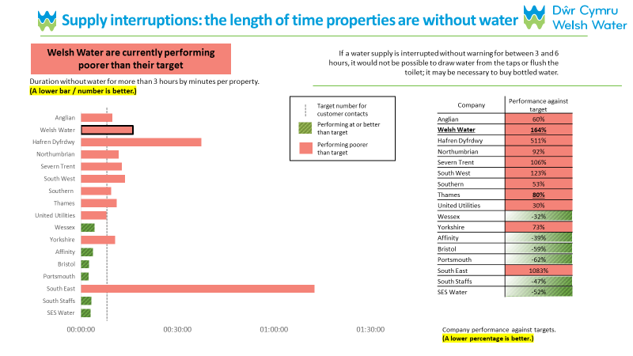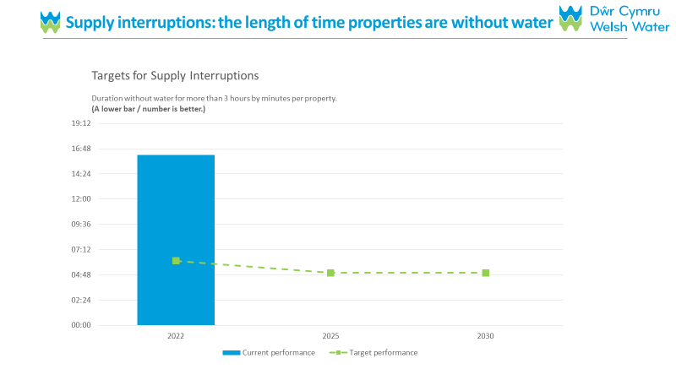

Option 2

Due to changes to the guidance in relation to the comparative data slides, the last 4 cognitive depths were shown alternative comparative data slides based on the latest updates in the guidance. Examples of these options are shown below.

Option 3
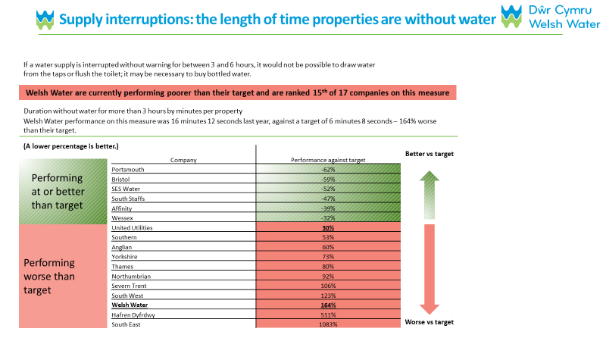

Option 4

Question | Comments | Action
General | Generally, the survey was well received with participants highlighting the good use of slides and that it contained a lot of information they weren’t aware of prior to this. Generally, participants felt that they weren’t bombarded with information. | None required
 | One participant found the survey interesting and thought it is nice to see WW’s future plans. | None required
 | One participant found the survey relevant as felt that service has declined since before and the work they are suggesting is relevant. | None required
 | One participant is pleased with WW and finds the current bill acceptable.  Was very clear and interesting to see and find out about improvements - especially ones that they would have not thought of. | None required
 | One participant had an overall a positive experience completing the questionnaire. Was happy that WW are seeking customers' views as part of the BP planning process.  Overall, the level of information felt right. | None required
 | One participant generally felt there was too much info to read throughout and too much detail. Lots of technical stuff about 'engineering'.  They felt they did not need the comparative PC graphs (old version); Struggled to understand them, and admitted they didn't spend the time looking at them. The time they did spend, they focused on the DCWW bars/data. | None required
Affordability | Generally, this section was found to be clear and straight forward by participants. | None required
 | Looking at impact and affordability, given the rise that are coming. WW are looking at rising the cost of water bills, so what is the impact of that on the service user. How many people will end up in arrears | None required
 | Did not find Qs too intrusive, clear that this is to give a baseline indication of the HH financial picture. Qs were easy to answer - no suggestions for change. | None required
 | Some participants felt like a check and it felt nice like they are checking in  understandable questions does not feel “nosey”. | None required
 | One participant seemed to struggle to respond to the affordability section. Some people don’t want to admit if they’re struggling.  But, noted purpose of this section is so WW can see if people can afford the plans. | This is understandable to not want to admit struggling financially especially when you are completing the survey in front of another person. When completing the survey participants will be doing this in the privacy of their homes and this can potentially cut down the embarrassment some people may feel
 | NHH – found the question to be OK and easy to answer. The participant knew that the survey was anonymous and did not feel the finance Qs were too personal or intrusive - happy to answer this Q block. | None required
 | NHH felt it was easy to answer this question as they are managing now, however they all worry about future increases | None required
Proposed changes to the water/ sewage bill | This section was generally well received and it the majority of participants felt the information could be understood | None required – though the text seems long for some participants, most felt it was necessary to get the information across.
One participant had dyslexia and struggled with the length of the text and the format in which the information was displayed another labelled it as information overload
It was suggested to make the information more bite sized would make it easier to read and would reduce the risk of people skimming over the section
Some participants noted that this section may be a bit long and people do not have much time to spend reading this much information and needs to be simplified – level the information at people’s understanding to make it available to everyone.

“I would add please contact your local CAB if you need help”
 | One participant suggested highlighting in colour some of the key messages to make them easier to stand out | Make key messages in the text bold to stand out
 | One participant felt that information was thin on the ground; there was less than expected. The fact that there is little information made the participant feel like "it's covering something up." | None required
Definition of inflation | Participants were generally happy with the definition, however some took issues with the idea that wages might rise to keep pace with inflation (one worked for central government and has not had a salary increase worth speaking of). | Could add and information button to add a further definition for inflation
 | One participant felt there was a need for a better definition of inflation perhaps adding an information button where they can click on and have more of an explanation
Proposed Bill graph | One participant was not sure where these figures came from. P wasn't sure if it was just a fluke that the bill amount in the graph started at the same as their bill, suggested to add the following text in introduction: “this is your predicted bill based on your bill amount of x amount” | Could add this text in the introduction text*
 | Some participants mentioned being confused about the text explaining the information but the graph really helped understand it | None required
 | The graph was well received by the majority of participants:  Clear that the blue is the increase to bill from DCWW and orange is the additional contribution of inflation each year.  "You expect bills to go up in the main anyway, but this is showing you by how much in each of the years up to 2030." | None required
About Welsh Water slide | This slide was a hit with the majority of the people we spoke to. The top two boxes of information were found to be very palatable with just the right amount of information.  The water drop infographic was really liked and all the information in it was well displayed and felt to be the right size.  Many have remarked that they did not know how much work water companies do and this really explains it well and helps them understand the process. | None required
 | One participant suggested it could be used in schools to teach children. | None required
 | One participant noted that the numbering was not consistent: the numbering appears to follow the flow of the river through the diagram, but this caused clear frustration to a participant who did not know how to navigate the image | None required
 | One participant felt section did not impart much more knowledge than P already had. P felt that the level of information here was 'just right' but noted that it did not help him answer the later questions | None required
Comparative data slides | The comparative data slides with both graph and table and were found to be overwhelming by the participants  Some participants tended to focus on either the graph or the table and gravitated to whatever they found easier to read  One participant questioned the need to display the data in two ways and wondered whether just one would suffice | N/A – amended slide to meet guidance
 | Some participants found it hard to understand what the graphs are showing – potentially make the key stand out more as it was not noticed.  On the comparative PC graphs, one participant had not initially spotted the dashed target lines and suggested this be brought to the reader's attention better - Maybe place close to yellow highlighted text advising that a lower number is better | N/A – amended slide to meet guidance
 | One participant felt that both graph and table comparing performance were easy to read and understand. Appreciates the 'honesty' around sharing this comparative pfmc data. Clear that we are outlining future targets/ambition. | N/A – amended slide to meet guidance
 | Participants seeing the new adapted comparative data slides did not complain about feeling overwhelmed | None required
 | The blue charts at the bottom of the slide were better received and participants felt that the explanation next to it also helped | Use target slide with additional text
 | A participant mentioned not being able to understand the chart with the green line and perhaps a better key would help | N/A – amended slide to meet guidance
Welsh Water business plans | Participants felt that the purpose of this section was to understand customers' preferences in order to direct future investment. DCWW will review preferences and use to justify their business plan. | None required
 | Participants found it easy in general to chose between the business plans and have chosen their answers based on what was relevant to them personally.  e.g. some participants go camping close to the site where sewage is spilled into the sea and would not let the children swim there, had issues with flooding and flies a few years back so hyper aware of that etc. | None required
 | Participants felt that this section does well to explain WW plans and justification for rising prices but they nevertheless worry about the bills  “Just saying what WW future plans are about - diagram before tells you what they are going to go in and tells you what the plans are and this is why the prices will go up.”  “It does justify it but for businesses - small like mine is still a worry.” | None required
Key investment areas | This section was very well received. Participants really liked the use of slides and the images. And really like how the Why? And How? Were made to stand out  One participant suggested also adding WHEN to these slides | None required
The level of information provided was said to be just about right:
"If you put too much [information] in, you'll get bogged down - it'll become too confusing. If you put too much in there, if it's too verbose, people will just skim over stuff."
"The user isn't bogged down in the survey."
 | It was noted that it was easier to choose a priority here as he was not required to compare performance with other companies before making the judgement. Participants in general chose this priorities based on personal experience when questioned. However, a few have mentioned the wider environmental implication and next generations.
 | It was suggested if people would want more information on the key investment areas a link to be made available where participants can go back to and read in their own time | None required
Replacing the lead pipes | This slide has generated a lot of discussion around lead pipes:  - Are they still in use  - What areas are they still in use  - When are they going to be replaced  - Concerns posed to health  - Surely replacing them would lead to improved water quality | Consider adding more bullet points under ‘Why?’
Tackling threats | One participant remarked that the slide had “too many big words for me to understand”.  Another participant associated the word threat more with physical safety such as the war in Ukraine, terrorist incidents not really water companies. | Possibly consider amending the title of this slide
Acceptability | Participants felt the proposal is broadly acceptable and the information relayed helped them get to this conclusion – at Q34 they would have like the ability to chose more than two reasons | None required – part of the guidance so can’t be changed
Q35 – passing on the cost | Participants found it hard to choose what to answer here as they felt conflicted about passing this burden onto next generation and felt worried about their current financial wellbeing.  They would like to know exactly how much this is going to cost them before they go ahead and accept this increased bill now – this is even more so relevant for those financially vulnerable | None required
Overview | Overall, participants were able to make an informed decision on the business plan based on the information provided in the questionnaire. Participants commented the level of information was just right, however, it’s important to note that this could be impacted by the interview process and whilst interviewers tried to mitigate this as much as possible, participants still knew they were being viewed, which could be a reason why some took more time than they might have ordinarily done to read through the materials.

The minimum NHH sample size listed in the guidance for WOCs was 100.

