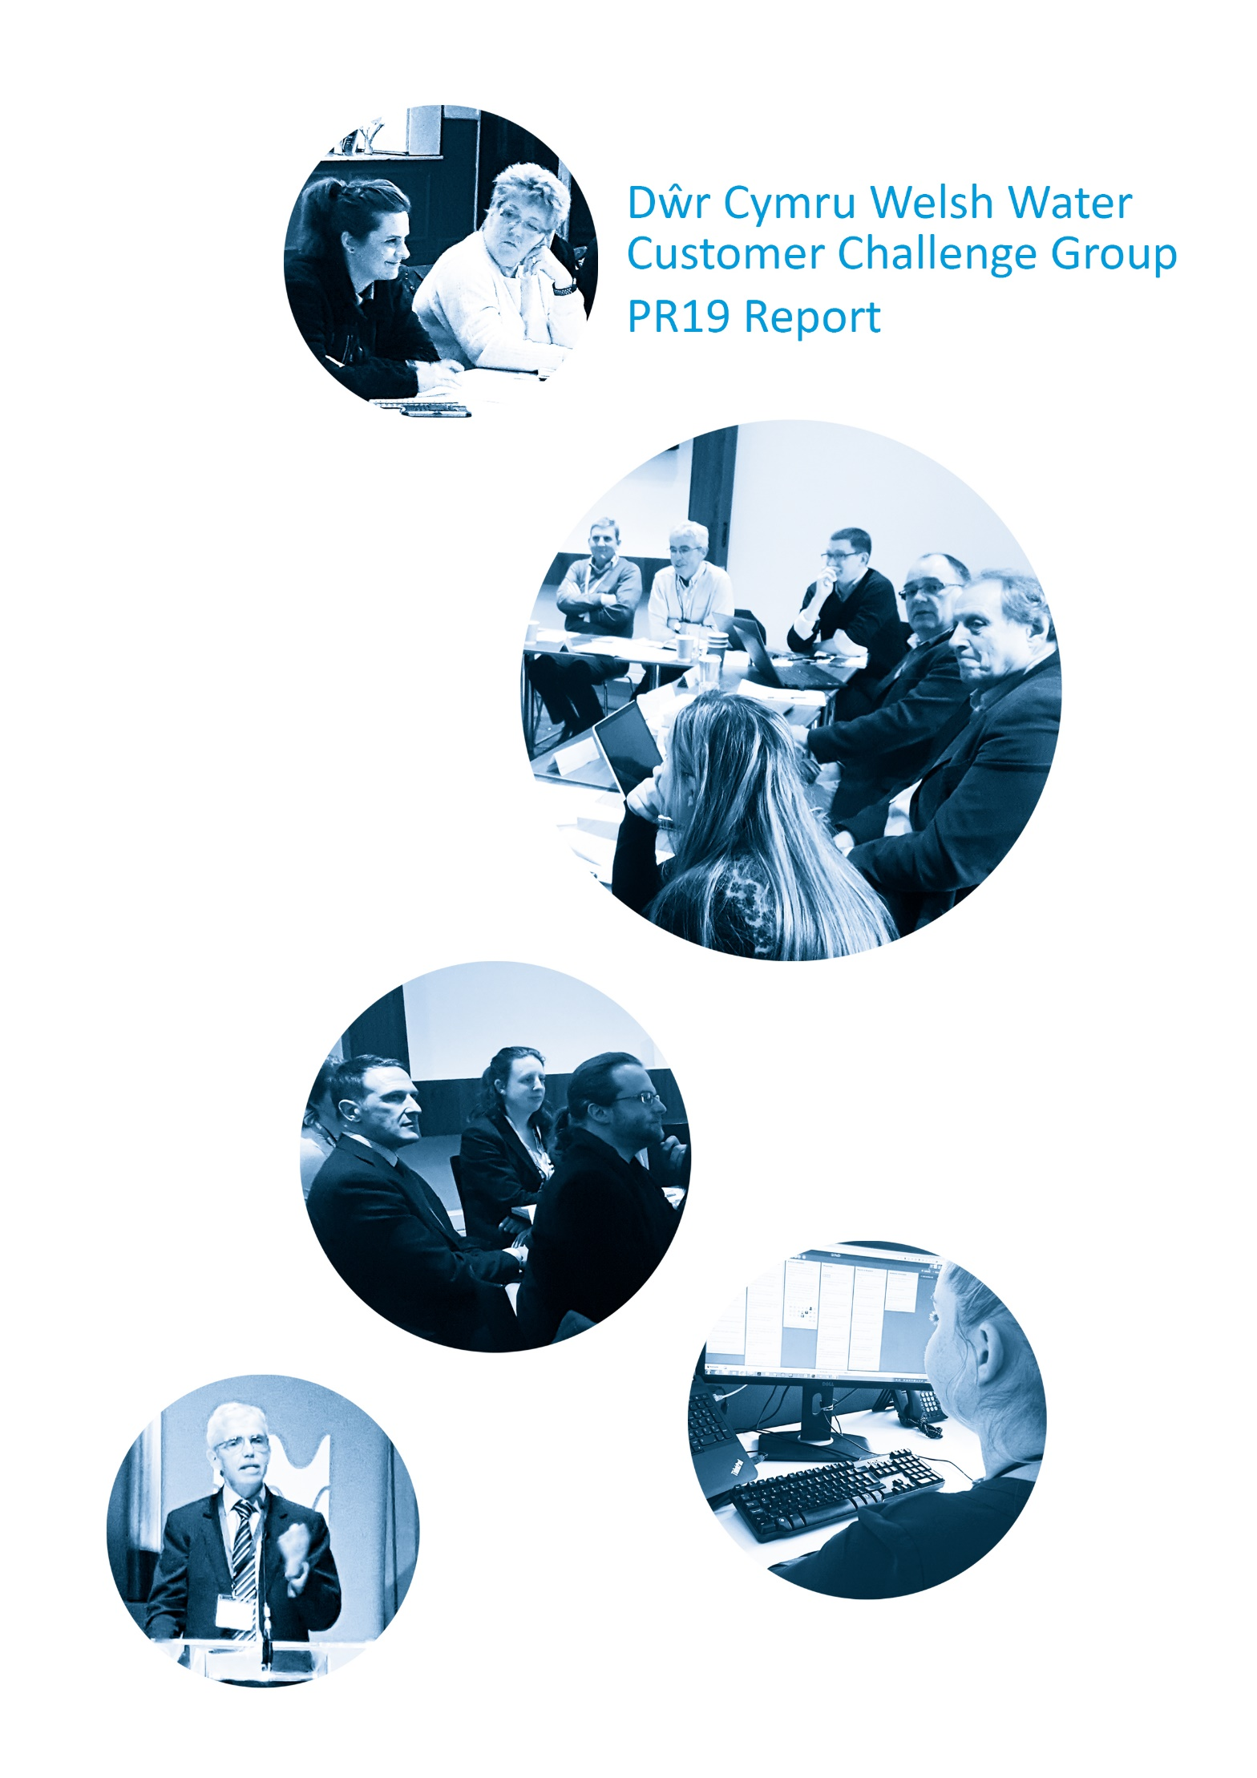

Executive Summary

Below is the executive summary of the CCG report for Welsh Water’s Business Plan. The full report has been submitted to Ofwat and can be found on the CCG’s webpage.

Executive Summary
- There has been a step-change in the Company’s customer involvement activities compared to PR14, with 30 pieces of research engaging over 40,000 customers with 9,000 participating in formal research that has contributed to the formation of the business plan. The CCG recognises this step-change in customer engagement from PR14 and that this body of research, along with other sources of customer evidence, has provided the basis for building the business plan. The PR19 Business Plan has been influenced by the views of customers throughout its development – as opposed to have been developed by the Company and then amended by consultation.

- The Company set out with the aim to build the plan from bottom up with an understanding of customer priorities shaping the design of the draft plan, which was then the basis of acceptability testing with customers. The final acceptability research indicates high levels of support from customers with 80% uninformed and 92% informed accepting of the plans. The acceptability research also shows 81% of customers felt it was good value for money.
- The CCG recognises the importance of the work that the Company has done in attempting to take a long term view through Welsh Water 2050. This plan was developed by the Company with expert input and, extensive customer engagement through the consultation resulting in changes to the strategic responses in the final plan. The 2050 plan provides the context for the PR19 plan and the CCG believes it is important that the Company demonstrates how the plan will deliver Welsh Water 2050 without placing undue burdens on future generations.

- The Customer Challenge Group’s six strategic challenges presented to the Board in May 2017 set out the evidence the CCG would expect to see in ensuring an effective process for customer engagement in the development of the business plan. These challenges reflected the Ofwat best practice guidance and the specific context of business operations in Wales. The Company has responded to these challenges in the development of the business plan as summarised in Appendix 01 ‘Company Responses to Strategic Challenges’. The CCG wants to ensure the Company applies this framework in delivering the PR19 business plan to build a more informed and involved customer base.

- The responses to the strategic challenges demonstrate that the Company has applied a range of research approaches and innovative techniques, as well as drawing on in-house data. The CCG commissioned Dr Dimitrios Xenias, a CCG member, to undertake an independent Customer Research Assurance Report (Appendix 02). This report indicated that the Company had broadened the research scope, expanded the range of methods applied and the breadth of available data. The report highlighted areas for improvement but concluded that “the Company has been successful in securing an understanding of the views of its customer base from the phase 1 research and triangulation process” (page 4). The CCG supports this finding and agrees that the Company has been successful in securing an understanding of the views of the customer base.

- The CCG did raise challenges over elements of the process in this phase of building the business plan, which were highlighted in the ‘Research Assurance Report’. These concerns are outlined in more detail in the report, with Company responses in Appendix 3, but can be summarised as the:
- challenges for the CCG in responding to the scale and timelines of the research programme reducing opportunities for co-design.
- complexities with the initial triangulation process, which while comprehensive, was complicated.
- nature of the Willingness to Pay methodology despite the improvements from the PR14 process.
- need for a clearer narrative to provide an overview of the process to demonstrate how the individual elements of the research stages contributed to the big picture.
- lack of clarity in the process by which the evidence base was being assimilated and applied to the decision making.
These last two points related to the desire of the CCG to see a clear ‘golden thread’ in the narrative between the evidence base, the measures of success and the Welsh Water 2050 Objectives. This was a strong and consistent challenge from the CCG throughout the ongoing process of building the business plan from the customer evidence base. The final PR19 submission from the Company includes documentation which demonstrates how customer evidence was applied to decision making in the formation of the business plan.

- The customer evidence base was used to establish the Measures of Success for the business plan using a triangulation process which drew on a range of evidence to establish a view of customer priorities. The second phase involved the application of the triangulation process to the evidence base to establish the targets or performance commitments against each measure. The CCG did provide challenge to this process but agrees that the measures as a whole do provide an effective performance framework that reflects customer priorities. Specific key points on which the CCG engaged with the Company in this process are set out below:
- The Company set out 45 measures of success, (subsequently amended following Ofwat feedback to 47) which was initially challenged by the CCG as being too many measures. It was further reviewed by the CCG and agreed that all measures were relevant to provide for a comprehensive business plan.
- The application of the Willingness to Pay methodology to the establishment of the performance commitment, with the concerns being acknowledged by the company which applied a wider range of sources of data to the process of target setting.
- While the CCG accepts that these measures provide an effective performance framework, it has stressed that some of the high-level measures may not be sufficient on their own, as they provide a quantitative figure which may not reflect the qualitative impact that is desired. For example, affordability and vulnerability related metrics will need to be supplemented by regular monitoring on the quality of assistance provided according to customer views; the Company has agreed to report on this qualitative element of this measure in a separate report.
- The CCG challenged the ambition of the performance commitments, particularly on priority measures of success for customers. The CCG stressed the need for a clear line-of-sight between the Welsh Water 2050 plan and the progress represented through the performance commitments in the PR19 plan. The CCG questioned whether enough of a start was being made in the key areas of water supply interruptions, per capita reduction levels, leakage, customer acceptability of water quality, pollution incidents, kms of rivers improved and lead pipe replacement. The CCG review of the Performance Commitments is summarised in Chapter 6: Measures of Success.
- The CCG accepts that while it encourages the Company to be ambitious across a range of measures this must be balanced against the evidence which shows the high level of financial vulnerably within the customer base in Wales. This needs to be fully recognised within the business plan, and its delivery, both in terms of affordability and other support for those who find it difficult to pay. The CCG supports passing through the reduction in cost of capital to reduce customer bills. In the acceptability testing 95% of customers considered the plan to be affordable, although 30% thought that it would be “a stretch”. This though is dependent on the Company keeping operating costs down, supporting vulnerable customers while clearly communicating with customers to keep them informed and engaged in the work it needs to undertake for customers.

- The customer research indicates that while affordability is an issue, bill reduction is not an overriding concern for most customers who support investment for the long term. The CCG notes that the Company intends to drive efficiency savings to deliver an increase in its investment plans for the next AMP. The options testing phase of the Acceptability Research did indicate that a small majority of customers were in favour of a smaller bill reduction to allow for extra investment. The CCG felt that this was not a strong enough mandate for the Company to proceed with the additional options in the business plan and the associated additional cost on the customer bill. The CCG welcomed the compromise of including the top priority extra investments in the plan while keeping the proposed level of bill reduction.

- The issue of support for customers in vulnerable circumstances has been a key focus as set out in the CCG challenge to the Company’s draft strategy. The Company’s commitment to increase engagement with Priority Service customers, from 2% to 8% in-line with the current energy sector benchmark, is welcome, but the CCG notes that Ofgem are seeking the energy sector to offer a far higher level of engagement in servicing various degrees of vulnerability. The CCG stressed the need for the Company to consider a holistic cross-sector, community-focused approach to enable customer participation and has put particular significance on the Water Resilient Community pilot in Rhondda Fach. The CCG supports the adoption of the Water Resilient Communities project as a mainstream approach within the business plan. We encourage the Company to go beyond the minimum number of five communities in five years, to ensure the wider application of learning across the business operations and to extend the collaboration with other companies.

- The CCG welcomes the Company’s commitment to continue to increase the number of customers supported through assistance schemes, given the number of low income customers in Wales. However, it has asked for consistency in reporting against the target of 148,000, distinguishing between the targets for the HelpU social tariff and the WaterSure Wales assistance. The CCG welcomes the continued ambition but notes that the most recent customer research did not demonstrate enough support to justify an increase in social tariffs cross-subsidy on bills beyond current levels. This result, along with the high potential numbers of eligible customers, the Company’s view on the likely reductions in profits to return to customers and evidence of the need for better targeting, indicates that a new approach in the Company’s assistance package going forward is required. The Company committed to working with the CCG to further develop the new affordability and vulnerability strategies in the autumn of 2018.

- Ofwat were clear in their methodology that they expect companies to engage with customers on the design of their rewards and penalties. The Company did not include reference to ODIs in its final quantitative acceptability testing of the business plan. This was an issue raised through the CCG by the Consumer Council for Water, who felt that there was opportunity for the Company to find an effective way of engaging customers on the impact of ODIs in the quantitative research. The Company undertook qualitative research on the application of ODIs of the acceptability testing, which influenced the design of the proposed ODI model. This research indicated only limited support for ODIs but also highlighted the difficulty of engaging customers on the detailed design of the ODI scheme, not least in that customers are confused as to its application in the not-for-profit model.

- The Company should ensure that there is a transparent approach to the application of the ODIs to ensure customers understand how the rewards and penalties are being applied. While recognising that the final quantitative acceptability testing research did not include a discussion on the potential impact of ODIs on bills, a key concern for CC Water, the CCG supported the approach the Company is proposing for ODIs, as consistent with customer views from the qualitative research that took place on ODIs which are: a greater focus on penalties; prioritisation across the measures which are important to customers; the application at the lower end of the range to minimise volatility and retain customer confidence; the plans for returning any net reward to benefit customers through a Water Share scheme.

- The CCG is pleased that the Company responded to its challenges to focus on Non-Household customers in Wales. In particular we note that the Company has incorporated a Non-Household Customer Experience Measure (B-Mex) which will replicate the Household customer C-Mex in Wales. In the context of no option for those customers to swap suppliers we think this is an important measure to include in the Company’s performance measure suite.

- Customers and stakeholders have high expectations of the Company’s contribution to environmental improvements. The scale of ambition for environmental improvement and the degree to which that can be achieved in the PR19 business plan has been the focus for negotiations with Natural Resources Wales (NRW) and the Environment Agency (EA) in agreeing the National Environment Programme. Neither the CCG nor the Independent Environment Advisory Panel were engaged in this process as it related to statutory obligations. The NRW and EA annexes set out their views on the Company’s proposals for the delivery of the National Environment Programme and the wider environmental ambitions for the business plan. The CCG supports the importance placed on "avoiding storing up problems for future generations", but believes that proposals for phasing the NEP can potentially lead to better value for money outcomes for customers and supports Welsh Government’s encouragement for the Company to seek out opportunities through alternative ways of working to identify different approaches to deliver environmental improvements in order to deliver value for money for customers, today and in the future.
- The CCG has been supportive of the importance of initiatives such as ‘RainScape’ and investment in catchment management schemes, which provide opportunity for customer participation. Customers support nature-based approaches and there is strong commitment across stakeholders to develop catchment management schemes. This is an area where the CCG expects strong leadership and ambition from the Company in embedding this approach as core to the business operation. The commitment to the application of the principles of the sustainable management of natural resources as required through the Environment (Wales) Act provides the opportunity to demonstrate innovative models of working with customers and stakeholders alike. This is reflected in the Company’s agreement to deliver on the principles set out in the ‘Blueprint for the 2019 Price Review in Wales’ issued by the NGO umbrella organisation, Wales Environment Link, who are represented on the CCG.

- It is important to recognise that the Dŵr Cymru not-for-profit business model provides the foundation for a much stronger and trusting relationship with customers who ‘have their say’ in how the return of value is distributed. The CCG will want to ensure that the Company uses this relationship to deliver leading practice in customer participation and coproduction in the delivery of the business plan.
- The CCG has worked closely with Welsh Government through its PR19 Forum to ensure that the business plan reflects the legislative framework and the priorities set out in the devolved Government’s ‘Water Strategy’ and the ‘PR19 Strategic Priorities and Objectives Statement’. The Welsh Water 2050 plan has been based on the frameworks of the Well-being of Future Generations and Environment (Wales) Acts and the CCG would expect progress against the business plan to be reported against this framework demonstrating its contribution to the achievement of the national well-being goals.
In summary
This report demonstrates the scale of engagement the CCG has had with the Company throughout the process of developing the plan. The plan has been influenced by customers and the contribution of the CCG throughout its development.
It is the CCG’s view that the Company has been successful in securing an understanding of the representative views of its customer base, and that this evidence has been used to develop the performance commitments and customer bills in the business plan. The final acceptability testing demonstrates strong support for the plan that meets customers’ expectations, representing improved value for money.
The CCG’s push for ambition in the plan recognised the necessary balance between addressing the affordability needs of the customer base in Wales and the need to make progress against the ambitions of Welsh Water 2050, in line with customers’ expectations. The plan sets out to deliver a reduction in bills and increased investment levels with stretching efficiency targets to keep costs low. The CCG will continue to challenge the Company to be ambitious through innovation and the participation of customers in delivering solutions.

Appendix 02 Research Assurance Report (page 4)
https://www.dwrcymru.com/en/Environment/IEAP.aspx
http://www.waleslink.org/sites/default/files/blueprint_for_the_2019_price_review_in_wales.pdf
https://gov.wales/docs/desh/publications/150521-water-strategy-for-wales-en.pdf
http://www.assembly.wales/laid%20documents/gen-ld11283/gen-ld11283-e.pdf
https://gov.wales/topics/people-and-communities/people/future-generations-act/?lang=en
https://gov.wales/topics/environmentcountryside/consmanagement/natural-resources-management/environment-act/?lang=en

