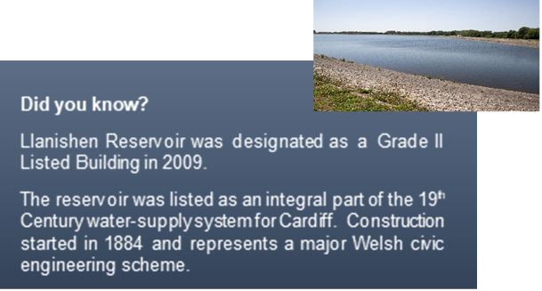
Hello
As 2020 draws to a close, we would like to update you on the latest news and progress that has taken place to support our vision to create a hub for recreation, health and wellbeing at Lisvane and Llanishen reservoirs
We would also like to take this opportunity to thank everyone for feedback and support and to wish you all a safe Christmas.
Proposed Visitor Hub
During the summer we revealed our plans to create a hub for health and wellbeing at the reservoirs. We were delighted with the response to the pre-planning application which attracted nearly 2,000 responses with more than 85% approval of the plans.
Thanks to your feedback from the consultation we revisited some of our early decisions and re-examined how we could improve the visitor centre’s green credentials.
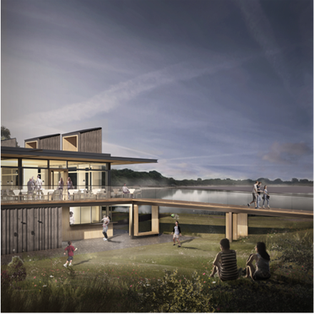
The formal planning application has now been submitted to Cardiff Council and changes to the design include the installation of photovoltaic (solar) panels, the use of ‘green gas’ generated from our core operations of treating sewage sludge and provision for more electric car charging points.
The planning consultation period runs for eight weeks, so there is still time to review the documents and comment on Cardiff Council’s Planning Portal using reference application no: 20/02175/MJR.

Reservoir Update
The work to restore the reservoirs has now been complete and Llanishen reservoir is once again filling up and returning to its previous glory.
We would just like to remind people that the site does remain closed for safety reasons, security are present and Welsh Water staff will be visiting on a regular basis, however if anyone notices any activity of concern on site then we kindly ask you to let us know

Friends Group
In May we announced our intention to support the formation of Welsh Water’s inaugural Friends Group, to enable local people to get involved with helping care for the site into the future. Since then we have received nearly 100 registrations of interest.
A small working group has now been formed with the help of Bernard Adshead, Treasurer of the Reservoir Action Group, to support the development of the constitution, policies and procedures. Wales Council for Voluntary Action has also offered advice and support. We really appreciate everyone’s time and effort and look forward to a long-term working relationship with the community.
If you’d like to find out more then please get in touch. You can register your interest by completing the online form at www.dwrcymru.com/volunteer
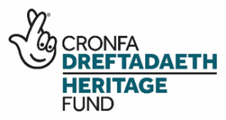
Woodlands Restoration
In November we received the exciting news that we’d been successful in our application to the Welsh Government Community Woodlands initiative and The National Lottery Heritage Fund.
The £200k grant will allow us to fast track the restoration of the Gwern-y-Bendy woods and part of the Rhyd-y-Penau woods complex, which have been left largely unmanaged for many years. Now, thanks to the award we can develop a woodland management plan to restore and enhance the woodland so that it can flourish for decades to come.
The grant will enable the removal of INNS, restoration of an historic pond and the planting of connecting hedgerows to serve as wildlife corridors. The intention is to do it all with the help of the local community and with the support of our ‘Friends of’ group. It will also fund the purchase of tools, equipment, PPE and training of volunteers, developing their skills and knowledge so they can continue to care for the woodlands into the future.
ENRAW Collaborations
We’ve always known that the reservoirs are an important part of the community and this was clearly demonstrated during the public consultation period when so many of you got in touch. Alongside residents, lots of organisations have also reached out to offer their support, such as national sporting bodies, educational institutions and community groups.
Through the Welsh Government funded ENRAW project we have been collaborating with the Glamorgan Fungus Trust on our annual waxcap survey. As the best time to spot the waxcaps is during the fungi fruiting season between October to November, volunteers have accompanied our Ecologist on a recent site visit. The site visit was carried out in line with COVID-19 Guidance and social distancing maintained at all times.
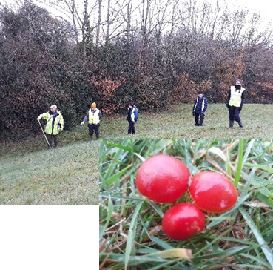
We are pleased to report that this year appears to be a good year for fungi, an example is Scarlet Waxcap (Hygrocybe coccinea) in the photo.
Thanks to a British Trust for Ornithology (BTO) volunteer the Wetland Bird Surveys (WeBS) have resumed at the reservoirs. The reservoirs also attracted some exciting birds in November. At the beginning of the month a Great Northern Diver, a White-fronted Goose and five Common Scoter turned up on site. Towards the end of the month a Whooper Swan paid us a brief visit. All these birds breed in the far north and are scarce winter visitors to Cardiff.
Wildfowl numbers will hopefully start to build up over the coming weeks, especially if we have a cold snap. Small numbers of Pochard and Teal, a Wigeon and a Goldeneye have already been seen and may soon be joined by many more. We will update you on progress as further collaborative projects are developed and delivered. Any organisations, community groups or charities which would be interested in finding out more about the partnership opportunities which could be available at the site can email us at lisvaneandllanishen@dwrcymru.com
Thank you
Finally, we would like to say thank you to everyone who took the time to share your special memories and photos of the reservoirs. We will be working on the signage and interpretation content in the New Year – and would love to incorporate your stories and pictures, to help visitors and future generations learn more about the site’s rich history.
Drop us a line with any stories or information you may have. All information will be held in the strictest of confidence. Material will not be shared further without contacting you for consent. Please email all information to: lisvaneandllanishen@dwrcymru.com

