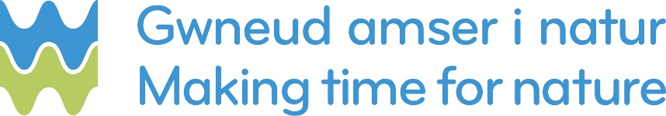

Biodiversity - Third Sector Funding Scheme

Project Proposal Form and Criteria 2018/2019
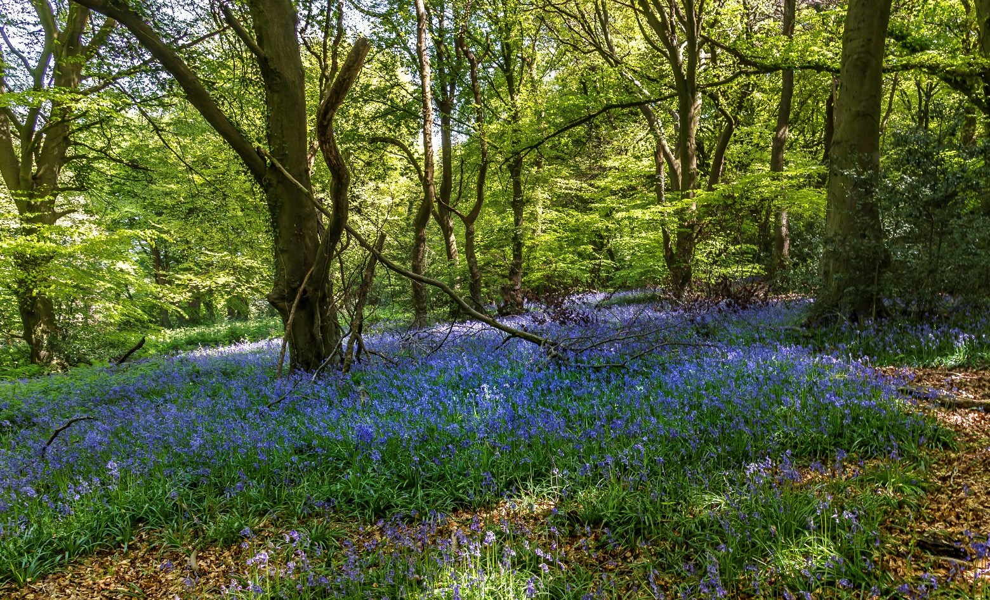

Dŵr Cymru’s Biodiversity Third Sector Funding Scheme
Following the publication of Dŵr Cymru’s statutory biodiversity plan, ‘Making Time for Nature’, the company is making funding available to support initiatives that will enhance biodiversity on our sites and in the wider community.
We are inviting applications from non-profit organisations to act as a delivery partner and improve biodiversity.
We are happy to discuss with applicants any proposals they may have in order to make sure that the value they will bring align with Dŵr Cymru’s interests.

Objectives
The overarching objectives of the funding scheme are:
- To contribute toward Dŵr Cymru meeting its legal duty to maintain and enhance biodiversity and in doing so promote the resilience of ecosystems in the exercise of its functions.

- To enable the delivery of actions and interventions that support the delivery of the Wales Nature Recovery Plan; or biodiversity related aspects of Area Statements; or address issues identified by Natural Resources Wales in its State of Natural Resources Report as contributing to biodiversity loss; or benefit species or habitats that are protected for nature conservation or have been identified as being of principal importance for biodiversity.

Eligibility
Non-profit organisations, including community groups, can express an interest to act as a delivery partner. Organisations are encouraged to submit joint proposals as combining interests and capabilities could improve biodiversity outcomes. Schemes that help to foster community engagement with their local environment would be welcome. Organisations are also encouraged to partner with Natural Resources Wales (or Natural England) from an early stage to ensure that the project aligns with wider efforts to deliver biodiversity benefits, such as by addressing issues identified in the Nature Recovery Plan or by benefitting protected species (e.g. organisms of principal importance under section 7 of the Environment (Wales) Act 2016).
The fund is not available to public authorities that have a biodiversity duty under section 6 of the Environment (Wales) Act 2016, but such authorities are encouraged to approach Dŵr Cymru with partnership opportunities to promote biodiversity.

Project Scope
- Projects funded by Dŵr Cymru must achieve credible and specific outputs within a specified period.

- Projects must offer added value to Dŵr Cymru’s customers. For example, projects may contribute to or complement Dŵr Cymru’s own on-going efforts to maintain and enhance biodiversity on Dŵr Cymru’s land or assets.

- Projects can include survey work, research, education and community engagement but a clear pathway to beneficial outcomes for biodiversity and/or ecosystem resilience must be demonstrated.

- Project budgets can include support for officers and costs directly related to delivery. Project budgets cannot include support for general staff costs or core activities of the third sector organisation.

- If on-going maintenance is required after a project is completed, applicants need to demonstrate the long-term sustainability of the project.

- Proposals should include a description of how project outcomes will be evaluated. This evaluation should then be undertaken after project completion, within the overall project timeframe. Where applicable, an evaluation may include a monitoring regime.

- If long term monitoring is required to confirm the proposed outcomes, for example, restoration of natural habitat, the proposal should be clear on how such monitoring would be done and by whom.

How to apply
- Begin by contacting the Environment Team at Dŵr Cymru-(Biodiversity@dwrcymru.com) to express your interest in applying for financial support to deliver a project.

- Without prejudice to any subsequent decisions we may make about whether to provide funding toward your project, we will be happy to discuss and help you develop your ideas to enable you to complete and submit the project proposal form below.

- The level of detail required in describing the project should be proportional to by the level of funding sought.

- Upon submission of the project proposal, an initial assessment will be undertaken to determine whether the proposal matches our objectives and the specified criteria and is considered to be good value for money.

- If suitable, the project proposal will then be presented to Dŵr Cymru’s Independent Environmental Advisory Panel for their recommendation on whether to award funding. A final decision will then be made by Dŵr Cymru based on recommendation from the panel.

How will project proposals be assessed?
Project proposals will be assessed by Dŵr Cymru using the following criteria:
- Does the project broadly align with the funding schemes overall objectives, eligibility and project scope?
- Is the project within Dŵr Cymru’s operational area?
- What value does the proposal offer to Dŵr Cymru’s operations or assets?
- What evidence is there which confirms that Dŵr Cymru’s funding is needed to ensure that the project happens and outcomes realised?

- Are there linkages with, for example, wider efforts to deliver biodiversity benefits, such as the Nature Recovery plan or local Biodiversity Action Plan?
- What biodiversity outcomes does the project have?
- Is the proposal conceptually and scientifically sound?
- Has the partner demonstrated capacity to deliver the project?
- Does the proposal demonstrate value for money?
- If the project will require land owner permission or a licence or consents, have these issues been addressed?
- Does the proposal clearly identify risks to delivery and describe measures to mitigate the risks?
- Does the applicant have credibility to ensure that the project is implemented in accordance with current Health & Safety legislation?

What is the deadline for project proposals?
There is no deadline for project proposals- they will be considered until funds are fully allocated.
However, assessment period will be dictated by the quarterly meetings of the Independent Environmental Advisory Panel. These meetings are in January, April, July and October.

How will funds be paid?
The release schedule of funds will vary according to the needs of delivery partners and their projects. For larger projects with staged payments, progress will be monitored at (pre-agreed) key delivery checkpoints before additional funds are released.

Project governance
All projects are subject to review by Dŵr Cymru. The proposals that meet the funding criteria are then reviewed by Dŵr Cymru’s Independent Environmental Advisory Panel who will provide comments and recommendations on projects.
Awarding of project funding thereafter will be confirmed by the Environment Team and is at the discretion of Dŵr Cymru.
- A successful applicant will sign a Letter of Agreement and be solely responsible for the project delivery.
- The successful applicant will be responsible for attaining all permissions and consents, and be legally responsible for all risks associated with the project.

Brief details of successful applications may be published on Dŵr Cymru’s website with prior permission from the Project Manager.

Application Form
Name of Organisation(s)
Organisation’s name in full. If more than one organisation will be delivering the project, list the partner, with the lead partner first.

Address of Organisation(s)
Organisation’s address in full. If more than one organisation will be delivering the project, list the partner addressed as in section 1.1.

Contact Details
Name and job title of contact person
This should be the lead delivery partner contact person for the project. Please include the full address, email and phone numbers, including dialling code.
Name

Address

Email address

Mobile Tel No
No

Lead Partner Organisation Information
Please provide information about your organisation’s charitable status, company registration and VAT registration. We may check these details with the relevant authorities.
Is the lead partner the sole applicant? Yes No N/A

Is the lead partner part of a consortium? Yes No N/A

Is the lead partner a registered charity? Yes No N/A

Charity Registration number

VAT registered Yes No N/a

VAT registration number
A registered company Yes No N/a

Company registration number

Project Description
The information in this section should summarise the project with sufficient detail to allow the proposal to be assessed against the criteria listed above.
Project title, cost and completion date
We will use the title to identify your project. The title should describe what the project does and where, for example, ‘Tree planting, River Taff in Cardiff’.
Project title:

What is the total capital cost of the project? What amount of funding is being requested?
Total project cost:

Funds requested:
When will the project be completed?
Project completion date:

Project location
Provide basic information on the project location. If the project delivery will occur at multiple locations, provide information in the ‘location description’. Feel free to add lines as required.
Location Description (a map showing the location is helpful):
Is the project relevant to a designated site? If so, please give the site name and of designation (e.g. SSSI)

Will the project benefit habitats or species that are, for example, of principal importance for the purpose of maintaining and enhancing biodiversity (see section 7 of the Environment (Wales) Act 2016 or section 41 of the Natural Environment and Rural Community Act 2006)

Project objectives description
Describe the objectives of the project.

Sustainability
Will the project continue after funding from Dŵr Cymru stops? If so, explain how the project will be sustained in the long term.
Project Governance
Checkpoints
Identify key delivery checkpoints (with dates) that could be included in the Letter of Agreement between Dŵr Cymru and your organisation. For projects with large budgets, or that require permissions/consents/feasibility studies, these delivery checkpoints will be used to determine the release schedule of staged payments.
Date | Checkpoint Indicator | Funds Released (£k)

Project Evaluation

It is critical that we learn from the projects that we help to deliver and we therefore ask that a project evaluation is undertaken upon completion. Briefly describe the information that you will include in your final Project Report and Evaluation to be submitted upon completion of the project. Also include a description of any ongoing monitoring that you will conduct to assess if the project delivers its environmental objectives.

Supplementary information
Use this section to reference any supplementary information that you have attached in support of your application.

Privacy Notice
The Data Protection Act 2018

Dŵr Cymru Welsh Water takes seriously the security of your personal information. We will always ensure that it is stored securely and seen only by those people involved in the funding process.

Your personal information

In applying to Dŵr Cymru Cyfyngedig for funding, any personal information that you provide will be processed by us so we can fully assess your application.
Processing of your personal details is necessary to carry out the assessment and eligibility of your funding request.

We may also process or release information to:
- Consult the public, public organisations and other organisations (for example, other organisations involved in Biodiversity Project delivery who are aiming to improve biodiversity and the environment in a similar way).
- Carry out research and development work on environmental issues.

We may pass the information on to our agents or representatives who are undertaking activities associated with the assessment or delivery of the funding request.

Dwr Cymru Welsh Water processes or uses the personal data it holds for the following purposes:

- Assessing the funding supplication;
- Awarding or declining a funding request;
- Maintaining records of funding applications (awarded or declined);
- Confirming that the information provided within the application is accurate;
- In some cases, transferring details to a third party which will be providing services on behalf of Dŵr Cymru Welsh Water;
- Fulfilling our reporting and audit obligations.

Further information on how we process personal information is available on Dŵr Cymru Welsh Water’s website.

Complaints

If you have any concerns about how your personal data is being handled by Dŵr Cymru Welsh Water, please contact our Data Protection Officer at DataProtectionOfficer@dwrcymru.com

You may also make a complaint to the Information Commissioner, who is an independent regulator. The Information Commissioner can be contacted on:

Information Commissioner’s Office
Wycliffe house
Water Lane
Wilmslow
Cheshire
SK9 5AF

Telephone: 0303 123 1113

Email: casework@ico.org.uk

Any complaint to the Information Commissioner is without prejudice to your right to seek redress through the courts.

Declaration

- I, a duly authorised officer, on behalf of the organisation whose name appears below agree that Dŵr Cymru Cyfyngedig reserve the right not to enter into any arrangement or obligation pursuant to this form without any liability on their part. For the avoidance of doubt, Dŵr Cymru Cyfyngedig do not relieve the organisation of any obligation it may have in statue or otherwise in respect of the project or any information contained in this form.
- I can confirm that the information contained in this form is true and complete and that all necessary support documents are attached to this form and are in accordance with the requirements set out in this form.

WARNING: A false or inaccurate statement may lead to disqualification from the assessment process and (without prejudice to the other rights and remedies of Dŵr Cymru Cyfyngedig) withdrawal of any grant award or offer of payment and recovery of payments made.

NOTE: If submitting this form electronically the phrase ‘signed’ in the signature box will confirm that you have read and agree with the information and conditions in this section.

Signature Date

Duly authorised to sign this form on behalf of

Name of
Organisation ………………………..

Position ………………………..

Name in Telephone

BLOCK
LETTERS

